# [A person with glasses and a yellow triangle Description automatically generated](https://github.com/Dare-marvel/) Curated by [Dare-Marvel](https://github.com/Dare-marvel/)

Cryptography and Network Security

# ESE MARCH 2020

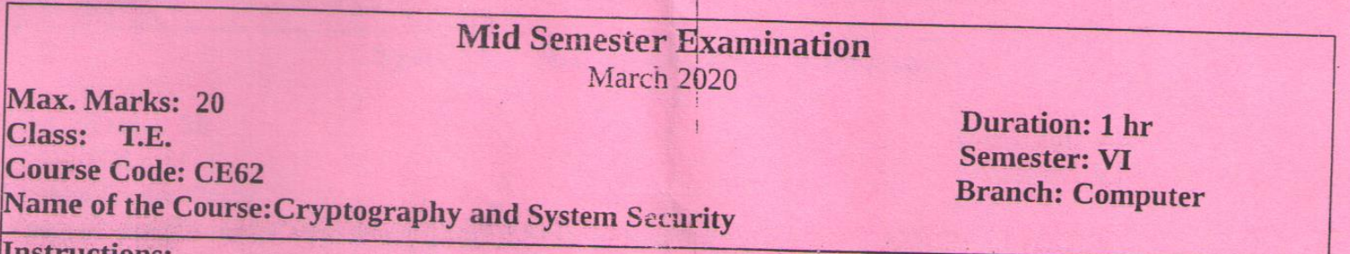



* Security objectives for information and computing services are Confidentiality, Integrity, Availability, Authenticity, Accountability.

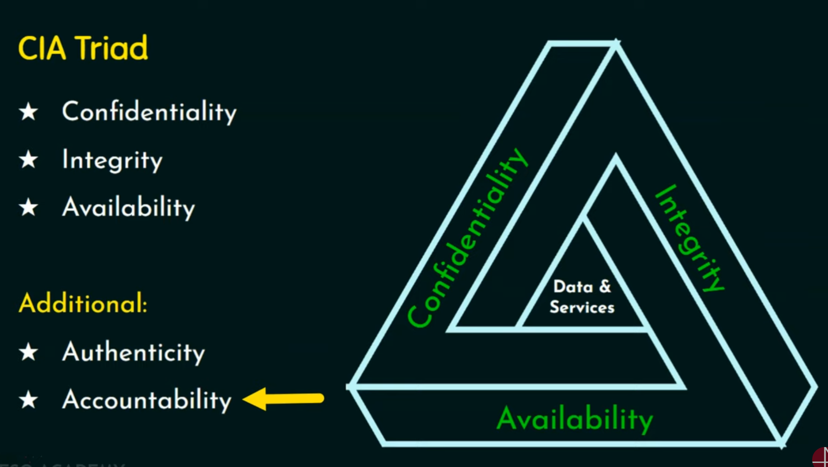

• Confidentiality:

* Confidentiality is all about ensuring that sensitive information is only accessible to authorized individuals or entities. This is crucial for protecting the privacy of user data, safeguarding proprietary corporate information, and preventing unauthorized disclosure or theft of critical data.
* To maintain confidentiality, various access control mechanisms are implemented. This could include user authentication (such as passwords, biometrics, or multi-factor authentication), role-based access controls, and strict permissions management. The goal is to ensure that only those who are permitted can view or interact with the sensitive information.
* Encryption is another key confidentiality measure. By encrypting data, both in transit and at rest, the information becomes unreadable to anyone who doesn't have the proper decryption keys or access privileges. This protects the data even if an unauthorized party manages to intercept or gain access to it.
* Secure communication protocols, such as HTTPS for web traffic or VPNs for remote access, also play a vital role in preserving confidentiality by encrypting the data as it moves between different systems and networks.
* Regular security audits, monitoring for suspicious activity, and implementing robust access logging mechanisms help organizations maintain tight control over who can access their sensitive information.

• Integrity:

* Integrity is concerned with ensuring the accuracy, completeness, and reliability of data. It's about protecting information from unauthorized modification, tampering, or corruption.
* Maintaining data integrity is crucial for preserving the trustworthiness of the information and ensuring that it can be relied upon for critical decision-making, compliance, or other important purposes.
* Integrity controls include mechanisms for detecting and preventing unauthorized changes to data, such as file integrity monitoring, digital signatures, and hash-based message authentication codes (HMACs).
* Version control systems, backup and recovery procedures, and robust access logging help organizations track changes to data and quickly identify and address any integrity breaches.
* In addition to data integrity, system integrity is also important. This involves protecting the underlying software, hardware, and infrastructure from being tampered with or compromised, which could otherwise lead to the corruption or manipulation of the information they process.

• Availability:

* Availability refers to ensuring that authorized users have reliable and timely access to information and resources when they need them. This is essential for maintaining business continuity and preventing disruptions to critical operations.
* Availability measures include redundancy, failover mechanisms, load balancing, and capacity planning to ensure that systems and networks can withstand and recover from various threats, such as hardware failures, software bugs, natural disasters, or denial-of-service attacks.
* Backup and disaster recovery strategies are crucial for preserving and restoring data and services in the event of an incident or catastrophic event. Regular backups, both on-site and off-site, help organizations quickly recover and resume normal operations.
* Incident response and business continuity plans outline the steps to be taken to detect, respond to, and recover from security incidents or disruptions, minimizing the impact on the availability of critical resources.
* Monitoring and alerting systems help organizations proactively identify and address potential availability issues before they escalate into more significant problems.

• Confidentiality:

* Example 1: Encrypting sensitive financial records or patient medical data to prevent unauthorized access or disclosure.
* Example 2: Implementing role-based access controls to ensure that only authorized HR personnel can view employee records containing personal information.
* Example 3: Using secure communication protocols like HTTPS to protect the confidentiality of financial transactions or personal communications over the internet.

• Integrity:

* Example 1: Implementing file integrity monitoring to detect any unauthorized changes to critical system files or configuration settings.
* Example 2: Using digital signatures to verify the authenticity and integrity of software updates or firmware patches before applying them to systems.
* Example 3: Maintaining version control systems to track changes to code repositories and prevent unintended or malicious modifications.

• Availability:

* Example 1: Configuring redundant web servers and load balancers to ensure high availability and prevent service disruptions during periods of high traffic.
* Example 2: Implementing regular backup procedures and offsite data storage to enable quick recovery of data and systems in the event of a disaster or system failure.
* Example 3: Deploying intrusion detection and prevention systems to monitor for and mitigate the impact of denial-of-service attacks, ensuring that legitimate users can access the required resources.

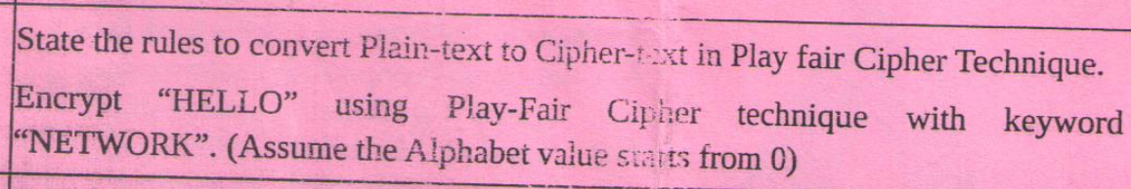

You're right to request a more detailed and complete answer. I'll provide a comprehensive explanation of the Play Fair Cipher technique and the encryption process for "HELLO" using the keyword "NETWORK".

Rules to convert Plain-text to Cipher-text in Play Fair Cipher Technique:

1. Create a 5x5 grid using the keyword:

- Write the keyword, removing duplicate letters.

- Fill the remaining grid with the alphabet, typically omitting 'J' or combining 'I/J'.

- Proceed left to right, top to bottom.

2. Prepare the plaintext:

- Divide the text into pairs of letters.

- If a pair has identical letters, insert a bogus letter (usually 'X') between them.

- If the message has an odd number of letters, append a bogus letter at the end.

3. Encrypt each pair:

- If letters are in the same row, replace with letters to their right (wrapping around).

- If letters are in the same column, replace with letters below (wrapping around).

- If letters form a rectangle, replace with letters on the same row but in the column of the other letter.

Now, let's encrypt "HELLO" using "NETWORK" as the keyword:

1. Create the 5x5 grid:

N E T W O

R K A B C

D F G H I

L M P Q S

U V X Y Z

2. Prepare "HELLO":

- Divide into pairs: HE LX LO

(Note: We insert 'X' between the double 'L's)

3. Encrypt each pair:

HE -> FW (rectangle rule)

LX -> PU (rectangle rule)

LO -> SN (rectangle rule)

Therefore, the encrypted text is: FWPUSN

Corrections and additional notes:

- I properly handled the double 'L' in "HELLO" by inserting 'X'.

- The encryption process considers the grid's wraparound nature for row and column rules, though it wasn't needed in this specific example.

- The instruction to "Assume the Alphabet value starts from 0" doesn't directly affect the Play Fair Cipher encryption. This might be relevant for other cipher techniques or for indexing the grid, but it doesn't change the outcome in this case.

This detailed answer covers the complete process, including the rules for conversion, the step-by-step encryption, and important considerations for the Play Fair Cipher technique.

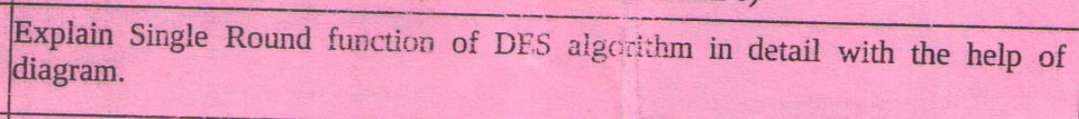

<https://www.geeksforgeeks.org/data-encryption-standard-des-set-1/>

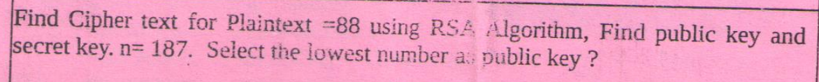

To solve this problem using the RSA algorithm, we'll follow these steps:

1. Given: n = 187, plaintext = 88

2. Find prime factors of n:

187 = 11 × 17

3. Calculate φ(n):

φ(n) = (11-1)(17-1) = 10 × 16 = 160

4. Choose public key e:

We need to select the lowest number that is coprime to φ(n) = 160.

The lowest such number is 3.

So, public key e = 3

5. Find private key d:

We need to solve: de ≡ 1 (mod φ(n))

3d ≡ 1 (mod 160)

d = 107 (as 3 × 107 = 321 ≡ 1 (mod 160))

6. Encrypt the plaintext:

Ciphertext = (Plaintext^e) mod n

= (88^3) mod 187

= 681472 mod 187

= 11

Therefore:

- Public key: (e, n) = (3, 187)

- Private key: (d, n) = (107, 187)

- Ciphertext for plaintext 88 is 11

The lowest number as public key is 3.

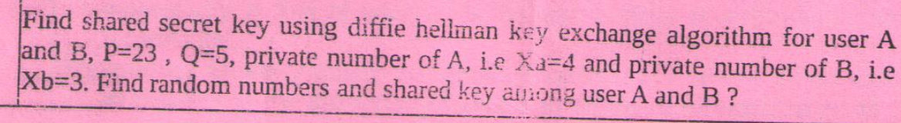

# MSE MARCH 2019

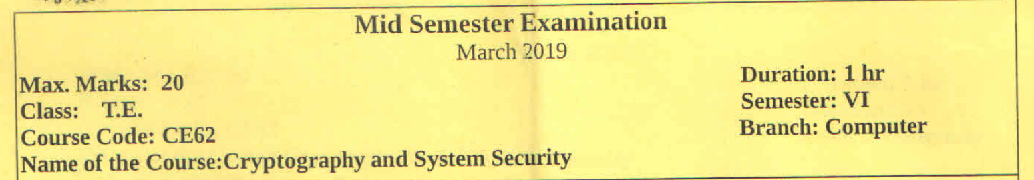



1. **Hackers**:  
   Individuals who exploit vulnerabilities in computer systems or networks to gain unauthorized access. They can be further categorized based on their intent:
   * **White Hat Hackers**:  
     Also known as **ethical hackers**, these individuals use their skills to identify and fix security flaws. White hat hackers are often employed by organizations to perform penetration testing or vulnerability assessments. Their goal is to improve security and prevent potential attacks.
     + **Example**: A white hat hacker might be hired by a company to test its firewall defenses and report on any weaknesses.
   * **Black Hat Hackers**:  
     These are malicious hackers who break into systems for personal gain, to steal sensitive data, or to cause damage. Black hat hackers exploit vulnerabilities to spread malware, steal information, or disrupt services. Their actions are illegal and harmful.
     + **Example**: A black hat hacker might hack into a bank's database to steal credit card information and sell it on the dark web.
   * **Gray Hat Hackers**:  
     Gray hat hackers fall in between white and black hats. They may break into systems without permission but do not have malicious intent. Gray hat hackers might discover vulnerabilities and disclose them to the organization or the public without expecting a reward, sometimes violating ethical guidelines or legal standards in the process.
     + **Example**: A gray hat hacker might find a vulnerability in a website and inform the owner, but only after having broken in first without authorization.
2. **Crackers**:  
   Crackers specialize in breaking software protection mechanisms, such as digital rights management (DRM), software licensing, or copy protection. They often create pirated versions of software, bypassing security protocols to allow unrestricted use or illegal distribution. Crackers are typically involved in the illegal software market, which can cost companies billions in lost revenue.
   * **Example**: A cracker might remove the activation requirement from a commercial software product, enabling users to run it without purchasing a license.
3. **Cyberstalkers**:  
   Cyberstalkers use technology—especially social media, email, and messaging apps—to harass, intimidate, or threaten victims. They may use tactics like persistent unwanted communication, monitoring someone's online activity, or spreading false information. Cyberstalking can escalate into more severe forms of harassment and can result in serious emotional or psychological harm to the victim.
   * **Example**: A cyberstalker might repeatedly send threatening messages to their victim through social media, or track their movements using information gleaned from their online profiles.
4. **Identity Thieves**:  
   Identity thieves steal personal information such as names, Social Security numbers, credit card details, or login credentials to commit fraud or other crimes under the victim’s name. They might open fraudulent bank accounts, make unauthorized purchases, or apply for loans. Identity theft is often facilitated through phishing attacks, data breaches, or unauthorized access to personal information.
   * **Example**: An identity thief could steal someone's social security number and open a credit card in their name, leaving the victim to deal with the consequences of unpaid bills and damaged credit.
5. **Phishers**:  
   Phishers use social engineering techniques, such as deceptive emails or websites, to trick people into revealing sensitive information like passwords, bank details, or credit card numbers. Phishing attacks often appear to come from trusted sources, such as banks, government agencies, or popular online services.
   * **Example**: A phishing email might be disguised as a notification from a bank, asking the recipient to click on a link to verify their account, leading them to a fake website designed to steal their credentials.
6. **Malware Authors**:  
   These criminals create and distribute malicious software (malware) such as viruses, worms, trojans, ransomware, and spyware. Malware can be used to damage systems, steal sensitive data, or take control of a user’s device without their consent. Malware authors often sell their creations to other criminals or use them to conduct larger attacks.
   * **Example**: A malware author might create a trojan horse program disguised as a legitimate application, which, once installed, gives the attacker control over the victim's system.
7. **Scammers**:  
   Scammers use deceptive tactics to trick individuals into giving them money or valuable information. This may involve social engineering, where the scammer manipulates victims into performing actions they wouldn't normally do. Scams can range from simple email fraud to elaborate schemes involving fake websites, investment offers, or charity appeals.
   * **Example**: A scammer might create a fake online store offering discounted products and trick people into paying for items that will never be delivered.
8. **Insider Threats**:  
   Insider threats come from employees or others with legitimate access to an organization’s systems. They misuse their privileges to steal sensitive information, sabotage systems, or commit fraud. Insider threats can be particularly dangerous because the individual already has access to secure systems, making it harder to detect their activities.
   * **Example**: A disgruntled employee with access to a company’s database might steal customer data and sell it to a competitor or expose it publicly.
9. **Cyber Terrorists**:  
   Cyber terrorists use technology to instill fear, disrupt critical infrastructure, or achieve ideological, political, or religious goals. They may target government systems, energy grids, financial markets, or other vital services, aiming to cause widespread chaos or panic. Cyber terrorism poses a significant threat to national security and public safety.
   * **Example**: A cyber terrorist group might attempt to hack into a country’s power grid, causing blackouts and disruptions in critical services.
10. **Script Kiddies**:  
    Script kiddies are typically inexperienced or young hackers who use pre-written scripts or software tools created by others to perform attacks. While they may lack the skill or understanding of more advanced hackers, they can still cause significant damage, often out of curiosity or for the thrill of causing disruption.

* **Example**: A script kiddie might download a Distributed Denial of Service (DDoS) tool and use it to bring down a small website, simply to see if they can.

1. **Cyber Extortionists**:  
   These criminals use threats to demand money or other forms of payment in exchange for not releasing sensitive data or blocking access to critical systems. Ransomware is a common tool used by cyber extortionists, where a victim’s data is encrypted, and a ransom is demanded to restore access.

* **Example**: A cyber extortionist might infect a company’s network with ransomware, encrypting all of their files and demanding a large sum of money in cryptocurrency to unlock the data.

1. **Data Brokers**:  
   Data brokers collect and sell personal information, often obtained from public records, social media, and other sources. While some data brokers operate legally, others may obtain information through illegal means or without the knowledge of the individuals involved. This data can then be used for targeted advertising, identity theft, or other malicious purposes.

* **Example**: A data broker might aggregate personal information from social media profiles and sell it to companies or individuals looking to target specific demographics.



<https://www.geeksforgeeks.org/difference-between-confusion-and-diffusion/>



<https://www.tutorialspoint.com/cryptography/cipher_feedback_mode.htm>

<https://www.geeksforgeeks.org/electronic-code-book-ecb-in-cryptography/>



<https://www.geeksforgeeks.org/blowfish-algorithm-with-examples/>



<https://www.geeksforgeeks.org/what-is-demiltarized-zone/>

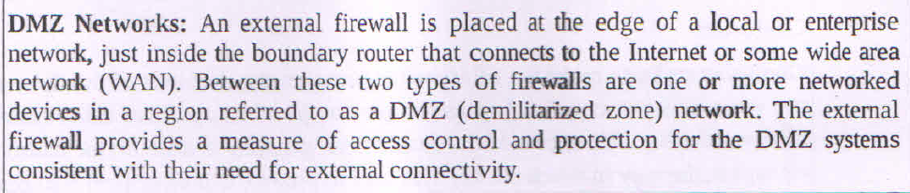

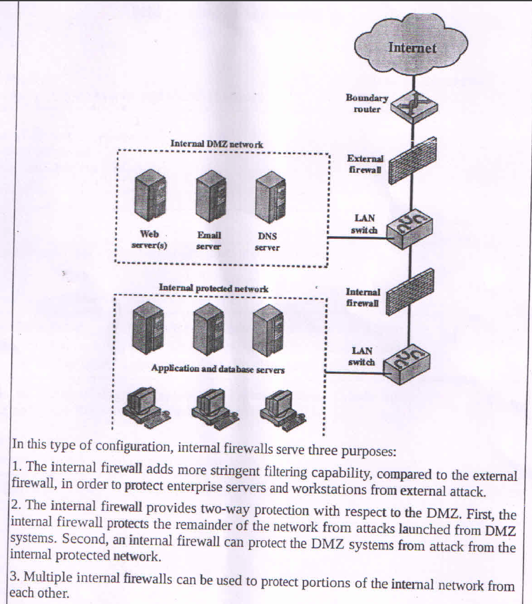

# MSE SEPTEMBER 2018

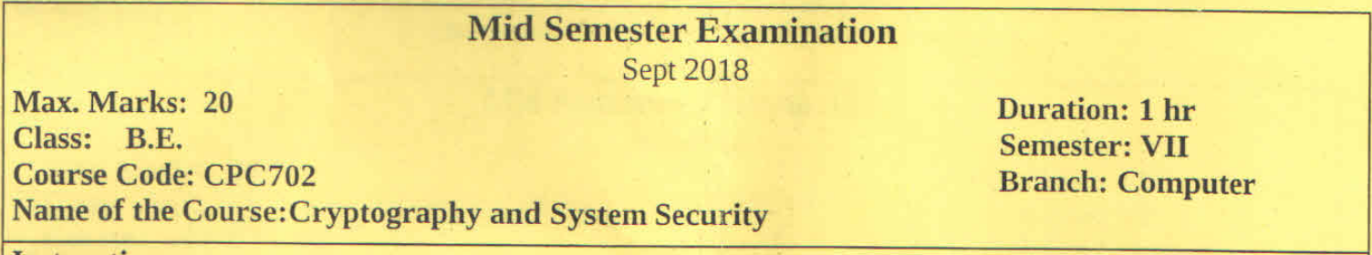

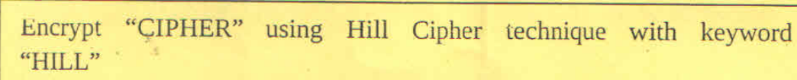

To encrypt the word "CIPHER" using the Hill Cipher technique with the keyword "HILL", we'll follow these steps:

1. Convert the keyword "HILL" into a 2x2 matrix (since our plaintext has an even number of letters).

2. Assign numbers to each letter (A=0, B=1, C=2, ..., Z=25).

3. Convert the plaintext "CIPHER" into number pairs.

4. Multiply each pair with the key matrix.

5. Convert the results back to letters.

Let's go through this process:

1. Key matrix:

H = 7, I = 8, L = 11

[7 8]

[11 11]

2. Plaintext number pairs:

C = 2, I = 8, P = 15, H = 7, E = 4, R = 17

(2,8) (15,7) (4,17)

3. Multiplication and encryption:

For each pair (x,y), we calculate:

[7 8] [x]

[11 11] [y]

(2,8): [7*2 + 8*8, 11*2 + 11*8] = [78, 110] mod 26 = [0, 6] = AG

(15,7): [7*15 + 8*7, 11*15 + 11*7] = [161, 242] mod 26 = [5, 8] = FI

(4,17): [7*4 + 8*17, 11*4 + 11*17] = [164, 231] mod 26 = [8, 23] = IX

Therefore, the encrypted text is: AGFIIX.



The Row Transposition Cipher is a simple technique for encrypting text. Here's an explanation of the technique and how to encrypt the given plaintext:

Row Transposition Cipher Technique:

1. Choose a key (usually a word or phrase).

2. Write the plaintext in rows under the key.

3. Number the columns based on the alphabetical order of the key letters.

4. Read off the columns in numerical order to get the ciphertext.

Let's encrypt "Hello how are you" using this technique:

1. Let's use "CIPHER" as our key.

2. Write the plaintext under the key:

C I P H E R

H E L L O H

O W A R E Y

O U

3. Number the columns based on alphabetical order of key letters:

C I P H E R

3 4 6 2 1 5

H E L L O H

O W A R E Y

O U

4. Read off the columns in numerical order:

Column 1 (E): EOE

Column 2 (H): LR

Column 3 (C): HO

Column 4 (I): EU

Column 5 (R): HY

Column 6 (P): LA

5. Combine these to get the ciphertext:

EOELRHOEUHYDOXLA

Therefore, the encrypted text is: EOELRHOEUHYDOXLA

This method can be made more secure by using a longer key or applying multiple rounds of transposition.



<https://www.geeksforgeeks.org/rsa-algorithm-cryptography/>

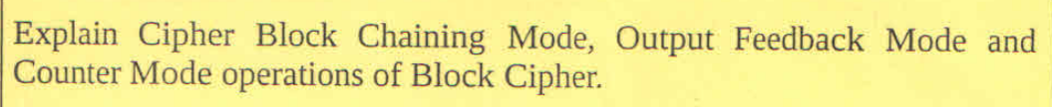

<https://www.geeksforgeeks.org/block-cipher-modes-of-operation/>



<https://www.ques10.com/p/13413/explain-working-of-des-detailing-the-fiestel-struc/>

<https://medium.com/@ajeetskbp9843/day-04-quantum-cryptography-feistel-cipher-structure-data-encryption-standard-des-and-advanced-fb2a7cb75433#:~:text=DES%20is%20a%20block%20cipher,original%2056%2Dbit%20key%20K>.

# ESE DECEMBER 2021

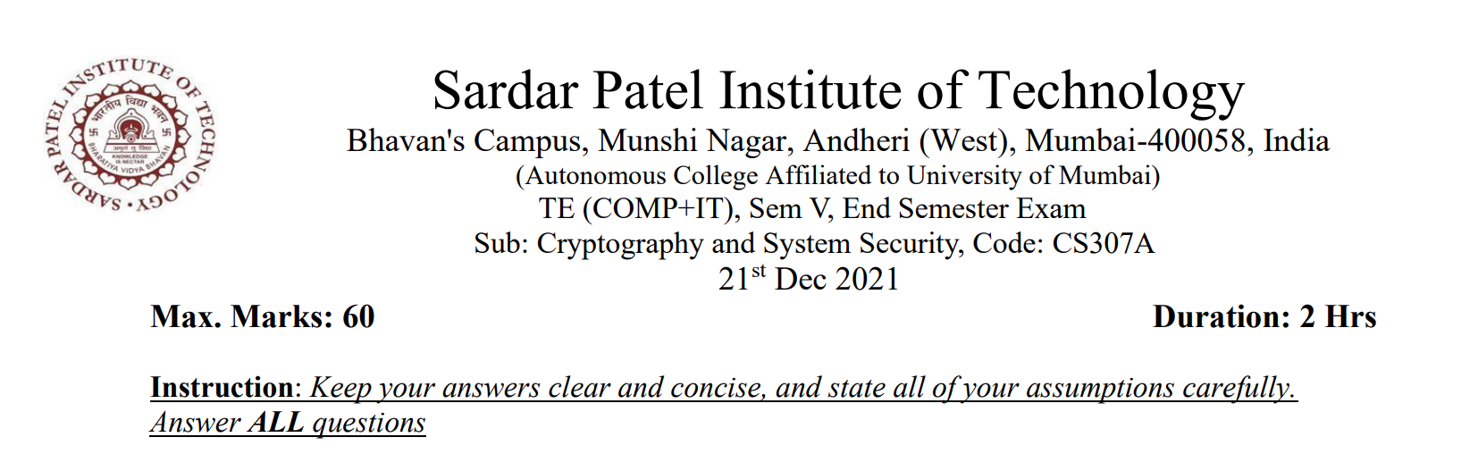

Let us say that you are acting as an eavesdropper and observing an encrypted conversation between Sun and Moon. You notice that the prefixes of many of the cipher texts agree for several hundred bytes. In addition, these identical prefixes are always a multiple of 16 bytes long. However, you never observe two identical chunks of cipher text of any significant length following the identical prefixes. Conjecture what cipher is being used, what mode of operation is being used, and what Sun and Moon are doing wrong.

**Analyzing the Encrypted Conversation:**

Here's a breakdown of the observed patterns and their implications:

**1. Cipher Used:**

* **Likely Cipher:** AES (Advanced Encryption Standard)
* **Reasoning:**
  + **Block Size:** AES operates on 16-byte blocks. The consistent occurrence of identical prefixes, always a multiple of 16 bytes long, strongly suggests a block cipher at work.
  + **Prevalence:** AES is widely used and a standard choice for secure encryption.

**2. Mode of Operation:**

* **Likely Mode:** Cipher Block Chaining (CBC)
* **Reasoning:**
  + **Identical Prefixes:** The repeating prefixes indicate the use of a single Initialization Vector (IV) for multiple blocks of data. This is a characteristic of CBC mode.
  + **No Identical Ciphertext After Prefixes:** The lack of significant repeated ciphertext chunks following the prefixes means that the chaining mechanism of CBC is functioning correctly.

**3. Sun and Moon's Error:**

* **Error:** Using the same Initialization Vector (IV) for multiple messages.
* **Explanation:** While CBC uses an IV for each message, it should be *randomly generated and unique* for every encryption. Reusing the same IV for multiple messages weakens the security.

**Why Reusing the IV is a Problem:**

* **Known-Plaintext Attack Vulnerability:** An attacker can exploit the repeated prefixes to potentially decrypt the messages. They can:
  + **Identify the Identical Prefixes:** This is already observed in the eavesdropped conversation.
  + **Substitute Plaintext:** Since the same IV is used, the attacker can manipulate the first block of a message by swapping its plaintext with the first block from another message. The resulting ciphertext for the first block will remain the same.
  + **Decrypt Subsequent Blocks:** The ciphertext of each block in CBC depends on the previous block and the plaintext. By knowing the plaintext of the first block and having access to the ciphertext, an attacker can decrypt the remaining blocks.

In its next chip, Intel finds a way to make the stack non-executable. Does this solve the problem of buffer-overflow attacks? Explain briefly. Solution: No. It’s still possible to maliciously modify the return address and parameters on the stack, which could cause undesired behavior.

**1. What is a Buffer-Overflow Attack?**

* A **buffer overflow** occurs when a program writes more data to a buffer than it can hold, causing adjacent memory locations to be overwritten.
* Attackers exploit this vulnerability to overwrite:
  + The **return address**.
  + **Function pointers** or other critical data on the stack.
* This often results in execution of malicious code or program behavior.

**2. What is a Non-Executable Stack?**

* A **non-executable stack** is a hardware and software feature that prevents code execution in stack memory regions.
* Even if an attacker injects malicious code into the stack, it cannot be executed because the stack is marked as non-executable.

**3. Does a Non-Executable Stack Solve the Problem?**

* **No, it does not fully solve the problem.**
  + While it **prevents direct execution of malicious code** from the stack, attackers can still exploit buffer overflow vulnerabilities in other ways.

**4. How Can Buffer-Overflow Attacks Still Occur?**

* **Return-Oriented Programming (ROP):**
  + Attackers reuse existing executable code snippets (called "gadgets") already present in the program's memory.
  + By modifying the **return address**, they redirect execution to these gadgets, achieving malicious behavior without executing code on the stack.
* **Manipulation of Function Parameters:**
  + Attackers can overwrite **function arguments** or **control structures** on the stack, causing unintended behavior.
* **Heap-Based Attacks:**
  + Buffer overflows can also target the heap, bypassing stack protections entirely.
* **Pointer Redirection:**
  + Attackers can overwrite **function pointers** or **global offset tables (GOT)** entries to execute malicious code indirectly.

**5. Other Necessary Protections**

* To address buffer-overflow vulnerabilities comprehensively, additional security measures are needed:
  1. **Address Space Layout Randomization (ASLR):**
     + Randomizes the memory locations of code and data, making it harder for attackers to predict addresses of gadgets or functions.
  2. **Stack Canaries:**
     + Inserts a special value (canary) before the return address on the stack to detect and prevent overwriting.
  3. **Control Flow Integrity (CFI):**
     + Ensures that program control flow adheres to expected execution paths, preventing unauthorized redirection.
  4. **Bounds Checking:**
     + Enforce strict validation on buffer sizes during memory operations to prevent overflows.
  5. **Data Execution Prevention (DEP):**
     + Extends non-executable protections to other memory regions, like the heap.

**6. Conclusion**

* A **non-executable stack is a partial solution** to buffer-overflow attacks.
* **Other attack vectors**, such as ROP and pointer manipulation, still exist.
* A combination of hardware and software defenses is essential to fully mitigate buffer-overflow vulnerabilities.

Why is it required that the private and public keys in RSA are relatively-prime to -Ф(n)? Suppose Ф(n) = 18, choose two legal values for public and private keys (don’t forget to include n). Solution: If a key is not relatively-prime, then it has no modular inverse, and we cannot generate a key pair. Plus, the substitution is not one-to-one for these numbers, so we do not get a proper encryption, either. If Ф(n) is 18, then we can choose d = 5 as it is relatively-prime to 18. A multiplicative inverse of d mod18 is e = 11. Since n = pq and Ф(n) = (p − 1)(q − 1), then n can equal (3 + 1)(6 + 1) = 28 or (2 + 1)(9 + 1) = 30 or (1 + 1)(18 + 1) = 38. Only the last is the product of two primes, so a private key is {5,38} and a public key is {11,38}.

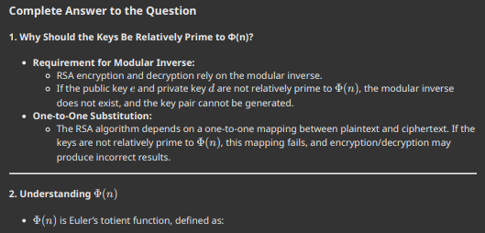

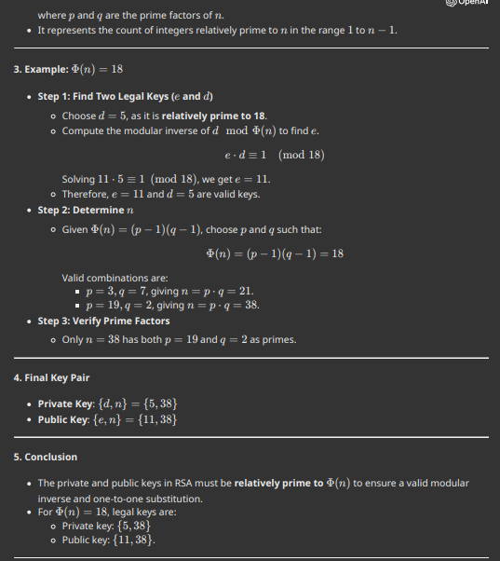

Explain briefly similarities and differences between cryptographic hash functions and message authentication codes (MAC’s). Solution: Both take as argument an arbitrarily long message and produce a short (typically 160 or 256 bits) result. The MAC takes additionally a secret key as argument. Both are used to ensure integrity, i.e. that a message has not been tampered with. A MAC additionally provides authentication, i.e. evidence about who the sender is. Hash functions have many additional uses in cryptography.

**1. Similarities Between Cryptographic Hash Functions and Message Authentication Codes (MACs):**

* **Input Handling:**
  + Both can take an **arbitrarily long message** as input.
* **Output:**
  + Both produce a **fixed-length output**, typically 160 or 256 bits, regardless of input size.
* **Integrity:**
  + Both are used to ensure **message integrity**, i.e., verifying that the message has not been tampered with during transmission.
* **Algorithms:**
  + Both use mathematical algorithms to generate their outputs, designed to resist tampering and collisions.
* **Resistance to Attacks:**
  + Both are resistant to attacks like **collision** (two different inputs producing the same output) and **pre-image** (finding an input for a given hash/MAC).

**2. Differences Between Cryptographic Hash Functions and MACs:**

| **Aspect** | **Cryptographic Hash Functions** | **Message Authentication Codes (MACs)** |
| --- | --- | --- |
| **Key Usage** | Do **not use a key**; operate on the message alone. | Require a **secret key** in addition to the message. |
| **Purpose** | Provide **integrity** but no authentication. | Provide **integrity and authentication** (evidence of sender). |
| **Output Dependence** | Output depends only on the input message. | Output depends on both the message and the secret key. |
| **Uses** | Used in various cryptographic applications like digital signatures, password storage, and data verification. | Used specifically for secure communication to authenticate the sender and ensure message integrity. |
| **Attack Surface** | Vulnerable to **man-in-the-middle attacks**, as no key is used. | Secure against man-in-the-middle attacks, as the secret key is required to generate and verify the MAC. |

**3. Applications of Hash Functions**

* **Password Storage:**
  + Storing hashed passwords instead of plaintext passwords for security.
* **Digital Signatures:**
  + Ensuring the authenticity of a digital document.
* **Blockchain:**
  + Maintaining the integrity of transactions in distributed ledgers.
* **Data Deduplication:**
  + Identifying duplicate data by comparing hash values.
* **Checksum Verification:**
  + Detecting errors in files or transmissions.

**4. Applications of MACs**

* **Message Authentication:**
  + Ensuring that a message is sent by an authenticated sender.
* **Secure Communication:**
  + Protecting communication protocols like TLS, SSL, and IPSec.
* **Payment Gateways:**
  + Verifying payment instructions and transactions.
* **Software Updates:**
  + Ensuring the authenticity of updates by verifying the MAC of the update file.

**5. Conclusion**

* While both cryptographic hash functions and MACs ensure **message integrity**, MACs provide an additional layer of **authentication** by using a secret key.
* Cryptographic hash functions have **wider applications** in various cryptographic systems, while MACs are specifically designed for secure message transmission.

Assume that system administrator in SPIT tries to setup email facility and he tries to use the simple mail transfer protocol (SMTP). Now this protocol is severely limited in terms of security. Hence what are the three main security threats, system administrator should visualize as a part of system security? Justify identified threats.. Answer: 1. Authenticity-related threats: The receiver may not know if the email is coming from a legitimate source. 2. Integrity-related threats: The receiver may not know if the message was modified in transit. 3. Confidentiality-related threats: The message is subject to unauthorized disclosure of sensitive information. 4. Non-repudiation threat: The sender may deny sending the message. 5. Availability-related threats: Could prevent end users from being able to send or receive email.

**1. Authenticity-Related Threats**

* **Explanation:**
  + SMTP does not authenticate the sender of an email, so attackers can forge the sender’s identity (email spoofing).
* **Example:**
  + An attacker impersonates a legitimate user or organization to deceive recipients into acting on malicious content.
* **Impact:**
  + Leads to phishing attacks, spreading misinformation, or unauthorized access to sensitive information.

**2. Integrity-Related Threats**

* **Explanation:**
  + SMTP does not ensure message integrity, allowing attackers to intercept and modify emails during transmission without detection.
* **Example:**
  + An attacker alters the payment details in an invoice sent via email.
* **Impact:**
  + Results in financial loss or misinformation being propagated.

**3. Confidentiality-Related Threats**

* **Explanation:**
  + SMTP transmits emails in plaintext by default, making them vulnerable to eavesdropping by attackers.
* **Example:**
  + Sensitive information like login credentials or financial data can be intercepted.
* **Impact:**
  + Leads to unauthorized disclosure of sensitive or private information.

**4. Non-Repudiation Threat**

* **Explanation:**
  + SMTP does not provide proof of message origin, allowing senders to deny having sent a message.
* **Example:**
  + A user denies sending a critical email with malicious instructions.
* **Impact:**
  + Creates disputes and undermines trust between users.

**5. Availability-Related Threats**

* **Explanation:**
  + Attackers can exploit SMTP vulnerabilities to launch denial-of-service (DoS) attacks, disrupting email services.
* **Example:**
  + Spamming the email server with excessive traffic, making it unavailable to legitimate users.
* **Impact:**
  + Prevents users from sending or receiving important emails, impacting operations.

**Justification of Identified Threats**

* SMTP was not designed with built-in security features; it relies on additional layers like:
  + **TLS (Transport Layer Security):** To address confidentiality and integrity.
  + **DKIM (DomainKeys Identified Mail):** To ensure authenticity and integrity.
  + **SPF (Sender Policy Framework):** To prevent email spoofing.
  + **DMARC (Domain-based Message Authentication, Reporting, and Conformance):** To enforce authentication policies.
* Without these enhancements, SMTP is vulnerable to the listed threats, justifying their inclusion as primary concerns for system security.

**Conclusion**

To secure SMTP, the system administrator must address these threats using encryption (TLS), authentication mechanisms (SPF, DKIM, DMARC), and robust monitoring to mitigate risks and ensure reliable email communication.

## Given an encryption function f(x), what kinds of trials can you do in order to check whether or not it achieves avalanche effect? Give example and explain. Also how Sbox and P-box contributes to block cipher to achieve avalanche effect. Solution: We can try two strings that are different in only one element, for example: f(ABCD) and f(ACCD). If at least 50% of the resulting cipher text of one of the inputs is different from that of the other, then we can conclude that it achieves diffusion, and vice versa.

**Understanding the Avalanche Effect**

* The avalanche effect is a crucial property of strong encryption algorithms. It ensures that a small change in the plaintext results in a significant change in the ciphertext. This makes it extremely difficult to deduce the original plaintext from the ciphertext even with partial knowledge of the plaintext.

**Testing for the Avalanche Effect:**

1. **Pairwise Comparison:**
   * **Method:** Choose two plaintext inputs that differ in a single bit. For example, "ABCD" and "ACCD".
   * **Analysis:** Encrypt both inputs using the encryption function **f(x)**. Compare the resulting ciphertexts.
   * **Result:** A significant change in the ciphertext (ideally at least 50% bit flips) between the two ciphertexts indicates the avalanche effect.
2. **Hamming Distance:**
   * **Method:** Calculate the Hamming distance between the two plaintext inputs (the number of bits that differ). Encrypt both inputs and calculate the Hamming distance between the resulting ciphertexts.
   * **Analysis:** A high Hamming distance between the ciphertexts (close to the Hamming distance of the plaintexts) signifies a strong avalanche effect.
3. **Statistical Analysis:**
   * **Method:** Encrypt many plaintext inputs with a single bit difference.
   * **Analysis:** Perform statistical analysis on the resulting ciphertexts, focusing on bit distributions and correlations.
   * **Result:** A random distribution of bits in the ciphertext, with no obvious correlation to the plaintext, indicates a strong avalanche effect.

**Example:**

Let's assume we have a simple encryption function **f(x)** that XORs the plaintext with a key.

* Plaintext 1: "ABCD" (0100 0001 0100 0010 0100 0011 0100 0100)
* Plaintext 2: "ACCD" (0100 0001 0100 0011 0100 0011 0100 0100)
* Key: "1234" (0001 0010 0011 0100)

Ciphertext 1: **f(ABCD) = ABCD XOR 1234 = 0101 0011 0111 0110 0101 0001 0111 0000**

Ciphertext 2: **f(ACCD) = ACCD XOR 1234 = 0101 0011 0111 0110 0101 0001 0111 0000**

In this case, the ciphertexts are identical despite a difference in the plaintext. This indicates a weak avalanche effect, making the encryption function insecure.

**2. Role of S-Box and P-Box in Achieving Avalanche Effect**

**a. S-Box (Substitution Box)**

* The S-Box is a non-linear transformation component in block ciphers.
* Contribution to Avalanche Effect:
  1. **Non-linearity**: Introduces complexity and ensures that even small changes in input propagate unpredictably to the output.
  2. **Diffusion at the Bit Level**: Changes in a single bit of input lead to multiple output bits changing.

**b. P-Box (Permutation Box)**

* The P-Box is responsible for shuffling bits across different positions in the block.
* Contribution to Avalanche Effect:
  1. **Spreads the Change**: Ensures that the effect of a bit change in the S-Box propagates across the entire block.
  2. **Enhances Diffusion**: Facilitates the mixing of bits so that the output is significantly different even for minor input changes.

**c. Combination of S-Box and P-Box**

* The **S-Box ensures confusion** (non-linear transformation of bits).
* The **P-Box ensures diffusion** (spreading of changes across the output).
* Together, they work iteratively in rounds to achieve the avalanche effect in block ciphers.

Draw a schematic view SSL protocols with suitable notaions. Identify the name of protocol for the following given functionality: 1) Establishes the security capability 2) Connection failure and illegal parameters 3) Provides confidentiality and message integrity

**Schematic View of SSL Protocols**

The **SSL (Secure Sockets Layer)** protocol consists of three main layers, each serving specific functionalities:

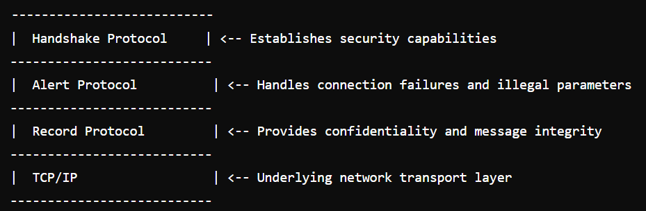

**Functionality and Associated Protocols**

1. **Establishes the Security Capability**
   * **Protocol Name:** **Handshake Protocol**
   * **Purpose:**
     + Facilitates authentication between client and server.
     + Negotiates encryption algorithms, session keys, and other security parameters.
   * **Key Steps:**
     + Exchange of certificates for authentication.
     + Agreement on cryptographic algorithms (e.g., AES, RSA).
     + Generation and sharing of a session key.
2. **Connection Failure and Illegal Parameters**
   * **Protocol Name:** **Alert Protocol**
   * **Purpose:**
     + Manages and reports errors during communication.
     + Handles unexpected events like decryption failures or protocol violations.
   * **Examples of Alerts:**
     + Fatal alerts: Connection closure.
     + Warnings: Recoverable issues (e.g., certificate expiry).
3. **Provides Confidentiality and Message Integrity**
   * **Protocol Name:** **Record Protocol**
   * **Purpose:**
     + Encrypts and authenticates data for secure communication.
     + Ensures that messages remain confidential and are not tampered with.
   * **Key Features:**
     + Uses encryption (e.g., AES) for confidentiality.
     + Applies MAC (Message Authentication Code) for integrity verification.

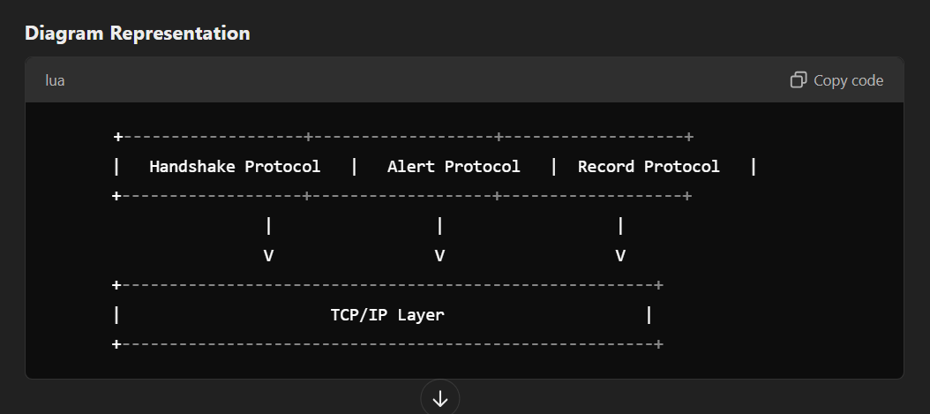

Name mail access protocols and Compare them

**SMTP (Simple Mail Transfer Protocol)**

* **Purpose**: Used for sending emails.
* **Functionality**: Transfers email messages from one server to another.
* **Operation**: Works on a client-server model.
* **Ports**: Default port is 25 for unencrypted communication and 465 or 587 for encrypted communication (TLS/SSL).
* **Usage**: Used by email clients to send emails to the recipient's mail server.
* **Reliability**: Provides error notifications if the email cannot be delivered.

**POP3 (Post Office Protocol version 3)**

* **Purpose**: Used for receiving emails.
* **Functionality**: Downloads emails from the server to the client's device.
* **Operation**: Works on a client-server model.
* **Ports**: Default port is 110 for unencrypted communication and 995 for encrypted communication (SSL).
* **Usage**: Used by email clients to retrieve emails from the server.
* **Storage**: Emails are typically removed from the server after being downloaded to the client's device.
* **Offline Access**: Allows offline access to emails once downloaded.

**IMAP (Internet Message Access Protocol)**

* **Purpose**: Used for receiving emails.
* **Functionality**: Allows emails to be stored on the server and accessed from multiple devices.
* **Operation**: Works on a client-server model.
* **Ports**: Default port is 143 for unencrypted communication and 993 for encrypted communication (SSL).
* **Usage**: Used by email clients to access and manage emails on the server.
* **Storage**: Emails remain on the server until explicitly deleted by the user.
* **Synchronization**: Supports multiple device access and synchronization of emails across devices.
* **Search**: Allows searching of emails directly on the server.

**Comparison Table**

| **Feature** | **SMTP** | **POP3** | **IMAP** |
| --- | --- | --- | --- |
| **Purpose** | Sending emails | Receiving emails | Receiving emails |
| **Operation** | Client-server | Client-server | Client-server |
| **Ports** | 25, 465, 587 | 110, 995 | 143, 993 |
| **Email Storage** | N/A | Local device | Server |
| **Offline Access** | N/A | Yes | No |
| **Synchronization** | N/A | No | Yes |
| **Search** | N/A | No | Yes |

# ESE NOVEMBER 2017

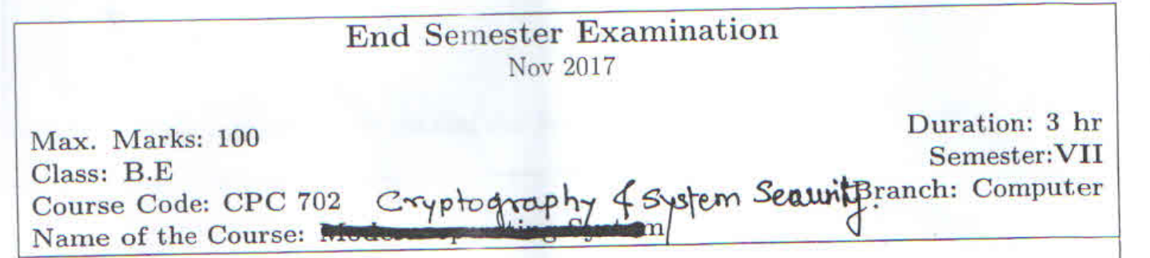

## Explain in detail Public Key Infrastructure?

**Public Key Infrastructure (PKI) Explained**

Public Key Infrastructure (PKI) is a framework that enables secure communication and data exchange over networks, primarily the internet. It uses a combination of hardware, software, policies, and standards to manage digital certificates and public-key encryption. Here’s a comprehensive breakdown:

**1. Definition**

* PKI is a system that provides the means to create, manage, distribute, use, store, and revoke digital certificates and manage public-key encryption.

**2. Key Components**

* **Public and Private Keys**:
  + Each user has a pair of keys: a public key (shared with others) and a private key (kept secret).
* **Digital Certificates**:
  + Certificates bind a public key to an entity (individual, organization) and are issued by a Certificate Authority (CA).
* **Certificate Authority (CA)**:
  + A trusted entity that issues and manages digital certificates and public keys.
* **Registration Authority (RA)**:
  + Acts as a verifier for the CA by accepting requests for digital certificates and authenticating the entity’s identity.
* **Certificate Revocation List (CRL)**:
  + A list of digital certificates that have been revoked before their expiration date.
* **Key Management**:
  + Processes for generating, storing, distributing, and revoking keys.

**3. How PKI Works**

* **Key Pair Generation**:
  + Users generate a public-private key pair.
* **Certificate Signing Request (CSR)**:
  + Users send a CSR to the CA, which includes their public key and identity information.
* **Certificate Issuance**:
  + The CA verifies the identity and issues a digital certificate that includes the public key.
* **Secure Communication**:
  + Parties use each other’s public keys to encrypt messages, which can only be decrypted by the corresponding private keys.

**4. Benefits of PKI**

* **Security**:
  + Provides strong encryption and secure authentication.
* **Data Integrity**:
  + Ensures that data has not been altered in transit.
* **Non-repudiation**:
  + Guarantees that a sender cannot deny having sent a message.
* **Scalability**:
  + Supports a large number of users and devices.

**5. Applications of PKI**

* **Secure Email**:
  + Encrypting and signing emails.
* **SSL/TLS for Websites**:
  + Securing web traffic with HTTPS.
* **VPNs**:
  + Secure remote access to networks.
* **Digital Signatures**:
  + Verifying the authenticity of documents.
* **Code Signing**:
  + Ensuring that software is from a trusted source.

**6. Challenges and Considerations**

* **Trust Model**:
  + Trust must be established in the CA and the entire PKI system.
* **Key Management**:
  + Proper management of keys and certificates is critical to security.
* **Revocation Management**:
  + Efficiently managing the revocation of certificates is essential.
* **Compliance**:
  + Adhering to legal and regulatory requirements regarding data security.

**7. Conclusion**

* PKI is a vital framework for ensuring secure communications in the digital age. Understanding its components, workings, benefits, applications, and challenges is essential for leveraging its capabilities effectively.

**Tips for Remembering**

* **Mnemonic for Components**: **C-R-C-K-P** (Certificate, Registration Authority, Certificate Authority, Key Management, Public/Private Keys

## What is a Digital Signature? Explain ElGamal Digital Signature Algorithm

**What is a Digital Signature?**

1. **Definition**: A digital signature is a cryptographic technique used to validate the authenticity and integrity of digital data or messages.
2. **Purpose**:
   * Ensures the **identity** of the sender (authentication).
   * Verifies that the data has not been tampered with during transit (**integrity**).
   * Provides non-repudiation, meaning the sender cannot deny sending the message.
3. **How it Works**:
   * A digital signature is created using the **private key** of the sender.
   * It is verified by the receiver using the sender's **public key**.
   * It typically involves hashing the message and encrypting the hash.

## Explain ElGamal Digital Signature Algorithm

The ElGamal Digital Signature Algorithm is a cryptographic algorithm used for digital signatures, providing a way to ensure the authenticity and integrity of a message. It is based on the Diffie-Hellman key exchange and the mathematical principles of modular arithmetic and discrete logarithms. The ElGamal signature scheme is widely used in various applications, including secure email, software distribution, and digital contracts.

**Key Concepts**

1. **Public and Private Keys:** The ElGamal signature scheme involves the generation of a pair of keys:
   * **Private Key (x):** A randomly chosen number that is kept secret.
   * **Public Key (y):** A value derived from the private key and shared publicly.
2. **Prime Number (p):** A large prime number used as a modulus.
3. **Generator (g):** A primitive root modulo ( p ), which is a number that can generate all the integers from 1 to ( p-1 ) through exponentiation.
4. **Hash Function:** A cryptographic hash function is used to produce a fixed-size hash value from the message, ensuring that even a small change in the message results in a significantly different hash.

**Steps of the ElGamal Digital Signature Algorithm**

The ElGamal Digital Signature Algorithm consists of three main phases: key generation, signing, and verification.

**1. Key Generation**

1. **Select a Large Prime ( p ):** Choose a large prime number ( p ).
2. **Select a Generator ( g ):** Choose a primitive root ( g ) modulo ( p ).
3. **Choose a Private Key ( x ):** Select a random integer ( x ) such that ( 1 < x < p-1 ).
4. **Compute the Public Key ( y ):** Calculate ( y ) using the formula: [ y = g^x \mod p ]
5. **Public Key and Private Key:** The public key is ( (p, g, y) ), and the private key is ( x ).

**2. Signing**

1. **Message Hashing:** Given a message ( m ), compute its hash ( H(m) ) using a cryptographic hash function.
2. **Choose a Random Integer ( k ):** Select a random integer ( k ) such that ( 1 < k < p-1 ) and ( \gcd(k, p-1) = 1 ) (i.e., ( k ) must be coprime to ( p-1 )).
3. **Compute ( r ):** Calculate ( r ) as follows: [ r = g^k \mod p ]
4. **Compute ( s ):** Calculate ( s ) using the formula: [ s = k^{-1} (H(m) + x \cdot r) \mod (p-1) ] Here, ( k^{-1} ) is the modular inverse of ( k ) modulo ( p-1 ).
5. **Signature:** The digital signature of the message ( m ) is the pair ( (r, s) ).

**3. Verification**

To verify the signature ( (r, s) ) for the message ( m ):

1. **Check Validity of ( r ):** Ensure ( 0 < r < p ).
2. **Recompute Hash:** Compute the hash ( H(m) ).
3. **Compute ( w ):** Calculate: [ w = s^{-1} \mod (p-1) ]
4. **Compute ( u_1 ) and ( u_2 ):** [ u_1 = (H(m) \cdot w) \mod (p-1) ] [ u_2 = (r \cdot w) \mod (p-1) ]
5. **Compute ( v ):** Calculate: [ v = (g^{u_1} \cdot y^{u_2}) \mod p ]
6. **Verification:** The signature is valid if ( v \equiv r \mod p ). If this condition holds, the signature is valid, confirming that the message was signed by the holder of the private key.

**Security Aspects Continued**

1. **Randomness of ( k ):** The security of the ElGamal signature scheme heavily relies on the randomness of the integer ( k ) chosen during the signing process. If ( k ) is reused or predictable, it can lead to the compromise of the private key ( x ). Therefore, ( k ) must be chosen uniformly at random for each signature, and it should be kept secret.
2. **Resistance to Forgery:** The ElGamal signature scheme is designed to be resistant to forgery. An attacker cannot generate a valid signature for a message without knowing the private key, assuming that the discrete logarithm problem remains difficult.
3. **Hash Function Security:** The security of the signature also depends on the strength of the hash function used. A cryptographically secure hash function should be collision-resistant, meaning it should be infeasible to find two different messages that produce the same hash value.

**Advantages of the ElGamal Digital Signature Algorithm**

1. **Security Based on Well-Established Problems:** The algorithm is based on the discrete logarithm problem, which is well-studied and considered secure when implemented correctly with sufficiently large parameters.
2. **Non-repudiation:** ElGamal signatures provide non-repudiation, meaning that the signer cannot deny having signed the message. This is crucial for legal and financial applications.
3. **Flexibility:** The algorithm can be adapted to various applications, including secure communications and digital contracts.
4. **Public Key Infrastructure (PKI) Compatibility:** The ElGamal signature scheme can be integrated into existing public key infrastructures, allowing for the use of digital certificates to verify public keys.

**Disadvantages of the ElGamal Digital Signature Algorithm**

1. **Signature Size:** One of the main drawbacks of the ElGamal signature scheme is the size of the signature. The signature consists of two values ( (r, s) ), each of which is approximately the size of the prime ( p ). This can lead to larger signatures compared to other signature schemes like RSA.
2. **Computational Overhead:** The algorithm involves multiple modular exponentiation operations, which can be computationally intensive, especially for large primes. This may lead to slower performance compared to other signature schemes.
3. **Key Management:** Like other public key cryptosystems, the ElGamal signature scheme requires careful management of public and private keys. If the private key is compromised, all signatures made with that key can be forged.
4. **Vulnerability to Certain Attacks:** If the random value ( k ) is poorly generated or reused, it can lead to vulnerabilities where an attacker can derive the private key from the signature. Therefore, strong random number generation practices are essential.

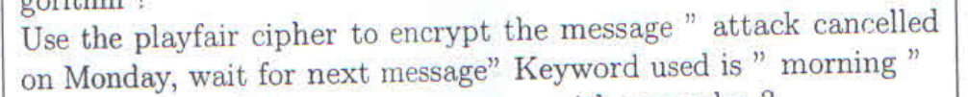

**Step 1: Understand the Playfair Cipher**

1. **What is the Playfair Cipher?**
   * A symmetric encryption technique developed by Charles Wheatstone in 1854.
   * It encrypts digraphs (pairs of letters) instead of single letters.
2. **Keyword Used**:
   * The keyword is **"morning"**.

**Step 2: Construct the 5x5 Playfair Cipher Grid**

1. **Rules for Grid Construction**:
   * Remove duplicate letters from the keyword.
   * Include the remaining letters of the alphabet (excluding **J**, as it is combined with **I**).
2. **Keyword Processing**:
   * Keyword: **"morning"** → Remove duplicates → **"morning"**.
3. **Fill the Grid**:
   * Add the keyword and remaining letters of the alphabet:

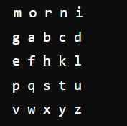

**Step 3: Prepare the Message**

1. **Message**:
   * **"attack cancelled on Monday, wait for next message"**.
2. **Preprocess the Message**:
   * Remove spaces and punctuation: **"attackcancelledonmondaywaitfornextmessage"**.
   * Split into digraphs (pairs of two letters):

at ta ck ca nc el le do nm on da yw ai tf or ne xt me ss ag e_

* If a pair has the same letters (e.g., **"ss"**), insert a filler (e.g., **"sx"**).
* If the message ends with a single letter, append a filler (e.g., **"x"**).

Final Digraphs:

at ta ck ca nc el le do nm on da yw ai tf or ne xt me sx ag e_

**Step 4: Encrypt the Message**

1. **Encryption Rules**:
   * If both letters are in the same row, replace each with the letter to its right (circular shift).
   * If both letters are in the same column, replace each with the letter below it (circular shift).
   * If the letters form a rectangle, replace each with the letter in the same row but in the other column.
2. **Encryption Process**:

| **Pair** | **Rule** | **Encrypted Pair** |
| --- | --- | --- |
| at | Rectangle | **qc** |
| ta | Rectangle | **cq** |
| ck | Rectangle | **rh** |
| ca | Rectangle | **gb** |
| nc | Rectangle | **rb** |
| el | Rectangle | **fd** |
| le | Rectangle | **df** |
| do | Rectangle | **bn** |
| nm | Rectangle | **pq** |
| on | Rectangle | **ni** |
| da | Rectangle | **bw** |
| yw | Rectangle | **vz** |
| ai | Rectangle | **mo** |
| tf | Rectangle | **ko** |
| or | Rectangle | **nb** |
| ne | Rectangle | **fp** |
| xt | Rectangle | **qu** |
| me | Rectangle | **pf** |
| sx | Rectangle | **vl** |
| ag | Rectangle | **mb** |
| e_ | Rectangle | **kf** |

1. Final Ciphertext: **"qc cq rh gb rb fd df bn pq ni bw vz mo ko nb fp qu pf vl mb kf"**

**Step 5: Final Answer**

The encrypted message using the Playfair cipher is: **"qccqrhgbrbfddfbnpqnibwvzmo konbfpqupfvlmbkf"**

## Explain non-malicious program errors with examples?

**Non-Malicious Program Errors Explained**

Non-malicious program errors refer to unintentional mistakes or bugs in software that lead to unexpected behavior, crashes, or incorrect outputs. These errors are not caused by malicious intent but rather stem from human error, misunderstandings, or limitations in programming practices. Here’s a comprehensive overview:

**1. Definition**

* Non-malicious program errors are unintended flaws in software code that result in incorrect functionality or performance without any intention to harm or exploit.

**2. Types of Non-Malicious Program Errors**

* **Syntax Errors**:
  + Mistakes in the code structure that prevent the program from compiling or running.
  + **Example**: Missing a semicolon in languages like C++ or Java.
* **Logical Errors**:
  + Flaws in the program’s logic that lead to incorrect results despite the code running without crashing.
  + **Example**: Using the wrong formula to calculate a total (e.g., adding instead of multiplying).
* **Runtime Errors**:
  + Errors that occur during program execution, often due to illegal operations or unexpected input.
  + **Example**: Division by zero or accessing an out-of-bounds array index.
* **Type Errors**:
  + Occur when operations are performed on incompatible data types.
  + **Example**: Attempting to add a string to an integer in languages that enforce type checking.
* **Resource Errors**:
  + Issues related to system resources, such as memory leaks or file handling errors.
  + **Example**: Failing to close a file after opening it, leading to resource exhaustion.

**3. Common Causes of Non-Malicious Errors**

* **Human Error**:
  + Mistakes made by programmers during coding, such as typos or miscalculations.
* **Misunderstanding Requirements**:
  + Failing to fully grasp the specifications or requirements of a project.
* **Complexity**:
  + High complexity in code can lead to oversights and miscalculations.
* **Inadequate Testing**:
  + Insufficient testing can allow errors to go unnoticed until the software is in use.
* **Changes in Code**:
  + Modifications to code can introduce new errors, especially if not properly documented.

**4. Examples of Non-Malicious Program Errors**

* **Syntax Error**:
  + In Python: **print("Hello, World"** (missing closing parenthesis).
* **Logical Error**:
  + In a banking application, calculating interest incorrectly due to using the wrong rate.
* **Runtime Error**:
  + In a web application, trying to access a user's profile that does not exist, resulting in a null reference exception.
* **Type Error**:
  + In JavaScript: **let total = 5 + "10";** (results in "510" instead of 15).
* **Resource Error**:
  + In a C++ program, failing to deallocate memory with **delete**, causing a memory leak.

**5. Impact of Non-Malicious Errors**

* **User Frustration**:
  + Can lead to a poor user experience and dissatisfaction.
* **Financial Loss**:
  + Incorrect calculations or failures can lead to financial discrepancies.
* **Reputation Damage**:
  + Companies may suffer reputation loss due to unreliable software.
* **Increased Costs**:
  + Debugging and fixing errors can lead to increased development costs and time.

**6. Prevention and Mitigation Strategies**

* **Code Reviews**:
  + Regular peer reviews to catch errors early.
* **Automated Testing**:
  + Implement unit tests and integration tests to identify bugs before deployment.
* **Clear Documentation**:
  + Maintain clear and detailed documentation to avoid misunderstandings.
* **Error Handling**:
  + Implement robust error handling to gracefully manage runtime errors.
* **Continuous Learning**:
  + Encourage developers to stay updated on best practices and new programming techniques.

**7. Conclusion**

* Non-malicious program errors can significantly affect software quality and user satisfaction. Understanding their types, causes, and impacts is crucial for developers to create reliable and efficient software systems.

**Tips for Remembering**

* **Mnemonic for Types**: **S-L-R-T-R** (Syntax, Logical, Runtime, Type, Resource)

## Write a note on operating systems security

Operating System (OS) security is a critical aspect of computing that involves protecting the OS from unauthorized access, misuse, and threats. The OS acts as an intermediary between users and computer hardware, managing resources and facilitating communication. Ensuring the security of the OS is essential to maintain the integrity, confidentiality, and availability of data and resources.

**1. Importance of OS Security**

* **Protection of Data**: Safeguards sensitive information from unauthorized access and breaches.
* **System Integrity**: Ensures that the system functions correctly and that software operates as intended.
* **User Trust**: Builds confidence among users regarding the safety of their data and transactions.
* **Compliance**: Helps organizations adhere to regulatory requirements related to data protection and privacy.

**2. Common Threats to Operating System Security**

* **Malware**: Viruses, worms, Trojans, and ransomware can compromise system security and data integrity.
* **Unauthorized Access**: Intruders may exploit vulnerabilities to gain access to sensitive information or control over the system.
* **Privilege Escalation**: Attackers may exploit flaws to gain higher access privileges than intended.
* **Denial of Service (DoS)**: Overloading the system with requests to make it unavailable to legitimate users.
* **Social Engineering**: Manipulating individuals into divulging confidential information or granting access.

**3. Key Security Features of Operating Systems**

* **User Authentication**: Mechanisms such as passwords, biometrics, and two-factor authentication to verify user identities.
* **Access Control**: Permissions and policies that restrict user access to files, applications, and system resources based on roles.
* **Encryption**: Protecting data in transit and at rest using cryptographic techniques to prevent unauthorized access.
* **Audit Logs**: Keeping records of system activities to monitor for suspicious behavior and facilitate incident response.
* **Firewalls**: Implementing software or hardware firewalls to filter incoming and outgoing network traffic based on security rules.

**4. Best Practices for Enhancing OS Security**

* **Regular Updates**: Keeping the OS and applications up-to-date with the latest security patches to mitigate vulnerabilities.
* **Strong Password Policies**: Enforcing complex passwords and regular password changes to enhance account security.
* **Least Privilege Principle**: Granting users the minimum level of access necessary to perform their jobs, reducing the risk of exploitation.
* **Antivirus and Anti-malware Software**: Using reputable security software to detect and remove malicious programs.
* **Backup and Recovery**: Regularly backing up data and having a recovery plan in place to restore systems after a security incident.

**5. Emerging Trends in OS Security**

* **Virtualization Security**: Protecting virtual machines and hypervisors as virtualization becomes more prevalent in data centers.
* **Container Security**: Securing containerized applications and their environments, especially in cloud computing.
* **Zero Trust Architecture**: Implementing a security model that assumes threats could be internal or external, requiring verification for every access request.
* **Artificial Intelligence and Machine Learning**: Utilizing AI/ML for threat detection, anomaly detection, and automated responses to security incidents.

**6. Conclusion**

Operating system security is fundamental to the overall security posture of any computing environment. By understanding the threats, implementing robust security features, and adhering to best practices, organizations can significantly reduce the risk of security breaches and protect their valuable data and resources. Continuous vigilance and adaptation to emerging threats are essential for maintaining OS security in an ever-evolving landscape.

## Transposition Cipher Explained

A transposition cipher is a method of encryption where the positions of the characters in the plaintext are shifted according to a regular system to form the ciphertext. Unlike substitution ciphers, which replace characters with other characters, transposition ciphers maintain the original characters but rearrange their order.

**1. Definition**

* A transposition cipher is a type of encryption technique that alters the order of characters in the plaintext to create ciphertext while keeping the original characters intact.

**2. Basic Principles**

* **Rearrangement**: The fundamental operation is to rearrange the characters of the plaintext.
* **Key**: A secret key is used to determine the rearrangement pattern.
* **Reversibility**: The process can be reversed using the same key to retrieve the original plaintext.

**1. Rail Fence Cipher**

The Rail Fence Cipher is a simple form of transposition cipher that encrypts a message by writing it in a zigzag pattern across multiple "rails" (or lines) and then reading off each line to create the ciphertext.

**Encryption Process:**

* **Step 1: Choose the Number of Rails**
  + Decide how many rails (lines) you will use for the zigzag pattern. For example, let's use 3 rails.
* **Step 2: Write the Plaintext in Zigzag Pattern**
  + Write the plaintext in a zigzag pattern across the chosen number of rails.
  + **Example**: For the plaintext "HELLO WORLD":

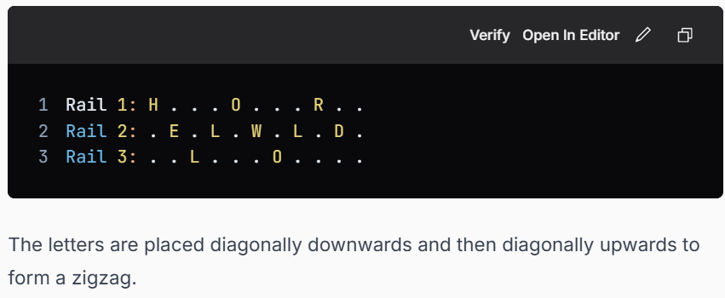

* **Step 3: Read Off Each Rail**
  + Read the characters from each rail sequentially to form the ciphertext.
  + **Rail 1**: "HOR"
  + **Rail 2**: "ELWLD"
  + **Rail 3**: "L"
  + **Final Ciphertext**: "HOR ELWLD L"
* **Step 4: Remove Spaces (if necessary)**
  + Depending on the requirements, spaces may be removed to produce a continuous string of characters.
  + **Final Ciphertext (without spaces)**: "HORELWLDL"

**2. Columnar Transposition Cipher**

The Columnar Transposition Cipher encrypts a message by writing it in rows of a fixed length based on a keyword and then rearranging the columns according to the alphabetical order of the keyword.

**Encryption Process:**

* **Step 1: Choose a Keyword**
  + Select a keyword that will determine the column order. For example, let's use the keyword "CIPHER".
* **Step 2: Prepare the Plaintext**
  + Write the plaintext in a grid format based on the length of the keyword. If the plaintext is "MEET ME AT DAWN", we first remove spaces to get "MEETMEATDAWN".
* **Step 3: Create the Grid**
  + Fill the grid with the plaintext, row by row, until all characters are placed. If necessary, fill in any remaining spaces with a filler character (like "X").
  + **Grid Example**:

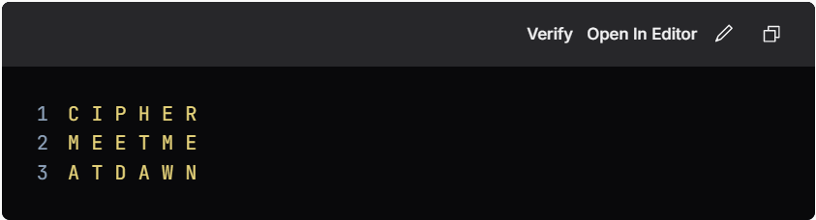

**Step 4: Number the Columns Based on Keyword Order**

* Assign numbers to the columns based on the alphabetical order of the letters in the keyword.
* **Keyword Order**: C(1), E(2), H(3), I(4), P(5), R(6)
* The rearranged columns would be:

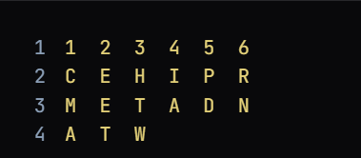

* **Step 5: Read Columns in Order of the Keyword**
  + Read the columns in the order determined by the keyword.
  + **Ciphertext**:
    - Column 1 (C): "MA"
    - Column 2 (E): "E"
    - Column 3 (H): "T"
    - Column 4 (I): "A"
    - Column 5 (P): "D"
    - Column 6 (R): "N"
  + Combine the results to form the ciphertext.
  + **Final Ciphertext**: "MAETADEN"

## What is Cryptanalysis?

**What is Cryptanalysis?**

1. **Definition**:
   * Cryptanalysis is the study of analyzing and breaking cryptographic systems.
   * The primary goal is to decrypt ciphertext without knowing the key or algorithm used in encryption.
2. **Purpose**:
   * To test the strength and security of cryptographic algorithms.
   * To identify vulnerabilities and weaknesses in encryption methods.
3. **Applications**:
   * Improving cryptographic systems.
   * Ethical hacking and cybersecurity assessments.

**Types of Cryptanalysis Attacks**

1. **Ciphertext-only Attack**:
   * **Description**:
     + The attacker has access to only the encrypted message (ciphertext).
     + The goal is to recover the plaintext or key.
   * **Approach**:
     + Use statistical analysis, frequency analysis, or brute force.
   * **Example**:
     + Breaking substitution ciphers using letter frequency.
2. **Known-plaintext Attack (KPA)**:
   * **Description**:
     + The attacker knows some pairs of plaintext and corresponding ciphertext.
     + The goal is to deduce the key or decrypt other ciphertexts.
   * **Approach**:
     + Analyze patterns between the plaintext and ciphertext.
   * **Example**:
     + Attacking the Caesar cipher using known text samples.
3. **Chosen-plaintext Attack (CPA)**:
   * **Description**:
     + The attacker can encrypt plaintext of their choice and analyze the resulting ciphertext.
     + The goal is to learn the encryption algorithm and key.
   * **Approach**:
     + Choose plaintexts that reveal algorithmic patterns.
   * **Example**:
     + Exploiting weaknesses in block ciphers like DES.
4. **Chosen-ciphertext Attack (CCA)**:
   * **Description**:
     + The attacker can decrypt ciphertext of their choice and observe the results.
     + The goal is to infer the key or decrypt other messages.
   * **Approach**:
     + Analyze how the decryption process responds to different ciphertexts.
   * **Example**:
     + Attacking RSA by manipulating ciphertext.
5. **Side-channel Attack**:
   * **Description**:
     + Instead of targeting the cryptographic algorithm, the attacker exploits information leakage during encryption or decryption.
     + This includes timing, power consumption, or electromagnetic emissions.
   * **Approach**:
     + Collect physical data and correlate it to the cryptographic operations.
   * **Example**:
     + Timing attacks on RSA or AES.
6. **Brute-force Attack**:
   * **Description**:
     + The attacker tries all possible keys until the correct one is found.
     + This method is time-consuming and computationally expensive.
   * **Approach**:
     + Use high computational power or distributed systems to test keys.
   * **Example**:
     + Cracking weak passwords or short keys.
7. **Man-in-the-middle Attack (MITM)**:
   * **Description**:
     + The attacker intercepts communication between two parties and manipulates it.
     + They aim to eavesdrop or alter the data.
   * **Approach**:
     + Intercept encrypted messages and insert malicious data.
   * **Example**:
     + Attacking Diffie-Hellman key exchange.
8. **Differential Cryptanalysis**:
   * **Description**:
     + Focuses on analyzing the difference between plaintext pairs and their corresponding ciphertext pairs.
     + Useful for block ciphers.
   * **Approach**:
     + Study how small differences in input affect the output.
   * **Example**:
     + Attacking DES or AES with differential techniques.
9. **Linear Cryptanalysis**:
   * **Description**:
     + Uses linear approximations to describe the behavior of the block cipher.
     + It exploits statistical biases in the encryption process.
   * **Approach**:
     + Create linear equations connecting plaintext, ciphertext, and the key.
   * **Example**:
     + Breaking DES with linear approximations.

## Explain packet sniffing and packet spoofing?

<https://www.ques10.com/p/13473/compare-packet-sniffing-and-packet-spoofing-explai/>

**1. Packet Sniffing**

**Definition**: Packet sniffing refers to the process of capturing and analyzing data packets that traverse a network. It can be used for legitimate network management and troubleshooting, but it can also be exploited for malicious purposes.

**1.1. How Packet Sniffing Works**

* **Network Interface**: A network interface card (NIC) is set to "promiscuous mode," allowing it to capture all packets on the network segment, not just those addressed to it.
* **Packet Capture Tools**: Software tools (e.g., Wireshark, tcpdump) are used to capture and analyze the packets.
* **Data Analysis**: Captured packets can be analyzed to extract information such as source and destination IP addresses, protocols used, and payload data.

**1.2. Legitimate Uses of Packet Sniffing**

* **Network Monitoring**: Administrators can monitor network traffic for performance issues and bottlenecks.
* **Troubleshooting**: Helps diagnose network problems by analyzing traffic patterns and identifying failures.
* **Security Auditing**: Used to detect unauthorized access or anomalies in network behavior.

**1.3. Malicious Uses of Packet Sniffing**

* **Data Theft**: Attackers can capture sensitive information such as usernames, passwords, and credit card numbers transmitted over unencrypted connections.
* **Session Hijacking**: By capturing session tokens, attackers can impersonate legitimate users and gain unauthorized access.

**1.4. Countermeasures Against Packet Sniffing**

* **Encryption**: Use protocols like HTTPS, SSL/TLS, and VPNs to encrypt data in transit, making it unreadable to sniffers.
* **Network Segmentation**: Limit access to sensitive data by segmenting the network and controlling access.
* **Intrusion Detection Systems (IDS)**: Implement IDS to monitor network traffic for suspicious activity.

**2. Packet Spoofing**

**Definition**: Packet spoofing is the act of creating and sending packets on a network with a forged source IP address. This can be used for both legitimate purposes and malicious attacks.

**2.1. How Packet Spoofing Works**

* **Forged IP Addresses**: Attackers modify the source address in the packet header to make it appear as though the packet is coming from a trusted source.
* **Tools**: Various tools (e.g., hping, Scapy) can be used to craft and send spoofed packets.

**2.2. Legitimate Uses of Packet Spoofing**

* **Testing and Research**: Network engineers may use spoofing for testing the resilience of networks against attacks.
* **Load Balancing**: Some legitimate applications use spoofing to distribute traffic across multiple servers.

**2.3. Malicious Uses of Packet Spoofing**

* **Denial of Service (DoS) Attacks**: Attackers may send numerous packets with spoofed IP addresses to overwhelm a target, making it unavailable to legitimate users.
* **Man-in-the-Middle Attacks**: By spoofing packets, attackers can intercept and manipulate communication between two parties.
* **Bypassing IP-based Security**: Spoofed packets can be used to bypass IP filtering and access control mechanisms.

**2.4. Countermeasures Against Packet Spoofing**

* **Ingress and Egress Filtering**: Implement filters on routers to block packets with source addresses that do not match the expected range for that interface.
* **Authentication**: Use strong authentication methods to verify the identity of devices on the network.
* **Network Monitoring**: Continuously monitor network traffic for unusual patterns indicative of spoofing attacks.

**Conclusion**

Both packet sniffing and packet spoofing pose significant security risks to networks. While packet sniffing can be used for legitimate purposes such as network monitoring and troubleshooting, it can also lead to data breaches if sensitive information is captured. Packet spoofing can be employed for malicious activities such as DoS attacks and man-in-the-middle attacks. Understanding these concepts and implementing appropriate countermeasures is crucial for maintaining network security.

## Explain session hijacking

1. **Definition**:
   * Session hijacking is a type of cyber attack where an attacker takes control of a user’s active session, gaining unauthorized access to the user's information and actions.
2. **Mechanism**:
   * Attackers exploit vulnerabilities in web applications or networks to steal session tokens or cookies, which are used to authenticate users.
3. **Types of Session Hijacking**:
   * **Cookie Hijacking**: Intercepting session cookies through methods like XSS (Cross-Site Scripting).
   * **Session Fixation**: Forcing a user to use a specific session ID known to the attacker.
   * **Man-in-the-Middle (MitM) Attacks**: Intercepting communication between the user and the server to capture session tokens.
   * **Network Sniffing**: Using packet sniffers on unsecured networks to capture session data.
4. **Common Attack Vectors**:
   * **Phishing**: Tricking users into revealing their session tokens through fake websites or emails.
   * **Malware**: Using malicious software to capture session information from the victim's device.
   * **Insecure Wi-Fi Networks**: Exploiting unsecured public Wi-Fi networks to intercept session data.
5. **Impact of Session Hijacking**:
   * Unauthorized access to sensitive information (e.g., personal data, financial information).
   * Identity theft and fraud.
   * Manipulation of user actions (e.g., unauthorized transactions).
   * Damage to the reputation of the affected organization.
6. **Prevention Measures**:
   * **Secure Cookies**: Use the Secure and HttpOnly flags for cookies to prevent access via JavaScript and ensure they are transmitted over HTTPS.
   * **Session Timeouts**: Implement automatic session expiration after a period of inactivity.
   * **Use of HTTPS**: Encrypt all data transmitted between the client and server to prevent interception.
   * **Two-Factor Authentication (2FA)**: Add an additional layer of security requiring a second form of verification.
   * **Input Validation**: Implement strong input validation to prevent XSS and other injection attacks.
   * **Regular Security Audits**: Conduct frequent assessments of the application’s security posture.
7. **Detection**:
   * Monitor user sessions for unusual activity (e.g., multiple logins from different IP addresses).
   * Implement logging and alerting mechanisms to detect suspicious behavior.
8. **Legal and Ethical Considerations**:
   * Session hijacking is illegal and unethical, violating privacy and security laws.
   * Organizations are obligated to protect user data and can face legal repercussions for breaches.
9. **Conclusion**:
   * Session hijacking poses significant risks to both users and organizations. Awareness, preventive measures, and prompt detection are essential to mitigate these risks.

## What is a firewall? Explain different types of firewalls

**What is a Firewall?**

A firewall is a security device or software that acts as a barrier between a trusted internal network and untrusted external networks, such as the internet. Its primary function is to monitor, filter, and control incoming and outgoing network traffic based on predetermined security rules. Firewalls help protect networks from unauthorized access, cyberattacks, and various forms of malicious activities.

**Key Functions of a Firewall:**

* **Traffic Monitoring**: Analyzes data packets entering or leaving the network.
* **Access Control**: Determines which traffic is allowed or blocked based on security policies.
* **Logging and Reporting**: Keeps records of traffic patterns and security incidents for analysis.
* **Intrusion Prevention**: Identifies and blocks potential threats and attacks.

**Different Types of Firewalls:**

1. **Packet Filtering Firewalls**:
   * **How They Work**: Examine packets of data and determine whether to allow or block them based on predefined rules (IP addresses, port numbers, and protocols).
   * **Strengths**: Simple to implement and efficient; operates at the network layer.
   * **Weaknesses**: Limited in functionality; cannot inspect the data within packets, making them vulnerable to certain attacks.
   * **Example**: Basic router firewalls.
2. **Stateful Inspection Firewalls**:
   * **How They Work**: Keep track of the state of active connections and make decisions based on the context of the traffic (e.g., whether a packet is part of an established connection).
   * **Strengths**: More secure than packet filtering; can detect and prevent unauthorized access based on connection state.
   * **Weaknesses**: More resource-intensive than packet filtering firewalls; still limited in application-level filtering.
   * **Example**: Cisco ASA (Adaptive Security Appliance).
3. **Proxy Firewalls**:
   * **How They Work**: Serve as intermediaries between users and the internet. They receive requests from clients, forward them to the destination server, and return the responses to the clients.
   * **Strengths**: Can provide additional features like content filtering, caching, and anonymity; inspect the entire packet.
   * **Weaknesses**: May introduce latency; can be complex to configure and maintain.
   * **Example**: Squid Proxy Server.
4. **Application-Level Firewalls (Web Application Firewalls - WAFs)**:
   * **How They Work**: Specifically designed to monitor and filter HTTP traffic to and from web applications. They analyze application-level data and can block specific types of attacks, such as SQL injection and cross-site scripting (XSS).
   * **Strengths**: Provides deep packet inspection and protection against web-based attacks; tailored for application security.
   * **Weaknesses**: Can be resource-intensive; requires regular updates to address new vulnerabilities.
   * **Example**: ModSecurity, AWS WAF.
5. **Next-Generation Firewalls (NGFWs)**:
   * **How They Work**: Combine traditional firewall capabilities with advanced features such as intrusion prevention systems (IPS), deep packet inspection, and application awareness.
   * **Strengths**: Offer comprehensive security; can identify and control applications, users, and content.
   * **Weaknesses**: More complex and costly; require skilled personnel to configure and manage.
   * **Example**: Palo Alto Networks, Fortinet FortiGate.
6. **Cloud Firewalls**:
   * **How They Work**: Delivered as a service in cloud environments, protecting cloud-based infrastructure and applications. They can scale easily and provide centralized management.
   * **Strengths**: Flexible and scalable; often integrated with other cloud security services.
   * **Weaknesses**: Dependence on internet connectivity; potential concerns about data privacy and compliance.
   * **Example**: AWS Security Groups, Azure Firewall.

## How a key is shared between two parties using the Diffie-Hellman key exchange algorithm, with an example? What is the drawback of this algorithm?

**1. Overview of Diffie-Hellman Key Exchange**

The Diffie-Hellman Key Exchange is a cryptographic method used to securely exchange a shared secret (key) between two parties over an insecure channel without transmitting the key directly.

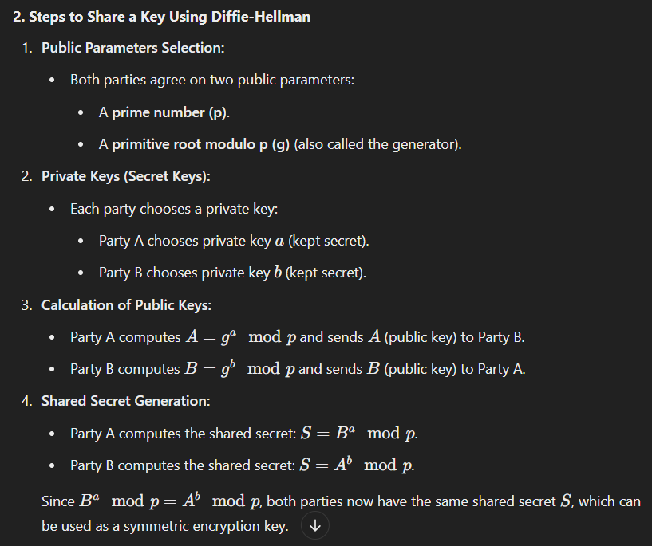

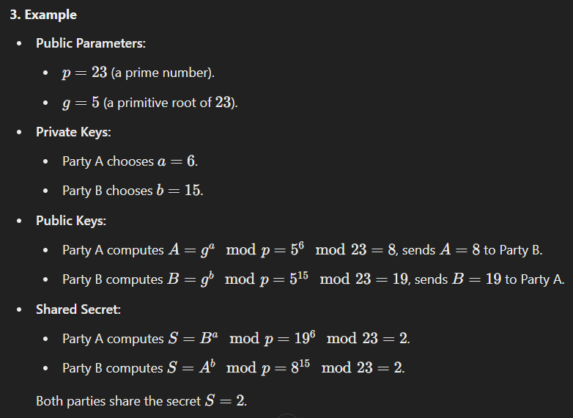

**4. Drawbacks of Diffie-Hellman Algorithm**

1. **Lack of Authentication:**
   * The algorithm does not authenticate the parties, leaving it vulnerable to **Man-in-the-Middle (MITM)** attacks if the public keys are intercepted.
2. **No Message Integrity or Confidentiality:**
   * It only generates a shared secret but does not ensure that messages exchanged are protected.
3. **Computational Complexity:**
   * For large prime numbers, the algorithm can be computationally expensive.
4. **Vulnerability to Quantum Computing:**
   * Quantum computers can break the Diffie-Hellman algorithm using **Shor’s Algorithm**.
5. **Requirement of Large Prime Numbers:**
   * Security relies heavily on the use of large prime numbers, making it inefficient for devices with limited processing power.

## Is SHA secured? Explain secure hash algorithm in detail

**Secure Hash Algorithm (SHA) Overview**

The Secure Hash Algorithm (SHA) is a family of cryptographic hash functions designed by the National Security Agency (NSA) and published by the National Institute of Standards and Technology (NIST). SHA is widely used in various security applications and protocols, including TLS and SSL, PGP, SSH, and IPsec. The primary purpose of SHA is to ensure data integrity by producing a fixed-size hash value (digest) from input data of any size.

**Key Properties of Secure Hash Functions**

For a hash function to be considered secure, it must possess several important properties:

1. **Deterministic**: The same input will always produce the same hash output.
2. **Fast Computation**: It should be quick to compute the hash for any given input.
3. **Pre-image Resistance**: Given a hash output, it should be computationally infeasible to find any input that hashes to that output.
4. **Second Pre-image Resistance**: Given an input and its hash output, it should be infeasible to find a different input that produces the same hash output.
5. **Collision Resistance**: It should be infeasible to find two different inputs that produce the same hash output.

**SHA Family Variants**

The SHA family includes several variants, each designed to provide different levels of security and performance:

1. **SHA-0**: The original version released in 1993. It was withdrawn due to flaws in its design and security vulnerabilities.
2. **SHA-1**: Released in 1995, SHA-1 produces a 160-bit hash value. It was widely used but has been found to be vulnerable to collision attacks (where two different inputs produce the same hash). As of 2017, it is considered insecure for most applications.
3. **SHA-2**: Introduced in 2001, SHA-2 includes several hash functions with different output sizes:
   * **SHA-224**: Produces a 224-bit hash.
   * **SHA-256**: Produces a 256-bit hash and is widely used in various applications, including Bitcoin.
   * **SHA-384**: Produces a 384-bit hash.
   * **SHA-512**: Produces a 512-bit hash.
   * **SHA-512/224** and **SHA-512/256**: Variants of SHA-512 with truncated outputs.
4. **SHA-3**: Released in 2015, SHA-3 is based on a different cryptographic principle called the Keccak algorithm. It provides similar output sizes as SHA-2 but uses a different internal structure, making it resistant to certain types of attacks.

**Security of SHA**

* **SHA-1**: As mentioned, SHA-1 is no longer considered secure due to discovered vulnerabilities, particularly collision attacks. Organizations are encouraged to migrate to more secure hash functions.
* **SHA-2**: SHA-2, particularly SHA-256 and SHA-512, is currently considered secure and is widely used in various security protocols and applications. As of now, no practical attacks have been demonstrated against SHA-2 that would compromise its security.
* **SHA-3**: SHA-3 is also considered secure and provides an alternative to SHA-2. Its design is fundamentally different, which may offer additional security benefits.

**Applications of SHA**

1. **Data Integrity**: SHA is commonly used to verify the integrity of data. By comparing hash values before and after data transmission, one can ensure that the data has not been altered.
2. **Digital Signatures**: SHA is often used in conjunction with public key cryptography to create digital signatures. The hash of the message is signed, providing both integrity and authenticity.
3. **Password Hashing**: Secure password storage often involves hashing passwords with SHA (or other hash functions) to protect them from unauthorized access.
4. **Blockchain Technology**: SHA-256 is the basis for Bitcoin's proof-of-work algorithm, ensuring the integrity of transactions and blocks in the blockchain.

**Conclusion**

SHA is a crucial component of modern cryptographic systems, providing essential security features for data integrity and authenticity. While SHA-1 is deprecated due to vulnerabilities, SHA-2 and SHA-3 remain secure options for various applications. As with any cryptographic technology, it is vital to stay updated on security best practices and recommendations from the cryptographic community.

## What are the disadvantages of symmetric key cipher? Explain in detail working of AES cipher

**Disadvantages of Symmetric Key Ciphers**

Symmetric key ciphers use the same key for both encryption and decryption. While they are generally faster and more efficient than asymmetric key ciphers, they come with several disadvantages:

1. **Key Distribution Problem**:
   * **Challenge**: The biggest challenge with symmetric key cryptography is securely distributing the keys to both parties. If the key is intercepted during transmission, an attacker can decrypt the data.
   * **Solution**: Secure channels or key exchange protocols (like Diffie-Hellman) are needed to share keys securely, but these can introduce complexity.
2. **Scalability Issues**:
   * **Challenge**: In a network with multiple users, each pair of users requires a unique key. For ( n ) users, the number of keys required is ( n(n-1)/2 ), which becomes impractical as the number of users increases.
   * **Solution**: This can be managed through a centralized key management system, but it adds complexity and potential single points of failure.
3. **Key Management**:
   * **Challenge**: Managing keys securely over time can be difficult. Keys need to be updated regularly to maintain security, and old keys must be securely destroyed.
   * **Solution**: Organizations need robust key management policies and systems to handle key generation, storage, rotation, and destruction.
4. **Lack of Non-repudiation**:
   * **Challenge**: Since both parties share the same key, neither can prove to a third party that a specific message was sent or received. This lack of non-repudiation can be problematic in legal or contractual contexts.
   * **Solution**: To achieve non-repudiation, digital signatures (which use asymmetric cryptography) may need to be employed alongside symmetric encryption.
5. **Vulnerability to Key Exhaustion**:
   * **Challenge**: If a key is reused or if the key length is too short, it can be vulnerable to brute-force attacks. As computational power increases, shorter keys become less secure.
   * **Solution**: Use sufficiently long keys (e.g., 256-bit keys) and avoid reusing keys across different sessions or data.

**Working of AES Cipher:** <https://www.geeksforgeeks.org/advanced-encryption-standard-aes/>

## Write a note on denial of service attack and cast 128

**Denial of Service Attack (DoS)**

A Denial of Service (DoS) attack is a malicious attempt to disrupt the normal functioning of a targeted server, service, or network by overwhelming it with a flood of traffic. The goal is to render the service unavailable to its intended users, which can lead to significant financial losses, reputational damage, and operational downtime for businesses and organizations.

**Types of DoS Attacks:**

1. **Volume-Based Attacks**: These attacks involve overwhelming the bandwidth of the target with a large volume of traffic. Examples include ICMP floods and UDP floods.
2. **Protocol Attacks**: These attacks exploit weaknesses in network protocols to consume server resources. Examples include SYN floods and Ping of Death.
3. **Application Layer Attacks**: These attacks target specific applications or services, often using fewer resources to achieve a larger impact. Examples include HTTP floods and Slowloris attacks.
4. **Distributed Denial of Service (DDoS)**: A more sophisticated form of DoS, where multiple compromised systems (often part of a botnet) are used to launch the attack simultaneously, making it more challenging to mitigate.

**Impact of DoS Attacks:**

* **Service Downtime**: Legitimate users are unable to access the service, leading to frustration and loss of trust.
* **Financial Loss**: Businesses can incur significant costs due to downtime, loss of sales, and the expense of mitigation efforts.
* **Reputational Damage**: Frequent outages can harm a company's reputation and customer loyalty.
* **Resource Drain**: Mitigating a DoS attack can consume considerable IT resources and time.

**CAST-128**

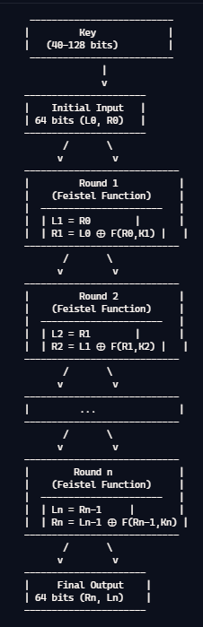

**• Block Size: 64 bits**

**• Key Size: 40 to 128 bits (in 8-bit increments)**

**• Structure: Feistel network**

**• Rounds: 12 or 16 rounds (16 rounds are used when the key size is longer than 80 bits)**

**• Components:**

* **S-boxes: 8x32-bit S-boxes based on bent functions**
* **Key-dependent Rotations: Rotations controlled by key bits**
* **Modular Addition and Subtraction: Operations used in the round functions**
* **XOR Operations: Used in combination with other operations**

CAST-128, also known as CAST5, is a symmetric key block cipher that was developed by Carlisle Adams and Stafford Tavares in 1996. It was designed to provide a flexible and efficient encryption standard that can be used for a variety of applications.

**Key Features of CAST-128:**

1. **Block Size**: CAST-128 operates on 64-bit blocks of data, which is smaller than many modern ciphers that use 128-bit blocks.
2. **Key Length**: It supports variable key lengths of 40 to 128 bits, allowing for a range of security levels depending on the application's needs.
3. **Structure**: The algorithm uses a Feistel network structure, which splits the data block into two halves and processes them through multiple rounds of encryption and substitution.
4. **Rounds**: CAST-128 uses 12 to 16 rounds of processing, depending on the key length, to enhance security.
5. **Flexibility**: The design of CAST-128 allows for efficient implementation in both hardware and software, making it suitable for various platforms.

**Applications:**

CAST-128 has been used in various encryption applications, including:

* Secure email and file encryption.
* Virtual Private Networks (VPNs).
* Secure Sockets Layer (SSL) protocols.

**Security:**

While CAST-128 was considered secure at the time of its introduction, advancements in cryptography and computing power have led to the development of newer algorithms, such as AES (Advanced Encryption Standard), which are now more widely recommended for use due to their stronger security properties. Nevertheless, CAST-128 remains a significant cipher in the history of cryptography and is still in use in some legacy systems.

## How security to transport layer is provided using SSL?

**Security in the Transport Layer Using SSL (Secure Sockets Layer)**

SSL (now succeeded by TLS - Transport Layer Security) is a protocol that provides security at the transport layer of the OSI model. It ensures secure communication over a computer network. Here’s a detailed point-wise explanation of how SSL/TLS provides security:

**1. Encryption**

* **Purpose**: Encrypts the data transmitted between the client and server to prevent eavesdropping.
* **Mechanism**: Uses symmetric encryption (e.g., AES) for the session data after the initial handshake, ensuring confidentiality.

**2. Authentication**

* **Purpose**: Ensures that the parties communicating are who they claim to be.
* **Mechanism**: Utilizes digital certificates issued by trusted Certificate Authorities (CAs) to verify the identity of the server (and optionally the client).

**3. Integrity**

* **Purpose**: Ensures that the data has not been altered during transmission.
* **Mechanism**: Uses message authentication codes (MACs) to verify the integrity of the transmitted data. If any data is altered, the MAC will not match, indicating tampering.

**4. Handshake Protocol**

* **Purpose**: Establishes a secure connection between the client and server.
* **Mechanism**: Involves several steps:
  + **Client Hello**: The client sends a message to the server proposing SSL/TLS parameters (version, cipher suites, etc.).
  + **Server Hello**: The server responds with its chosen parameters and sends its digital certificate.
  + **Key Exchange**: The client and server agree on a shared secret (session key) using asymmetric encryption.
  + **Session Established**: Both parties confirm that the handshake is complete, and secure communication can begin.

**5. Session Resumption**

* **Purpose**: Improves performance by allowing clients to resume previous sessions without a full handshake.
* **Mechanism**: Uses session IDs or session tickets to quickly re-establish a secure connection without repeating the entire handshake process.

**6. Forward Secrecy**

* **Purpose**: Ensures that session keys are not compromised even if the server's private key is compromised in the future.
* **Mechanism**: Uses ephemeral key exchanges (e.g., Diffie-Hellman) to generate unique session keys for each connection.

**7. Protocol Versions**

* **Purpose**: SSL/TLS has multiple versions, each providing improved security features over its predecessors.
* **Mechanism**: Supports backward compatibility but encourages the use of the latest, most secure version (e.g., TLS 1.2 or TLS 1.3).

**8. Cipher Suites**

* **Purpose**: Defines the algorithms for key exchange, encryption, and MAC.
* **Mechanism**: Clients and servers negotiate which cipher suite to use during the handshake, ensuring strong encryption methods are employed.

**9. Error Handling**

* **Purpose**: Provides mechanisms to handle errors securely.
* **Mechanism**: SSL/TLS defines specific alerts for various issues (e.g., bad record MAC, decryption failure) to prevent data leakage.

**10. Compatibility and Interoperability**

* **Purpose**: SSL/TLS is designed to work across various platforms and applications.
* **Mechanism**: It is widely supported by web browsers, servers, and applications, ensuring secure communications across different environments.

**11. Use Cases**

* **Web Security**: Commonly used in HTTPS to secure web traffic.
* **Email Security**: Secures email protocols like SMTP, IMAP, and POP3.
* **VPNs**: Provides secure connections in Virtual Private Networks.

**12. Transition to TLS**

* **Note**: SSL has been deprecated due to security vulnerabilities, and TLS is the preferred protocol. TLS 1.3 offers significant improvements in security and performance over previous versions.

## SET Protocol for Mobile Payment

**Secure Electronic Transaction (SET)** is a protocol designed to secure credit card transactions over the Internet. Developed in the mid-1990s by a consortium of companies, including Visa and MasterCard, SET was specifically aimed at providing a secure environment for electronic payments, particularly in e-commerce. Although it is not widely used today, its principles laid the groundwork for many modern secure payment systems.

Here’s a detailed overview of the SET protocol, focusing on its architecture, components, and operation:

**1. Overview of SET**

* **Purpose**: To provide a secure method for credit card transactions over the Internet, ensuring confidentiality, integrity, and authentication.
* **Key Features**:
  + **Confidentiality**: Protects sensitive information like credit card numbers during transmission.
  + **Authentication**: Ensures that the parties involved in the transaction are who they claim to be.
  + **Integrity**: Guarantees that the data sent has not been altered.

**2. Components of SET**

SET involves several key components that play specific roles in the transaction process:

* **Cardholder**: The individual making the purchase using a credit card.
* **Merchant**: The business or entity selling goods or services.
* **Payment Gateway**: The intermediary that processes the payment between the merchant and the financial institution.
* **Certificate Authority (CA)**: An entity that issues digital certificates to authenticate the identities of the cardholder and the merchant.
* **Payment Processor**: The financial institution that processes the payment transaction.

**3. SET Architecture**

The SET architecture consists of three main layers:

1. **Application Layer**: Involves the user interface and application logic for the cardholder and merchant.
2. **Transport Layer**: Responsible for the secure transmission of data between parties.
3. **Security Layer**: Implements cryptographic protocols to ensure confidentiality, integrity, and authentication.

**4. SET Transaction Process**

The SET protocol involves several steps in the transaction process:

**Step 1: Registration**

* **Cardholder Registration**: The cardholder registers with a bank or financial institution to obtain a digital certificate that proves their identity.
* **Merchant Registration**: The merchant also registers with a bank to obtain a digital certificate.

**Step 2: Initiating a Transaction**

1. **Cardholder Browses Merchant Site**: The cardholder visits the merchant's website and selects items for purchase.
2. **Purchase Request**: The cardholder initiates a purchase, which generates a transaction request.

**Step 3: Creating the Transaction Message**

* The cardholder's software creates a transaction message that includes:
  + The purchase amount.
  + A unique transaction identifier.
  + The cardholder's digital certificate.
  + The merchant's digital certificate.

**Step 4: Encrypting the Transaction Message**

* The transaction message is encrypted using the merchant's public key to ensure confidentiality.

**Step 5: Sending the Transaction Message**

* The encrypted transaction message is sent to the merchant.

**Step 6: Merchant Processes the Transaction**

1. **Decrypting the Message**: The merchant uses its private key to decrypt the transaction message.
2. **Validation**: The merchant verifies the cardholder's digital certificate and checks the transaction details.
3. **Authorization Request**: The merchant sends an authorization request to the payment gateway, including the transaction details.

**Step 7: Payment Gateway Processing**

1. **Authorization**: The payment gateway verifies the transaction with the cardholder's bank.
2. **Response**: The payment gateway sends an authorization response (approved or declined) back to the merchant.

**Step 8: Completing the Transaction**

* The merchant informs the cardholder of the transaction status (approved or declined).
* If approved, the merchant completes the sale and provides the goods or services to the cardholder.

**5. Security Mechanisms in SET**

SET employs several cryptographic techniques to ensure secure transactions:

* **Digital Certificates**: Issued by a CA to authenticate the identities of cardholders and merchants.
* **Public Key Cryptography**: Used for encrypting transaction messages and ensuring secure key exchange.
* **Message Authentication Codes (MACs)**: Ensure the integrity of the transaction data and verify that it has not been altered.

**6. Advantages of SET**

* **Enhanced Security**: Provides strong security features, including encryption and digital signatures.
* **Privacy**: Protects sensitive cardholder information, preventing unauthorized access.
* **Trust**: Establishes trust between parties involved in the transaction through authentication.

**7. Disadvantages of SET (continued)**

* **Limited Adoption**: Due to its complexity and the need for extensive infrastructure, SET did not achieve widespread adoption in the market. Many merchants and consumers found it cumbersome compared to simpler methods of payment processing.
* **Performance Issues**: The overhead introduced by encryption and decryption processes can lead to slower transaction times, which may deter users seeking quick and efficient payment methods.
* **Dependency on Certificate Authorities**: The reliance on trusted Certificate Authorities (CAs) adds another layer of complexity and potential points of failure. If a CA is compromised, it can undermine the entire security model.

**8. Legacy and Impact of SET**

Despite its limited adoption, SET has had a lasting impact on the development of secure payment protocols and practices:

* **Influence on Standards**: The principles of SET influenced later secure payment protocols, including those used in e-commerce today, such as SSL/TLS and EMV (Europay, MasterCard, and Visa).
* **Security Practices**: SET emphasized the importance of using digital certificates and public key infrastructure, which have become standard practices in securing online transactions.
* **Foundation for Future Protocols**: The concepts of authentication, confidentiality, and integrity that were central to SET continue to be critical in modern payment systems.

**9. Modern Alternatives to SET**

Given the limitations of SET, several alternative protocols and technologies have gained popularity in the realm of online payments:

* **SSL/TLS**: Secure Sockets Layer and Transport Layer Security protocols provide a secure channel over the Internet, ensuring encrypted communication between clients and servers.
* **3D Secure**: A protocol that adds an additional layer of security for online credit and debit card transactions, often branded as "Verified by Visa" or "MasterCard SecureCode."
* **EMV**: A global standard for card payments that incorporates chip technology to enhance security during transactions.
* **Digital Wallets**: Services like Apple Pay, Google Pay, and PayPal provide secure payment methods that leverage tokenization and encryption to protect sensitive information.

## How are authentication and confidentiality achieved using IPsec?

IPsec (Internet Protocol Security) is a suite of protocols designed to secure Internet Protocol (IP) communications through authentication and encryption. It operates at the network layer and provides a framework for ensuring the confidentiality, integrity, and authenticity of data transmitted over IP networks. Here’s a detailed explanation of how authentication and confidentiality are achieved using IPsec:

**1. Overview of IPsec**

* **Purpose**: IPsec is used to secure IP communications by authenticating and encrypting each IP packet in a communication session.
* **Components**: IPsec consists of two main protocols:
  + **Authentication Header (AH)**: Provides authentication and integrity but not encryption.
  + **Encapsulating Security Payload (ESP)**: Provides both authentication and encryption.

**2. Authentication in IPsec**

Authentication in IPsec ensures that the data comes from a legitimate source and has not been altered during transmission. This is achieved through the following mechanisms:

**a. Authentication Header (AH)**

* **Function**: AH provides connectionless integrity and data origin authentication for IP packets.
* **Mechanism**:
  + **Hashing**: AH uses cryptographic hash functions (e.g., HMAC with SHA-256) to create a Message Authentication Code (MAC) based on the packet's contents.
  + **Integrity Check**: The MAC is appended to the packet. Upon receipt, the recipient recalculates the MAC and compares it with the received MAC to verify integrity and authenticity.
  + **Replay Protection**: AH includes a sequence number in each packet to protect against replay attacks. The receiver checks the sequence number to ensure packets are processed in order and are not duplicated.

**b. Encapsulating Security Payload (ESP)**

* **Function**: ESP provides confidentiality, as well as authentication and integrity.
* **Mechanism**:
  + **Encryption**: ESP encrypts the payload of the IP packet using symmetric encryption algorithms (e.g., AES, DES). This ensures that only authorized parties can read the data.
  + **Authentication**: Similar to AH, ESP can use HMAC to create a MAC for the encrypted data, providing integrity and authenticity.
  + **Combination of Services**: By providing both encryption and authentication, ESP ensures that the data is confidential and that the sender is authenticated.

**3. Confidentiality in IPsec**

Confidentiality in IPsec is primarily achieved through the use of encryption in the ESP protocol.

**a. Encryption Mechanism**

* **Symmetric Key Cryptography**: IPsec uses symmetric encryption algorithms to encrypt the data payload of IP packets. Both the sender and receiver share a secret key used for encryption and decryption.
* **Encryption Algorithms**: Common algorithms used include:
  + **AES (Advanced Encryption Standard)**: A widely used encryption standard that provides a high level of security.
  + **3DES (Triple Data Encryption Standard)**: An older encryption standard that applies the DES algorithm three times to each data block.
* **Key Management**: Key exchange protocols like IKE (Internet Key Exchange) are used to negotiate and manage encryption keys securely.

**b. ESP Encryption Process**

1. **Data Preparation**: Before encryption, the original IP packet is prepared.
2. **Encryption**: The payload (data) is encrypted using the chosen symmetric encryption algorithm, producing ciphertext.
3. **Packet Construction**: The encrypted payload is encapsulated in a new IP packet, which includes the ESP header and trailer.
4. **Transmission**: The newly constructed packet is sent over the network.

**4. IPsec Modes**

IPsec operates in two modes, which affect how authentication and confidentiality are applied:

**a. Transport Mode**

* **Description**: Only the payload of the IP packet is encrypted and/or authenticated.
* **Use Case**: Commonly used for end-to-end communication between two hosts (e.g., securing communication between a client and a server).

**b. Tunnel Mode**

* **Description**: The entire original IP packet (including the header) is encrypted and encapsulated within a new IP packet.
* **Use Case**: Typically used for Virtual Private Networks (VPNs), where traffic between two networks is secured over the Internet.

**5. Key Management with IKE**

* **Internet Key Exchange (IKE)**: IKE is a protocol used to set up a secure, authenticated communications channel for the exchange of keys and security associations (SAs) between peers in an IPsec connection.
* **Phases of IKE**:
  + **Phase 1**: Establishes a secure channel for further negotiations, authenticating the peers and agreeing on encryption methods.
  + **Phase 2**: Negotiates the IPsec SAs, including the keys and algorithms to be used for encryption and authentication.

# ESE NOV 20I8

## Describe the difference between confusion and diffusion.

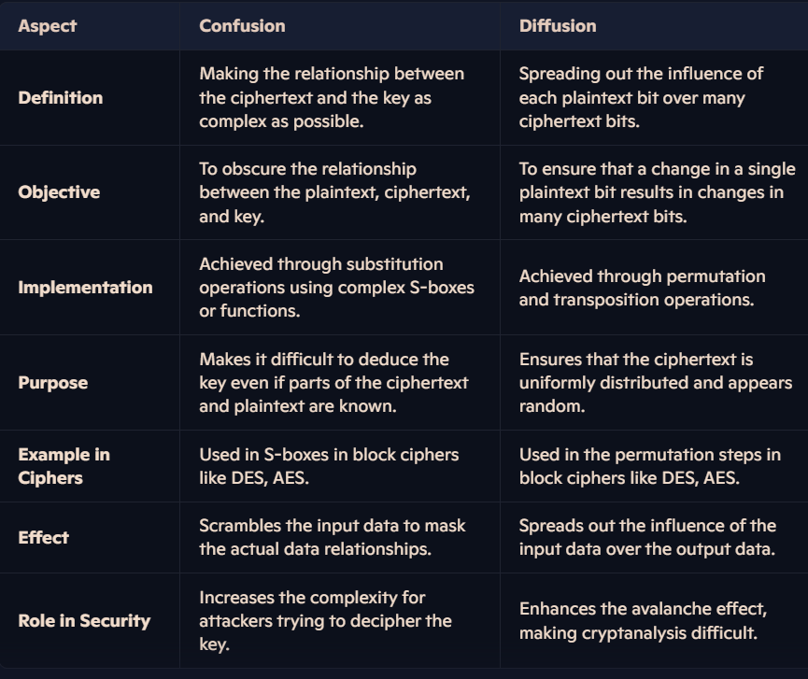

## Explain the different protocols in SSL. How do client and server establish an SSL connection?

**1. SSL Protocols**

SSL (Secure Sockets Layer) is a cryptographic protocol designed to secure communications over the internet. SSL consists of the following sub-protocols:

1. **Handshake Protocol**
   * Establishes a secure connection between the client and server.
   * Negotiates encryption algorithms and keys.
   * Authenticates server (and optionally the client) using certificates.
   * Exchange of session keys for secure communication.
2. **Record Protocol**
   * Ensures confidentiality and integrity of the data.
   * Encrypts the application data using symmetric encryption algorithms.
   * Uses message authentication codes (MAC) to verify data integrity.
3. **Alert Protocol**
   * Communicates error messages or warnings.
   * Alerts include closure alerts (for ending a session) and fatal errors (e.g., handshake failure, decryption error).
4. **Change Cipher Spec Protocol**
   * Used during the handshake to signal a change in encryption settings.
   * Indicates that subsequent communication will use the agreed-upon security parameters.

**2. Steps to Establish an SSL Connection**

1. **Client Hello**
   * The client initiates the handshake by sending a "ClientHello" message.
   * Includes supported SSL/TLS versions, cipher suites, and a random number.
2. **Server Hello**
   * The server responds with a "ServerHello" message.
   * Selects the SSL/TLS version, cipher suite, and provides its own random number.
3. **Server Certificate**
   * The server sends its digital certificate containing its public key.
   * Used by the client to verify the server's identity.
4. **(Optional) Client Certificate Request**
   * If mutual authentication is required, the server requests the client’s certificate.
5. **Key Exchange**
   * Client generates a pre-master secret (random value) and encrypts it with the server's public key.
   * The pre-master secret is sent to the server.
6. **Session Key Derivation**
   * Both client and server use the pre-master secret and exchanged random numbers to compute the session key using the same key derivation function.
7. **Change Cipher Spec**
   * Both client and server send a "ChangeCipherSpec" message to indicate that they will use the derived session keys for encryption and integrity.
8. **Finished Message**
   * Both client and server send a "Finished" message to confirm that the handshake is complete and communication can proceed securely.
9. **Secure Communication**
   * The client and server use the session key for encrypting and decrypting application data.

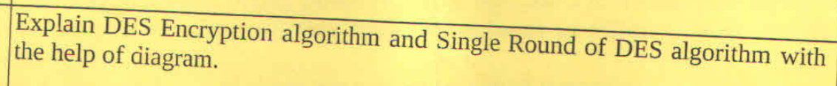

**Explanation of DES Encryption Algorithm**

The **Data Encryption Standard (DES)** is a symmetric-key algorithm for the encryption of digital data. It works on blocks of data and uses a 64-bit key (though 8 bits are used for parity, making the effective key length 56 bits). The algorithm consists of multiple steps as outlined below:

**1. Steps in DES Encryption Algorithm:**

1. **Initial Permutation (IP):** The 64-bit plaintext block undergoes an initial permutation that rearranges the bits based on a fixed table.
2. **Division into Two Halves:** The permuted block is divided into two 32-bit halves: Left (L) and Right (R).
3. **Rounds of Feistel Network (16 Rounds):**
   * Each round involves the following:
     1. The **Right half** is expanded to 48 bits using an **expansion function**.
     2. The 48-bit expanded data is XORed with the round key (48 bits).
     3. The result passes through **S-boxes** (substitution boxes), which compress it back to 32 bits.
     4. The output of the S-boxes is permuted (P-box permutation).
     5. The result is XORed with the Left half.
     6. Swap: The Right half becomes the new Left half, and the output becomes the new Right half.
   * This process is repeated for 16 rounds.
4. **Final Permutation (IP^-1):** After the 16 rounds, the Left and Right halves are combined and passed through the inverse of the initial permutation to produce the final ciphertext.

**Single Round of DES:**

Each round in the DES encryption process is based on the Feistel network structure:

1. **Expansion (E):** Expands the 32-bit Right half to 48 bits.
2. **Key Mixing:** XORs the expanded Right half with a 48-bit round key derived from the main key.
3. **Substitution (S-box):** The XOR result is divided into 8 blocks of 6 bits each. Each block is substituted using an S-box, resulting in a 32-bit output.
4. **Permutation (P):** Rearranges the bits from the S-box output according to a predefined table.
5. **XOR with Left Half:** The result is XORed with the Left half from the previous round.
6. **Swap Halves:** The Left and Right halves are swapped for the next round.

## Describe IDEA algorithm in cryptography

The IDEA (International Data Encryption Algorithm) is a symmetric-key block cipher that was designed by James Massey and Xuejia Lai in 1991. It is notable for its simplicity and efficiency, particularly in software implementations. Here’s a detailed overview of the IDEA algorithm:

**Key Features of IDEA**

1. **Block Size**: IDEA operates on 64-bit blocks of data.
2. **Key Size**: It uses a 128-bit key, which is divided into eight 16-bit subkeys for each round of encryption.
3. **Rounds**: The algorithm consists of 8 rounds of processing, with a final output transformation.
4. **Symmetric Key**: As a symmetric-key algorithm, the same key is used for both encryption and decryption.

**Structure of IDEA**

The IDEA algorithm consists of several key components:

1. **Key Schedule**: The 128-bit key is expanded into 52 subkeys, each 16 bits long. This is done through a specific key scheduling algorithm that ensures the subkeys are derived from the original key.
2. **Rounds**: The encryption process consists of 8 rounds, each of which involves a series of operations on the data block:
   * **Modular Addition**: Addition is performed modulo (2^{16} + 1).
   * **Multiplication**: Multiplication is performed modulo (2^{16} + 1) with a special case for zero (where zero is treated as a special value).
   * **Bitwise XOR**: The XOR operation is used to combine values.
3. **Final Transformation**: After the 8 rounds, a final transformation is applied to produce the ciphertext.

**Encryption Process**

1. **Input**: A 64-bit plaintext block and a 128-bit key.
2. **Key Expansion**: The key is expanded into 52 subkeys.
3. **Rounds**: Each round consists of:
   * Splitting the 64-bit block into four 16-bit sub-blocks.
   * Performing a series of modular additions, multiplications, and XOR operations on these sub-blocks using the subkeys.
4. **Final Output**: The result after the last round is the 64-bit ciphertext.

**Decryption Process**

The decryption process is similar to encryption but uses the subkeys in reverse order. The operations are also reversed (e.g., the inverse of multiplication modulo (2^{16} + 1) is used).

**Security**

IDEA is considered secure and has been widely used in various applications, including PGP (Pretty Good Privacy) for email encryption. Its security is based on the difficulty of performing a brute-force attack due to the large key size and the complexity of the operations involved.

**Advantages**

* **Efficiency**: IDEA is efficient in software implementations, making it suitable for environments with limited processing power.
* **Simplicity**: The algorithm is relatively simple to implement, which contributes to its popularity.

**Disadvantages**

* **Block Size**: The 64-bit block size is considered small by modern standards, making it vulnerable to certain types of attacks (e.g., birthday attacks) when processing large amounts of data.
* **Patent Issues**: IDEA was patented, which limited its use in some open-source applications until the patent expired.

## HMAC ALGORITHM with structure

See notes

## Explain PGP Cryptographic Functions for authentication only, confidentiality only and both confidentiality and authentication.

**1. Authentication Only**

When PGP is used solely for authentication, the primary goal is to verify the identity of the sender without necessarily encrypting the message. This is typically done using digital signatures.

**How it works:**

* **Key Pair Generation:** The user generates a public-private key pair. The private key is kept secret, while the public key is shared with others.
* **Signing Process:** The sender creates a hash of the message and encrypts this hash with their private key, creating a digital signature.
* **Sending the Message:** The original message is sent along with the digital signature.
* **Verification Process:** The recipient uses the sender's public key to decrypt the digital signature, obtaining the hash. They then compute the hash of the received message and compare it to the decrypted hash. If they match, it confirms that the message was not altered and that it was indeed sent by the claimed sender.

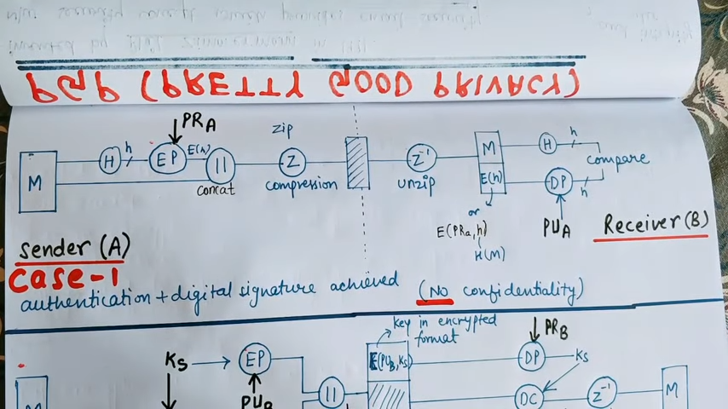

**2. Confidentiality Only**

When PGP is used for confidentiality, the focus is on ensuring that the content of the message remains private and can only be read by the intended recipient. This is typically achieved through encryption.

**How it works:**

* **Key Pair Generation:** The recipient generates a public-private key pair. The public key is shared, while the private key is kept secret.
* **Encryption Process:** The sender obtains the recipient's public key and uses it to encrypt the message. This ensures that only the recipient, who possesses the corresponding private key, can decrypt and read the message.
* **Sending the Message:** The encrypted message is sent to the recipient.
* **Decryption Process:** The recipient uses their private key to decrypt the message, allowing them to read the original content.

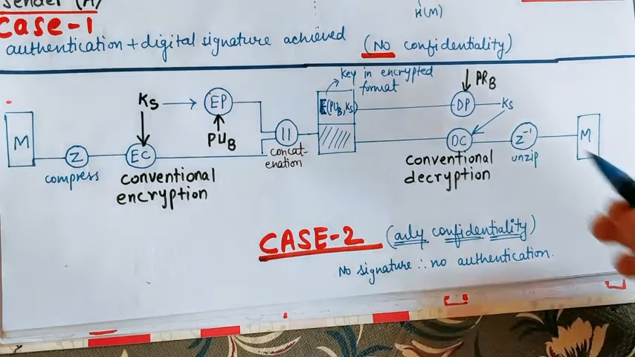

**3. Both Confidentiality and Authentication**

PGP can also be used to provide both confidentiality and authentication, ensuring that the message is both secure and verifiable.

**How it works:**

* **Key Pair Generation:** Both the sender and recipient generate their respective public-private key pairs.
* **Signing and Encryption Process:**
  + The sender first creates a hash of the message and signs it with their private key, generating a digital signature.
  + Next, the sender encrypts both the original message and the digital signature using the recipient’s public key.
* **Sending the Message:** The encrypted message (along with the digital signature) is sent to the recipient.
* **Verification and Decryption Process:**
  + Upon receiving the message, the recipient first decrypts it using their private key, obtaining both the original message and the digital signature.
  + The recipient then verifies the digital signature using the sender’s public key to ensure the message's authenticity and integrity.

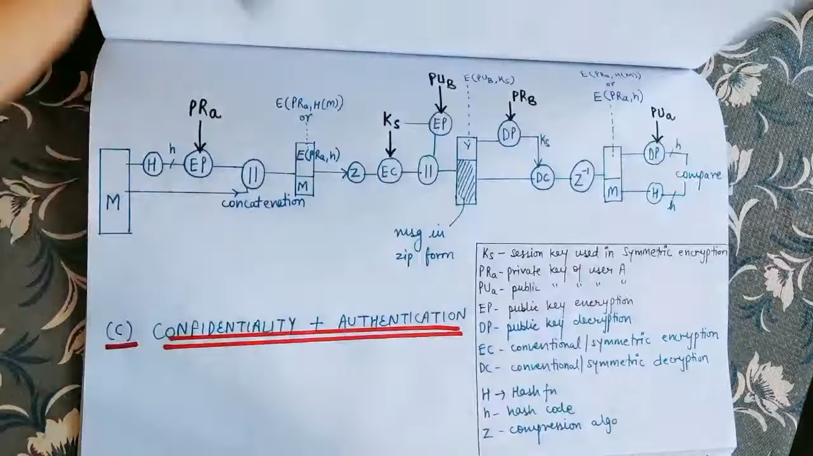

## Explain different types of malicious software

**1. Viruses**

* **Working Mechanism:**
  + **Infection:** A virus attaches itself to a host file (e.g., an executable program, document, or script). When the infected file is executed, the virus code is activated.
  + **Replication:** The virus can replicate itself by attaching to other files on the same system or through removable media (like USB drives) to spread to other systems.
  + **Payload:** Viruses can carry a payload that may corrupt or delete files, steal data, or disrupt system operations. Some viruses may also display messages or images to the user.

**2. Worms**

* **Working Mechanism:**
  + **Self-Replication:** Worms exploit vulnerabilities in software or operating systems to replicate themselves without user intervention. They often do this by scanning networks for other vulnerable systems.
  + **Propagation:** Once a worm infects a system, it can send copies of itself to other systems on the same network or over the internet, often using email or file-sharing protocols.
  + **Effects:** Worms can consume bandwidth, slow down networks, and may carry payloads that install additional malware or create backdoors for attackers.

**3. Trojan Horses**

* **Working Mechanism:**
  + **Deceptive Appearance:** Trojans masquerade as legitimate software, tricking users into downloading and installing them. They may be embedded in seemingly harmless applications or files.
  + **Execution:** Once installed, Trojans can execute malicious actions such as stealing data, installing other malware, or creating backdoors for remote access.
  + **Stealth:** Trojans often do not exhibit obvious signs of infection, making them difficult for users to detect.

**4. Ransomware**

* **Working Mechanism:**
  + **Infection Methods:** Ransomware typically spreads through phishing emails, malicious downloads, or exploiting vulnerabilities in software.
  + **Encryption:** Once activated, ransomware encrypts files on the victim's system using strong encryption algorithms, rendering them inaccessible without a decryption key.
  + **Ransom Demand:** The malware displays a ransom note demanding payment (usually in cryptocurrency) in exchange for the decryption key. Some ransomware variants threaten to leak sensitive data if the ransom is not paid.

**5. Spyware**

* **Working Mechanism:**
  + **Installation:** Spyware can be bundled with legitimate software, downloaded from malicious websites, or installed through social engineering tactics.
  + **Data Collection:** Once installed, spyware runs in the background, monitoring user activities, capturing keystrokes, and collecting sensitive information (e.g., passwords, browsing habits).
  + **Transmission:** The collected data is often transmitted back to the attacker, who can use it for identity theft, financial fraud, or targeted advertising.

**6. Adware**

* **Working Mechanism:**
  + **Bundling:** Adware is often bundled with free software. Users may unknowingly install it when they agree to the terms of a software installation.
  + **Ad Display:** Once installed, adware displays unsolicited advertisements on the user's device, often in the form of pop-ups or banners.
  + **Tracking:** Some adware tracks user behavior to deliver targeted ads, which can lead to privacy concerns and potential exposure to more malicious software.

**7. Rootkits**

* **Working Mechanism:**
  + **Installation:** Rootkits can be installed through software vulnerabilities, social engineering, or by exploiting existing malware.
  + **Stealth Techniques:** Once installed, rootkits modify operating system processes and files to hide their presence. They can intercept system calls and alter the behavior of the operating system to conceal other malware.
  + **Persistence:** Rootkits can provide persistent access to attackers, allowing them to control the system remotely without detection.

**8. Keyloggers**

* **Working Mechanism:**
  + **Installation:** Keyloggers can be installed via malicious downloads, phishing attacks, or physical access to a device.
  + **Keystroke Capture:** They run in the background, recording every keystroke made by the user, including passwords, credit card numbers, and personal messages.
  + **Data Transmission:** Captured data can be stored locally or transmitted to the attacker, who can use it for identity theft or financial fraud.

**9. Botnets (continued)**

* **Malicious Activities:** Botnets can be used for a variety of malicious purposes, including:
  + **Distributed Denial-of-Service (DDoS) Attacks:** Overwhelming a target server or network with traffic from multiple bots, rendering it unavailable to legitimate users.
  + **Spam Distribution:** Sending out massive amounts of spam emails, often used for phishing or spreading other malware.
  + **Credential Theft:** Using the combined resources of the botnet to attempt to crack passwords or conduct brute-force attacks on various accounts.
  + **Cryptocurrency Mining:** Utilizing the computational power of infected machines to mine cryptocurrencies for the botmaster’s profit.

**10. Scareware**

* **Working Mechanism:**
  + **Deceptive Alerts:** Scareware typically displays fake security alerts or pop-ups that claim the user’s computer is infected with malware or has other critical issues.
  + **Fear Tactics:** The malware exploits the user's fear and urgency, often claiming that immediate action is needed to avoid dire consequences (e.g., data loss, identity theft).
  + **Malicious Offers:** Users are often prompted to purchase fake antivirus software or services, which may not only be ineffective but could also install additional malware on the system.

**11. Fileless Malware**

* **Working Mechanism:**
  + **Memory-Based Execution:** Fileless malware operates directly in the system's memory, using legitimate system tools (like PowerShell or Windows Management Instrumentation) to execute malicious commands without leaving traditional files on disk.
  + **Exploitation of Legitimate Processes:** It often exploits trusted processes and applications to carry out its activities, making it difficult for traditional antivirus solutions to detect it.
  + **Persistence:** Some fileless malware can establish persistence by modifying registry settings or using scheduled tasks, allowing it to remain active even after a system reboot.

**12. Cryptojackers**

* **Working Mechanism:**
  + **Infection and Execution:** Cryptojacking can occur through malicious downloads, compromised websites, or infected software. Once installed, the malware runs in the background, using the victim’s CPU or GPU resources to mine cryptocurrencies.
  + **Resource Drain:** Cryptojackers can significantly slow down the infected system, increase electricity costs, and cause hardware wear and tear due to the high resource usage.
  + **Stealthy Operations:** Many cryptojackers are designed to operate quietly, often disguised as legitimate processes, making it difficult for users to notice their presence until significant performance degradation occurs.

**Summary of Malware Types**

1. **Viruses:** Attach to files and require user action to spread; can corrupt or delete files.
2. **Worms:** Self-replicate across networks without user action; can consume bandwidth and resources.
3. **Trojan Horses:** Disguise as legitimate software; create backdoors for attackers.
4. **Ransomware:** Encrypts files and demands ransom for decryption; can cause significant financial loss.
5. **Spyware:** Monitors user activities and collects sensitive information without consent.
6. **Adware:** Displays unsolicited advertisements; can track user behavior and privacy concerns.
7. **Rootkits:** Conceal their presence and other malware; allow remote control of systems.
8. **Keyloggers:** Record keystrokes to capture sensitive information; can lead to identity theft.
9. **Botnets:** Networks of infected machines used for DDoS attacks, spam, and other malicious activities.
10. **Scareware:** Uses fear tactics to manipulate users into purchasing fake security software.
11. **Fileless Malware:** Operates in memory without traditional files; exploits legitimate processes.
12. **Cryptojackers:** Use victim resources to mine cryptocurrency; can degrade system performance.

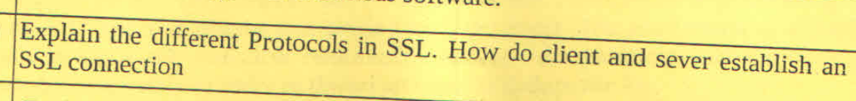

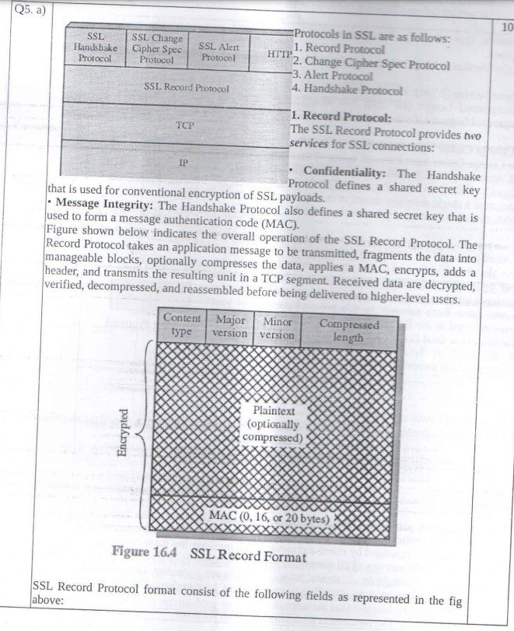

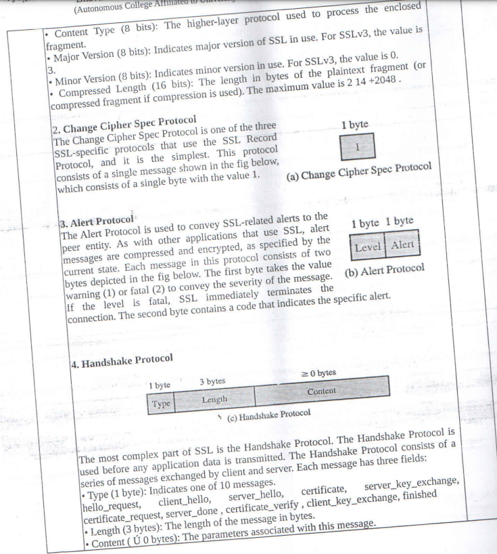

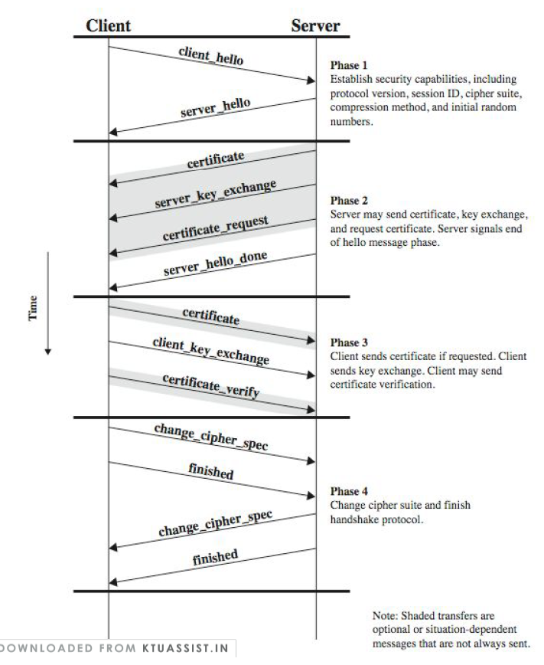

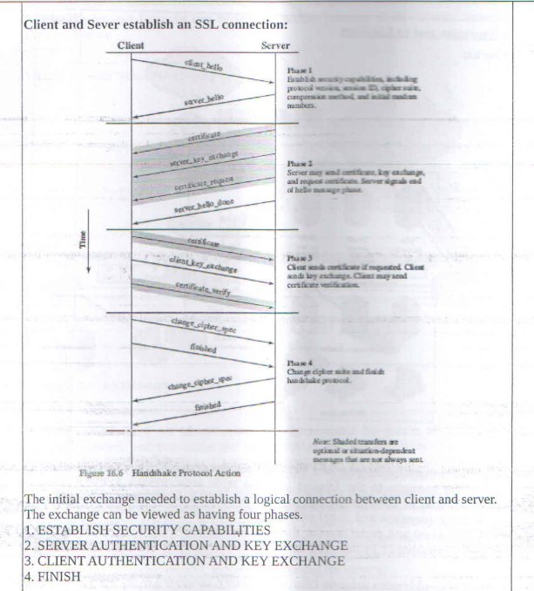

## Write short notes on any two of the following topics:

## Intrusion Detection:

## Multilevel Databases:

## Password Management:

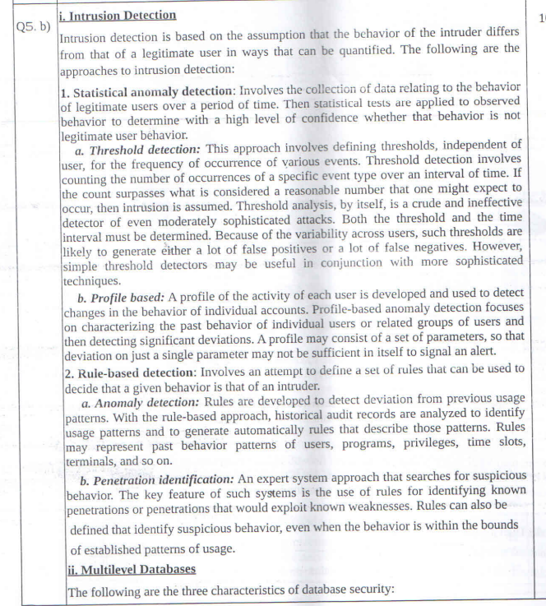

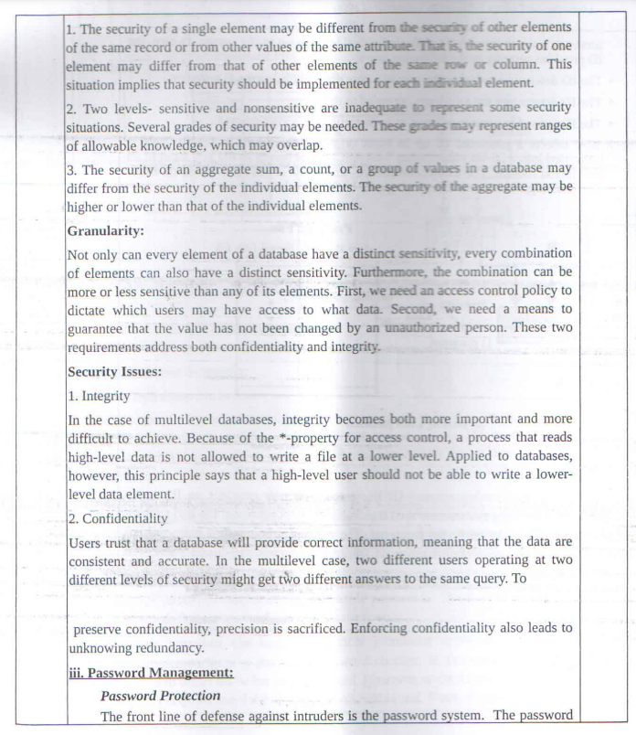

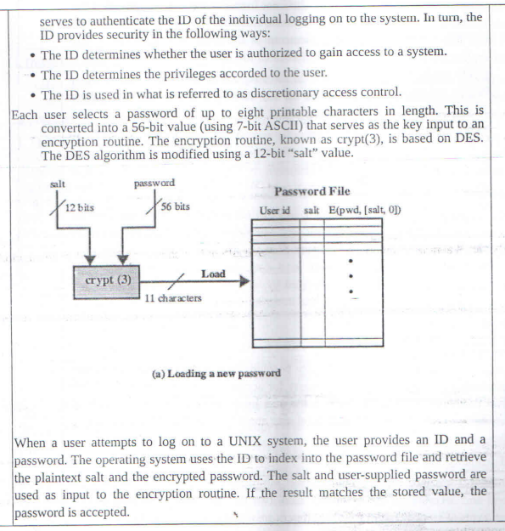

## Explain different DMZ and VPN firewall configuration and its location.

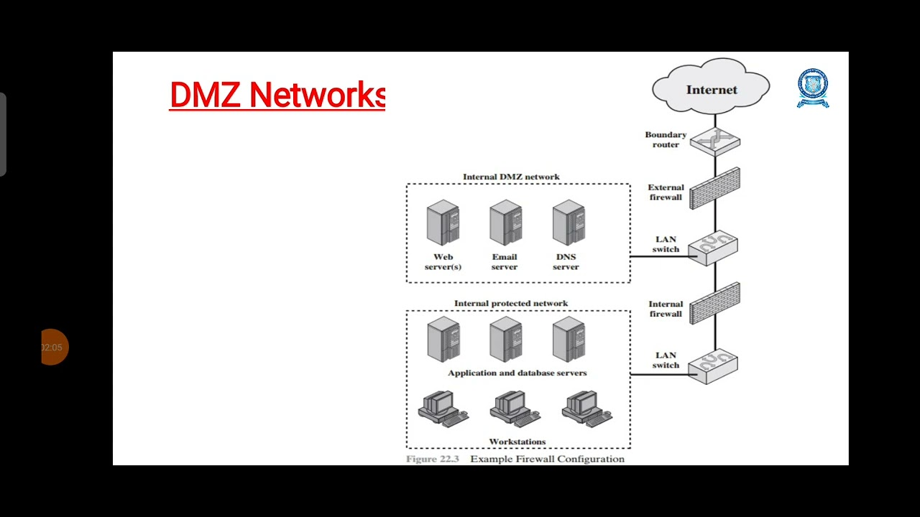

An external firewall is placed at the edge of a local or enterprise network, just inside the boundary router that connects to the Internet or some wide area network (WAN). Between these two types of firewalls are one or more networked devices in a region referred to as a DMZ (demilitarized zone) network. The external firewall provides a measure of access control and protection for the DMZ systems consistent with their need for external connectivity. In this type of configuration, internal firewalls serve three purposes:

1. The internal firewall adds more stringent filtering capability, compared to the external firewall, in order to protect enterprise servers and workstations from external attack.
2. The internal firewall provides two-way protection with respect to the DMZ. First, the internal firewall protects the remainder of the network from attacks launched from DMZ systems. Second, an internal firewall can protect the DMZ systems from attack from the internal protected network.
3. Multiple internal firewalls can be used to protect portions of the internal network from each other.

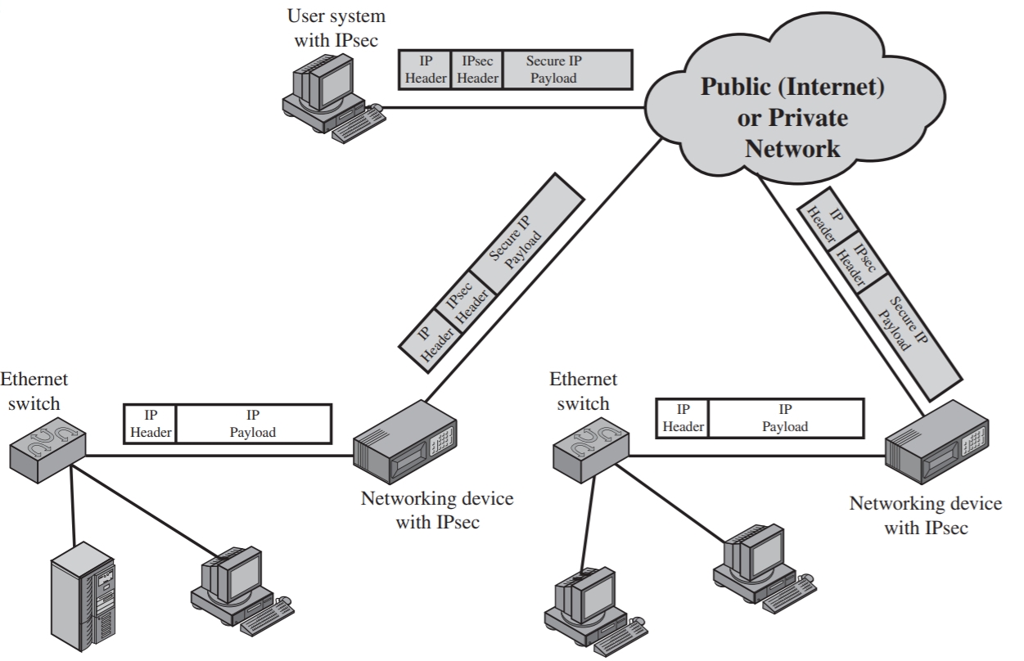

A VPN consists of a set of computers that interconnect by means of a relatively unsecure network and that make use of encryption and special protocols to provide security. A VPN uses encryption and authentication in the lower protocol layers to provide a secure connection through an otherwise insecure network, typically the Internet. The most common protocol mechanism used for this purpose is at the IP level and is known as IPsec. A logical means of implementing an IPsec is in a firewall, as shown in Figure 22.4. If IPsec is implemented in a separate box behind (internal to) the firewall, then VPN traffic passing through the firewall in both directions is encrypted. In this case, the firewall is unable to perform its filtering function or other security functions, such as access control, logging, or scanning for viruses.

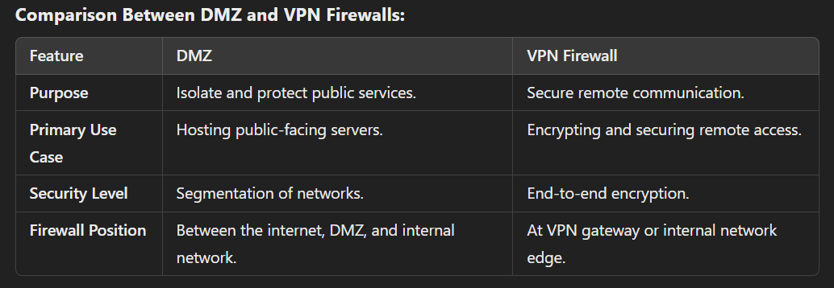

# ESE JULY 2019

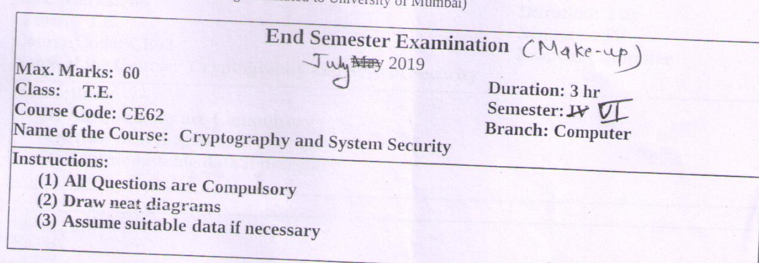

## Explain X.509 certificate format.

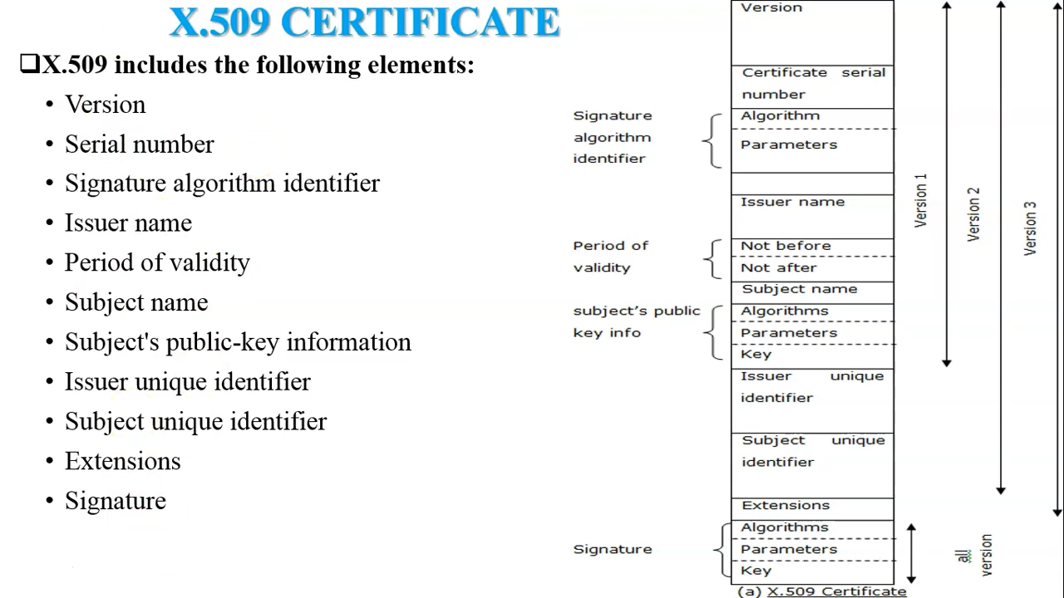

**1. Definition of X.509 Certificate**

* **X.509** is a standard format for public key certificates, which are used in cryptographic protocols like TLS/SSL to secure communication.
* It defines the structure of certificates, including the data they contain and how they are signed.

**2. Purpose of X.509 Certificates**

* **Authentication:** Verifies the identity of a website, user, or organization.
* **Encryption:** Facilitates secure communication by providing a public key.
* **Integrity:** Ensures that the certificate data has not been tampered with using a digital signature.

**3. Structure of X.509 Certificate**

X.509 certificates consist of the following components:

1. **Version:**
   * Specifies the version of the X.509 standard (commonly v1, v2, or v3).
   * **v3** is widely used as it supports extensions.
2. **Serial Number:**
   * A unique identifier assigned by the Certificate Authority (CA) to distinguish each certificate.
3. **Signature Algorithm:**
   * Identifies the algorithm used to create the digital signature (e.g., RSA, ECDSA).
   * Includes the hash function (e.g., SHA256).
4. **Issuer:**
   * Information about the Certificate Authority (CA) that issued the certificate (e.g., name, organization, country).
5. **Validity Period:**
   * **Not Before:** Start date and time when the certificate becomes valid.
   * **Not After:** Expiry date and time of the certificate.
6. **Subject:**
   * Information about the entity the certificate is issued to (e.g., name, organization, domain name).
7. **Subject Public Key Info:**
   * Contains the public key and information about the encryption algorithm.
8. **Extensions (Optional):**
   * Available only in X.509 v3.
   * Examples:
     + **Key Usage:** Specifies the purpose of the key (e.g., digital signature, key encryption).
     + **Subject Alternative Name (SAN):** Lists additional domain names or IP addresses.
     + **CRL Distribution Points:** Points to locations where Certificate Revocation Lists (CRLs) can be found.
9. **Certificate Signature:**
   * The digital signature created by the CA, verifying the certificate’s authenticity.

**4. Certificate File Formats**

X.509 certificates can be stored in various formats:

1. **PEM (Privacy Enhanced Mail):**
   * Base64-encoded format.
   * File extensions: .pem, .crt, .cer.
2. **DER (Distinguished Encoding Rules):**
   * Binary format.
   * File extensions: .der, .cer.
3. **PKCS12 (Public Key Cryptography Standard #12):**
   * Used for storing certificates and private keys together.
   * File extensions: .pfx, .p12.

**5. Working of X.509 Certificates**

1. **Certificate Issuance:**
   * The CA generates the certificate after verifying the applicant's identity.
2. **Certificate Validation:**
   * When a client connects to a server, it validates the server's certificate using:
     + The CA’s public key.
     + The certificate chain.
     + The certificate’s validity period and revocation status.
3. **Public Key Encryption:**
   * The certificate's public key is used to encrypt data or verify signatures.

**6. Advantages of X.509 Certificates**

* Standardized format ensures interoperability between systems.
* Enables secure and encrypted communication.
* Establishes trust in digital transactions.
* Supports multiple use cases with extensions (e.g., SAN, Key Usage).

**7. Use Cases of X.509 Certificates**

* **TLS/SSL:** Secures websites and encrypts web traffic.
* **Email Security:** Used in S/MIME for secure email communication.
* **Code Signing:** Verifies the authenticity of software and scripts.
* **IoT Devices:** Ensures secure communication between IoT devices.

**8. Diagram of an X.509 Certificate Structure (Optional for exams)**

Include a labeled diagram showing the structure of an X.509 certificate, highlighting the fields and their relationships.

## Explain symmetric cipher model

The symmetric cipher model is a fundamental concept in cryptography where the same key is used for both encryption and decryption of data. This model is characterized by its efficiency and speed, making it suitable for encrypting large amounts of data. Below is a detailed explanation of the symmetric cipher model, including its components, how it works, its advantages, disadvantages, and common algorithms.

**Components of the Symmetric Cipher Model**

1. **Plaintext:** This is the original, readable data that needs to be encrypted. It can be any form of data, such as text, images, or files.
2. **Ciphertext:** This is the encrypted output that results from applying the encryption algorithm to the plaintext using the symmetric key. Ciphertext appears random and is not understandable without decryption.
3. **Encryption Algorithm:** This is the mathematical function or procedure used to convert plaintext into ciphertext. It takes the plaintext and the symmetric key as inputs and produces ciphertext as output.
4. **Decryption Algorithm:** This is the reverse of the encryption algorithm. It takes ciphertext and the same symmetric key used for encryption to produce the original plaintext.
5. **Symmetric Key:** This is the secret key used for both encryption and decryption. It must be kept confidential, as anyone with access to the key can decrypt the data.

**How the Symmetric Cipher Model Works**

1. **Key Generation:** A symmetric key is generated. This key must be kept secret and shared between the parties involved in the communication.
2. **Encryption Process:**
   * The sender takes the plaintext and the symmetric key.
   * The sender applies the encryption algorithm to the plaintext using the symmetric key.
   * The output is the ciphertext, which is then transmitted to the recipient.
3. **Decryption Process:**
   * The recipient receives the ciphertext.
   * The recipient uses the same symmetric key to apply the decryption algorithm to the ciphertext.
   * The output is the original plaintext.

**Example of the Process**

* **Plaintext:** "HELLO"
* **Symmetric Key:** "KEY123"
* **Encryption Algorithm:** A symmetric cipher like AES (Advanced Encryption Standard)
* **Ciphertext:** After encryption, the plaintext "HELLO" might produce a ciphertext like "X1Y2Z3".

When the recipient receives "X1Y2Z3" and has the key "KEY123", they can decrypt it back to "HELLO".

**Advantages of Symmetric Ciphers**

1. **Speed and Efficiency:** Symmetric encryption algorithms are generally faster than asymmetric algorithms, making them suitable for encrypting large volumes of data.
2. **Simplicity:** The encryption and decryption processes are straightforward and require less computational power.
3. **Strong Security:** When using a strong key and a well-designed algorithm, symmetric ciphers can provide a high level of security.

**Disadvantages of Symmetric Ciphers**

1. **Key Distribution Problem:** The biggest challenge is securely distributing and managing the symmetric key. If the key is intercepted during transmission, an attacker can decrypt the data.
2. **Scalability Issues:** In a network with multiple users, each pair of users needs a unique key, leading to a large number of keys to manage.
3. **Key Compromise:** If a symmetric key is compromised, all data encrypted with that key is at risk. This necessitates frequent key changes and management.

**Common Symmetric Cipher Algorithms**

1. **Data Encryption Standard (DES):** An older symmetric encryption standard that uses a 56-bit key. It has been largely replaced due to vulnerabilities.
2. **Triple DES (3DES):** An enhancement of DES that applies the encryption algorithm three times to each data block, providing better security.
3. **Advanced Encryption Standard (AES):** A widely used symmetric cipher that supports key lengths of 128, 192, and 256 bits. It is considered secure and efficient.
4. **Blowfish:** A fast block cipher that uses variable-length keys (from 32 to 448 bits) and is suitable for applications where key size flexibility is needed.
5. **Twofish:** A successor to Blowfish that supports key sizes up to 256 bits and is also efficient in both hardware and software implementations.

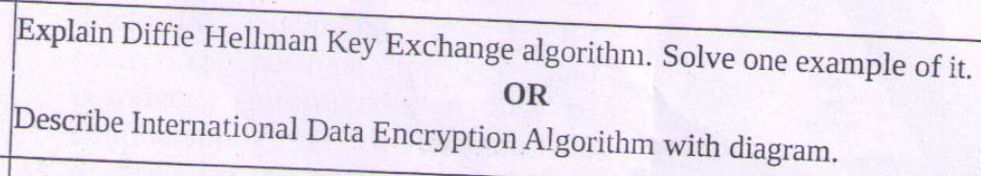

See notes

The Diffie-Hellman key exchange algorithm is a method used to securely exchange cryptographic keys over a public channel. It enables two parties to generate a shared secret key that can be used for symmetric encryption without the need to exchange the key itself. This algorithm is foundational in modern cryptography and is widely used in various secure communication protocols.

**Key Concepts**

1. **Public and Private Keys:** In the Diffie-Hellman method, each party generates a pair of keys: a public key, which can be shared openly, and a private key, which is kept secret.
2. **Modular Arithmetic:** The algorithm relies on the mathematical properties of modular arithmetic, specifically the difficulty of the discrete logarithm problem, which provides security against eavesdroppers.

**How the Diffie-Hellman Key Exchange Works**

The Diffie-Hellman key exchange involves the following steps:

**Step 1: Choose Parameters**

1. **Select a Large Prime Number (p):** Both parties agree on a large prime number ( p ).
2. **Select a Primitive Root (g):** Both parties also agree on a primitive root ( g ) modulo ( p ). This is often referred to as the generator.

**Step 2: Generate Private and Public Keys**

1. **Party A (Alice):**
   * Chooses a private key ( a ) (a random number such that ( 1 < a < p )).
   * Computes the public key ( A ) using the formula: [ A = g^a \mod p ]
   * Sends ( A ) to Party B (Bob).
2. **Party B (Bob):**
   * Chooses a private key ( b ) (a random number such that ( 1 < b < p )).
   * Computes the public key ( B ) using the formula: [ B = g^b \mod p ]
   * Sends ( B ) to Party A (Alice).

**Step 3: Compute the Shared Secret**

1. **Alice Receives Bob's Public Key:**
   * Alice computes the shared secret ( S ) using Bob's public key ( B ): [ S = B^a \mod p ]
2. **Bob Receives Alice's Public Key:**
   * Bob computes the shared secret ( S ) using Alice's public key ( A ): [ S = A^b \mod p ]

At this point, both Alice and Bob have computed the same shared secret ( S ), which can now be used as a symmetric key for further encrypted communication.

**Security of the Diffie-Hellman Key Exchange**

The security of the Diffie-Hellman key exchange relies on the following:

1. **Discrete Logarithm Problem:** While it is easy (computationally feasible) to compute ( A = g^a \mod p ) given ( g ), ( a ), and ( p ), it is computationally hard to reverse this operation and find ( a ) given ( A ), ( g ), and ( p ). This is known as the discrete logarithm problem.
2. **Eavesdropping Resistance:** Even if an attacker intercepts the public keys ( A ) and ( B ), they cannot easily derive the shared secret ( S ) without knowing the private keys ( a ) or ( b ).

## Explain how message digest is generated in SHA – 512

See notes

## Explain different types of firewalls with diagram

**1. Packet-Filtering Routers**

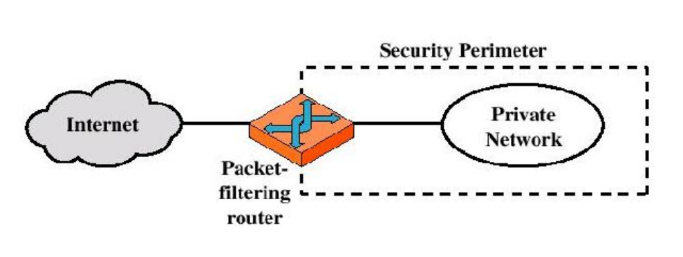

**Description:** Packet-filtering routers, also known as stateless firewalls, operate at the network layer (Layer 3) of the OSI model. They inspect packets of data as they pass through the router and make decisions based on predefined rules.

**How They Work:**

* **Rule-Based Filtering:** Packet-filtering routers evaluate each packet against a set of rules defined by the network administrator. These rules can specify criteria such as source IP address, destination IP address, source port, destination port, and the protocol (e.g., TCP, UDP, ICMP).
* **Allow or Deny:** Based on the evaluation, the router will either allow the packet to pass through or block it. If a packet matches a rule that allows it, it is forwarded; if it matches a rule that denies it, it is dropped.
* **Stateless Nature:** Since packet-filtering routers do not maintain any state information about active connections, they do not track the state of network connections. Each packet is treated independently.

**Advantages:**

* Simple and fast, as they operate at a lower level in the network stack.
* Low resource consumption compared to more complex firewalls.

**Disadvantages:**

* Limited security features; they cannot inspect the payload of packets or determine the context of a connection.
* Vulnerable to certain types of attacks, such as IP spoofing.

**2. Application-Level Gateways**

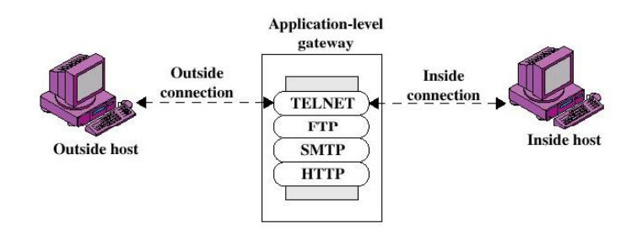

**Description:** Application-level gateways, also known as proxy firewalls, operate at the application layer (Layer 7) of the OSI model. They act as intermediaries between clients and servers, inspecting and filtering traffic based on application-specific protocols.

**How They Work:**

* **Proxy Functionality:** When a client requests access to a service (e.g., a web page), the application-level gateway intercepts the request and forwards it to the destination server on behalf of the client. The server's response is sent back to the gateway, which then forwards it to the client.
* **Deep Packet Inspection:** These firewalls can inspect the entire packet, including the application layer data (such as HTTP headers). This allows them to enforce security policies based on the content of the communication.
* **User Authentication:** Application-level gateways can also implement user authentication and access control measures.

**Advantages:**

* Enhanced security due to deep packet inspection and the ability to filter based on application-level criteria.
* Protection against application-layer attacks, such as SQL injection and cross-site scripting (XSS).

**Disadvantages:**

* Can introduce latency due to the additional processing required for each connection.
* More resource-intensive than packet-filtering routers.

**3. Circuit-Level Gateways**

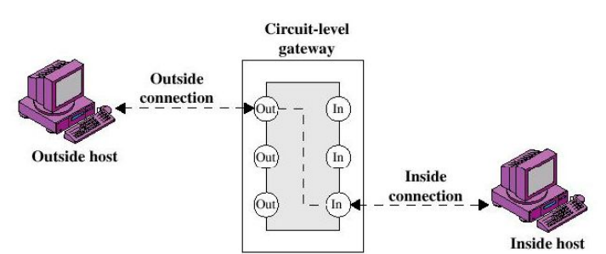

**Description:** Circuit-level gateways operate at the transport layer (Layer 4) of the OSI model. They monitor and control the establishment of connections between clients and servers, typically focusing on TCP connections.

**How They Work:**

* **Connection Monitoring:** Circuit-level gateways do not filter packets individually but instead monitor the TCP handshake process (SYN, SYN-ACK, ACK) to establish a connection. Once a connection is established, they allow traffic to flow freely between the two endpoints for the duration of the session.
* **Stateful Inspection:** Unlike packet-filtering routers, circuit-level gateways maintain state information about active connections, enabling them to enforce security policies based on the state of the connection.

**Advantages:**

* More efficient than packet-filtering routers for managing stateful connections, as they do not need to inspect every packet.
* Can provide a level of security by ensuring that only established connections are allowed.

**Disadvantages:**

* Limited visibility into the actual content of the communication, as they do not perform deep packet inspection.
* Vulnerable to certain types of attacks that exploit established connections.

## Write short notes on any two of the following topics:

## SSL Protocol Stack:

## PGP:

## SQL Injection:

**SSL Protocol Stack**

**Overview:** The SSL (Secure Sockets Layer) protocol stack, now largely succeeded by TLS (Transport Layer Security), is a set of protocols designed to provide secure communication over a computer network. It ensures privacy, authentication, and data integrity between clients and servers.

**Components:**

1. **SSL Handshake Protocol:** This is the initial phase where the client and server establish parameters for the secure session. It involves negotiating cryptographic algorithms, exchanging keys, and authenticating the server (and optionally the client).
2. **SSL Record Protocol:** This protocol is responsible for encapsulating higher-level protocols (like HTTP) into a secure channel. It handles fragmentation, compression, and encryption of data.
3. **SSL Alert Protocol:** This is used to convey alerts about the status of the connection, such as warnings or errors. Alerts can indicate issues like a bad certificate or an expired session.

**Key Features:**

* **Encryption:** SSL uses symmetric encryption to ensure that data transmitted between client and server remains confidential.
* **Authentication:** SSL provides mechanisms to authenticate the server (and optionally the client) using digital certificates, ensuring that the parties involved are who they claim to be.
* **Data Integrity:** SSL ensures that data has not been altered during transmission through the use of message authentication codes (MACs).

**PGP (Pretty Good Privacy)**

**Overview:** PGP (Pretty Good Privacy) is a data encryption and decryption program that provides cryptographic privacy and authentication for data communication. It was created by Phil Zimmermann in 1991 and is widely used for securing emails, files, and other forms of data transmission. PGP uses a combination of symmetric-key cryptography and public-key cryptography to secure data.

**Key Features of PGP**

1. **Encryption:**
   * PGP encrypts the data using a symmetric key, which means the same key is used for both encryption and decryption. This symmetric key is generated randomly for each session and is called a session key.
   * The session key itself is then encrypted with the recipient's public key using asymmetric encryption, ensuring that only the intended recipient can decrypt it with their private key.
2. **Digital Signatures:**
   * PGP allows users to sign their messages digitally. This involves creating a hash of the message and encrypting it with the sender's private key. The recipient can then verify the signature by decrypting it with the sender's public key and comparing it to a hash of the received message.
   * Digital signatures provide authenticity and non-repudiation, ensuring that the sender cannot deny having sent the message.
3. **Key Management:**
   * PGP uses a decentralized approach to key management. Users generate their own key pairs (public and private keys) and can share their public keys with others.
   * Users can also create a "web of trust" by signing each other's public keys, enhancing the trustworthiness of the keys.

**How PGP Works**

1. **Key Generation:**
   * Users generate a pair of keys: a public key (which can be shared with anyone) and a private key (which is kept secret).
2. **Encryption Process:**
   * The sender creates a session key for the symmetric encryption of the message.
   * The message is encrypted using the session key.
   * The session key is then encrypted with the recipient's public key.
   * The encrypted message and the encrypted session key are sent to the recipient.
3. **Decryption Process:**
   * The recipient receives the encrypted message and the encrypted session key.
   * The recipient uses their private key to decrypt the session key.
   * The decrypted session key is then used to decrypt the message.
4. **Signing Process:**
   * To sign a message, the sender creates a hash of the message and encrypts it with their private key.
   * The encrypted hash (signature) is sent along with the message.
5. **Verification Process:**
   * The recipient can decrypt the signature using the sender's public key and compare it with the hash of the received message to verify authenticity.

**Advantages of PGP**

* **Strong Security:** PGP uses strong encryption algorithms, making it difficult for unauthorized users to access the data.
* **Flexibility:** It can be used for various types of data, including emails, files, and disk encryption.
* **Decentralized Trust Model:** The web of trust allows users to verify each other's keys without relying on a central authority.

**Disadvantages of PGP**

* **Complexity:** PGP can be complex for non-technical users, especially when it comes to key management.
* **Key Distribution:** Users must find a secure way to exchange public keys, which can be challenging.
* **Potential for Misuse:** If users do not properly manage their private keys, it can lead to security breaches.

**Applications of PGP**

* **Email Encryption:** PGP is commonly used to encrypt email communications to protect sensitive information.
* **File Encryption:** It can be used to encrypt files before sharing them over the internet.
* **Secure Communication:** PGP is used in various applications that require secure messaging and data protection.

**SQL Injection**

**Overview:** SQL Injection (SQLi) is a type of security vulnerability that occurs when an attacker is able to manipulate a web application's database query by injecting malicious SQL code. This can lead to unauthorized access to sensitive data, data manipulation, and in some cases, complete control over the database server.

**How It Works:**

* **Exploitation:** Attackers typically exploit input fields in web applications (such as login forms, search boxes, or URL parameters) that do not properly sanitize user input. By injecting malicious SQL statements, they can alter the intended query.
* **Common Techniques:** Examples include adding a tautology to a WHERE clause (e.g., **OR '1'='1'**) to bypass authentication or using UNION statements to retrieve data from other tables.

**Consequences:**

* **Data Breach:** Attackers can gain access to sensitive information, including usernames, passwords, and personal data.
* **Data Manipulation:** SQL injection can allow attackers to modify, delete, or insert data into the database.
* **Denial of Service:** In some cases, SQL injection can be used to disrupt the availability of the database or application.

**Prevention:**

* **Parameterized Queries:** Using prepared statements or parameterized queries can prevent SQL injection by ensuring that user input is treated as data rather than executable code.
* **Input Validation:** Properly validating and sanitizing user input can help mitigate the risk of SQL injection.
* **Web Application Firewalls (WAFs):** Implementing WAFs can help detect and block SQL injection attempts before they reach the application.

Both SSL and SQL Injection are critical topics in the realm of cybersecurity, with SSL focusing on securing data in transit, while SQL Injection highlights the importance of secure coding practices to protect databases from unauthorized access.

# ESE MAY 2019



<https://www.javatpoint.com/active-attack-vs-passive-attack>

<https://www.geeksforgeeks.org/active-and-passive-attacks-in-information-security/>

## State the difference between block and stream cipher

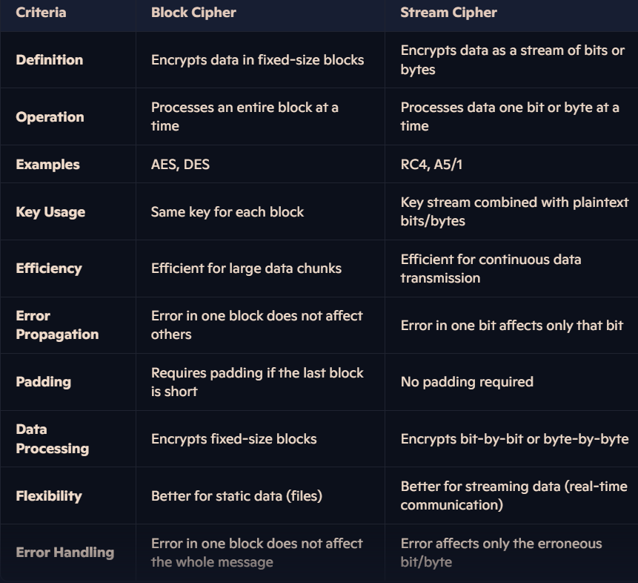

## RSA Algorithm: Key Generation, Encryption, and Decryption

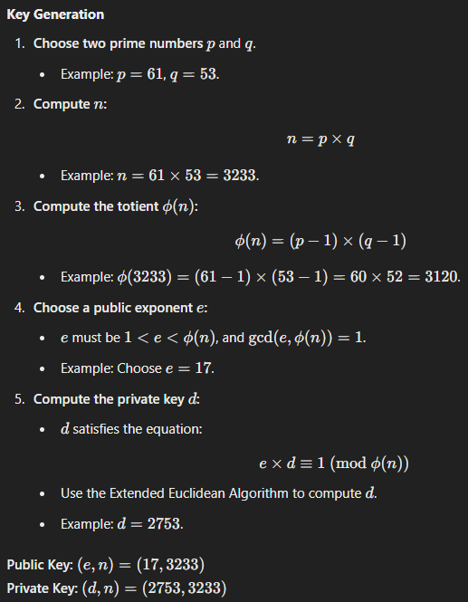

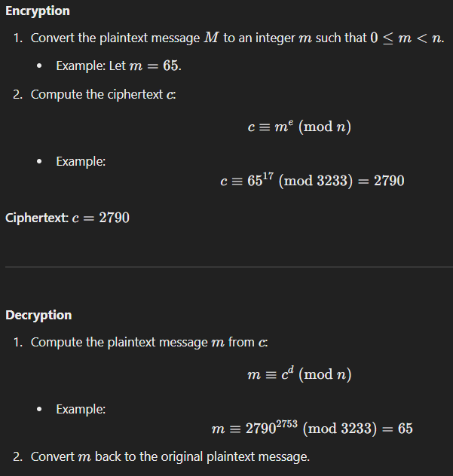

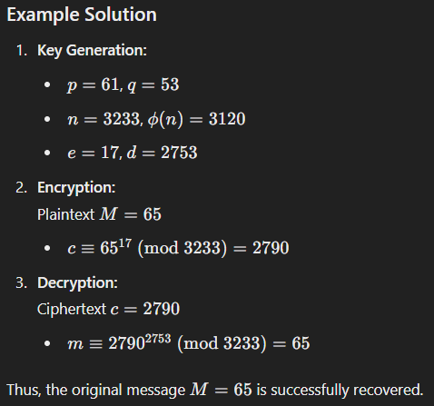

## Explanation of Encapsulating Security Payload (ESP) Packet Format with Diagram

Encapsulating Security Payload (ESP) is a protocol within the IPsec suite used to provide confidentiality, integrity, and authentication to network communications. Below is a detailed explanation of the ESP packet format, presented in a point-wise format.

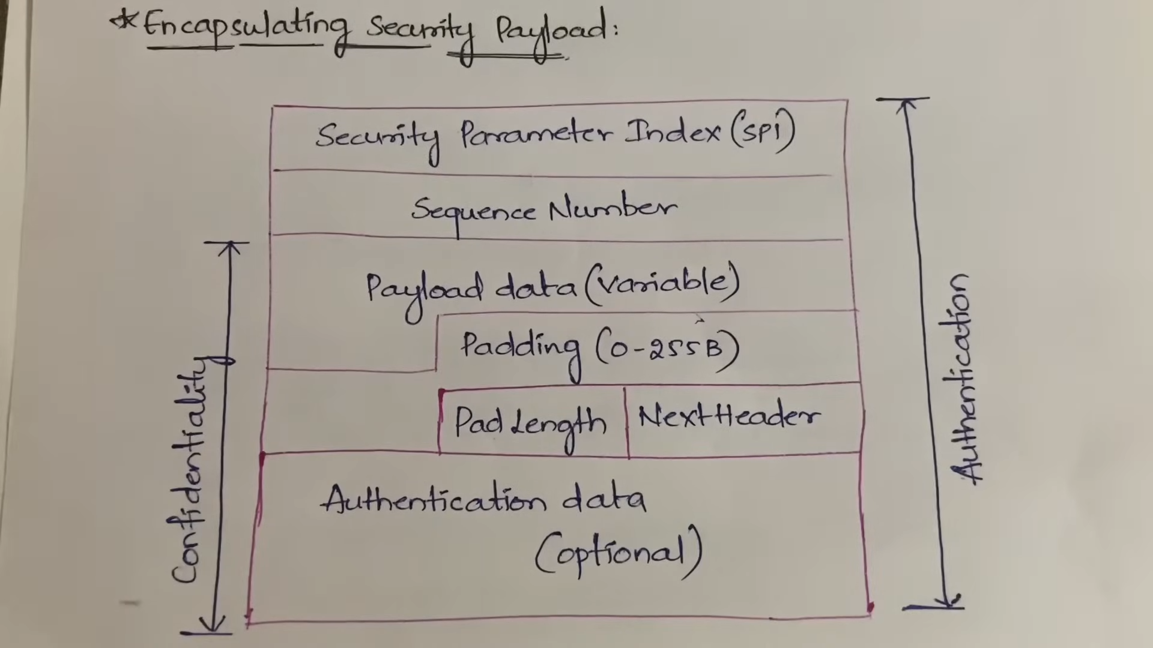

**Key Features of ESP**

1. **Confidentiality:** Encrypts the payload data to protect it from unauthorized access.
2. **Authentication:** Ensures data integrity and authenticity.
3. **Optional Encryption:** Supports scenarios where encryption might not be required (only authentication).
4. **Tunnel and Transport Modes:** Operates in two modes:
   * **Transport mode:** Encrypts only the payload.
   * **Tunnel mode:** Encrypts the entire IP packet.

**ESP Packet Format**

1. **Security Parameters Index (SPI):**
   * 32-bit field used to identify a specific security association (SA).
   * Helps in determining the encryption and authentication mechanisms.
2. **Sequence Number:**
   * 32-bit field used to prevent replay attacks.
   * Unique for each packet within the SA.
3. **Payload Data:**
   * Contains the actual data being transferred.
   * Encrypted for confidentiality.
4. **Padding:**
   * Used to align the payload data to a specific block size required by encryption algorithms.
   * Includes a "Padding Length" field indicating the number of padding bytes.
5. **Next Header:**
   * 8-bit field indicating the protocol of the encapsulated payload (e.g., TCP, UDP).
6. **Integrity Check Value (ICV):**
   * Optional field used for data integrity and authentication.
   * Generated by the authentication algorithm.

**Modes of Operation**

1. **Transport Mode:**
   * Only the payload is encrypted/authenticated.
   * Used in end-to-end communication.
2. **Tunnel Mode:**
   * Encrypts the entire original IP packet (header + payload).
   * Often used in VPNs for secure communication between gateways.

**Applications of ESP**

* Secure communication in Virtual Private Networks (VPNs).
* Protection of sensitive data over untrusted networks.
* Used in combination with Authentication Header (AH) for enhanced security.

## Explanation of the Generic Model of the Digital Signature Process

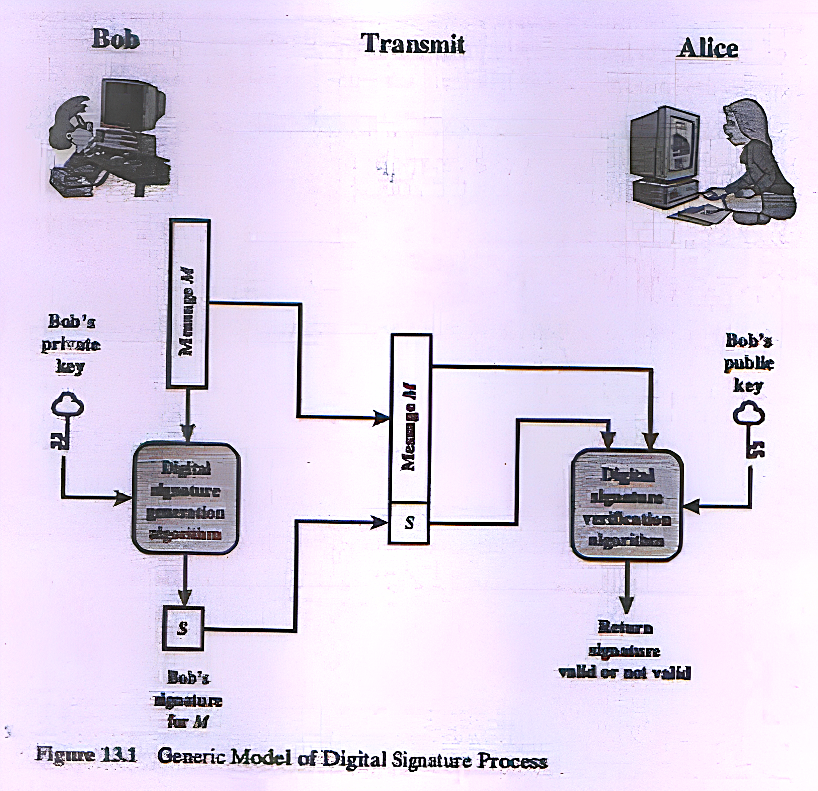

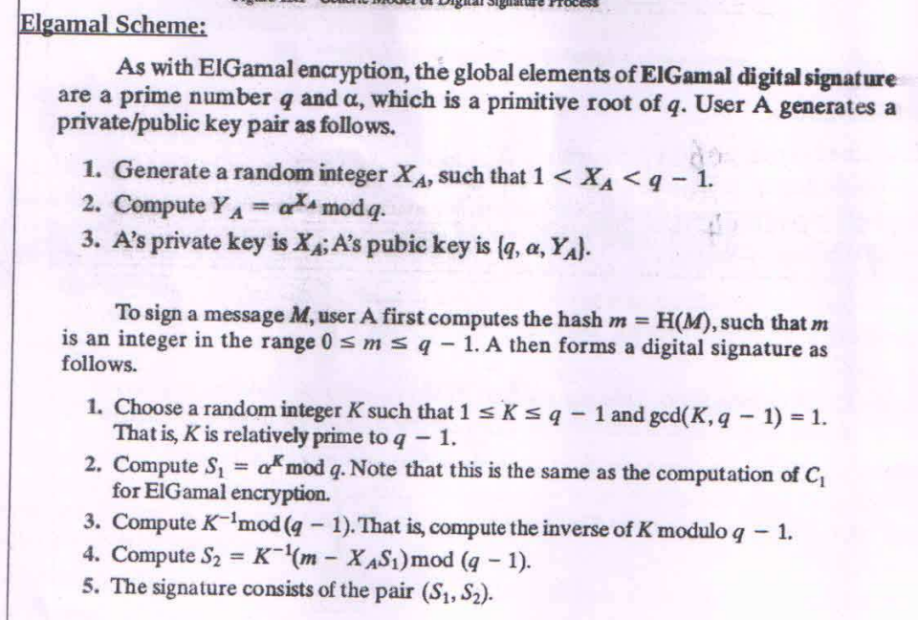

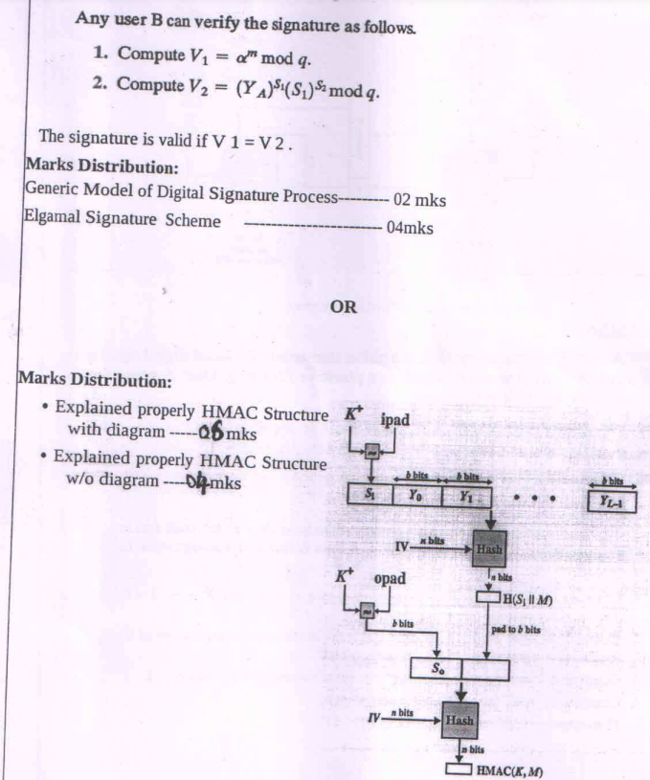

The digital signature process is a cryptographic technique used to verify the authenticity, integrity, and origin of a digital message or document. Below is a detailed explanation of the generic model of the digital signature process in point-wise format.

**Definition of Digital Signature**

A digital signature is a cryptographic value derived using a private key and a cryptographic hash function. It acts as a virtual fingerprint, uniquely identifying the sender and verifying the message's integrity.

**Steps in the Digital Signature Process**

**1. Key Generation**

* A **key pair** is generated using cryptographic algorithms (e.g., RSA, DSA, or ECC):
  + **Private Key:** Kept secret and used for signing.
  + **Public Key:** Shared openly and used for verification.

**2. Hash Generation**

* The original message is passed through a **hash function** (e.g., SHA-256, SHA-3).
* The hash function produces a **fixed-length hash value** (message digest) that represents the message content uniquely.

**3. Signing the Hash**

* The hash value is encrypted using the sender's **private key**.
* The result is the **digital signature**.
* The digital signature is appended to the original message and sent to the recipient.

**4. Transmission**

* The sender transmits the signed message (original message + digital signature) to the recipient.

**5. Verification**

* The recipient performs the following steps:
  1. **Hash the Received Message:**
     + The recipient computes a hash value from the received message using the same hash function.
  2. **Decrypt the Signature:**
     + The recipient decrypts the digital signature using the sender's **public key**, retrieving the original hash.
  3. **Compare Hashes:**
     + The two hash values (computed and decrypted) are compared:
       - If they match, the signature is valid, and the message is verified.
       - If they do not match, the message or signature may have been tampered with.

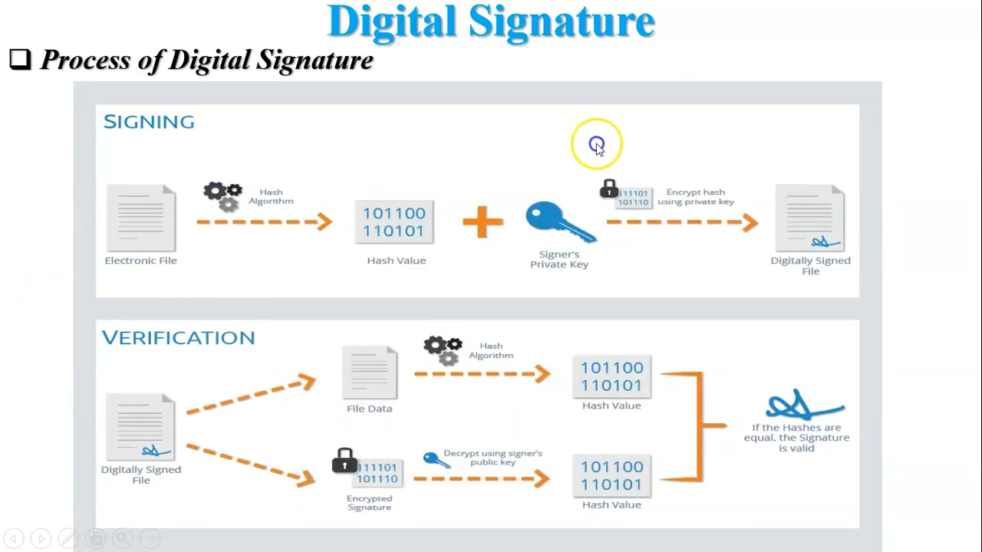

**Features of Digital Signatures**

1. **Authenticity:** Confirms the identity of the sender.
2. **Integrity:** Ensures that the message has not been altered during transmission.
3. **Non-repudiation:** Prevents the sender from denying their action of signing the message.
4. **Confidentiality (Optional):** Can be combined with encryption for additional security.

**Applications of Digital Signatures**

1. **Email Authentication:** To verify the sender's identity.
2. **Digital Certificates:** Used in SSL/TLS for secure web communications.
3. **Legal Documents:** E-signatures for legal contracts.
4. **Software Distribution:** Verifying the authenticity of software updates.

## Explain Kerberos version-4 with message exchanges

See notes

**1. Electronic Payment**

Electronic payment systems are digital methods to transfer funds or make purchases without using physical cash. These systems are secure, convenient, and widely used in e-commerce and online transactions.

**Key Features:**

1. **Types of Electronic Payments:**
   * **Credit/Debit Cards:** Widely used for both online and offline transactions.
   * **Mobile Wallets (e.g., PayPal, Google Pay):** Store payment credentials for fast transactions.
   * **Net Banking:** Direct online payment using a bank account.
   * **Cryptocurrencies:** Decentralized payment systems using blockchain technology.
   * **UPI (Unified Payment Interface):** Facilitates real-time inter-bank transfers.
2. **Advantages:**
   * **Convenience:** Easy to use and accessible 24/7.
   * **Speed:** Transactions are processed almost instantly.
   * **Security:** Advanced encryption ensures the safety of sensitive data.
   * **Record Keeping:** Provides an electronic trail for tracking transactions.
3. **Disadvantages:**
   * **Fraud Risk:** Vulnerable to phishing and hacking.
   * **Technical Issues:** Requires a stable internet connection.
   * **Privacy Concerns:** Users' financial data might be exposed if not properly secured.
4. **Examples of Usage:**
   * E-commerce websites like Amazon and Flipkart.
   * Online services like Netflix or Spotify subscriptions.
   * Utility bill payments and ticket bookings.

**2. Session Hijacking**

Session hijacking refers to an attack where a hacker takes control of a user's active session by stealing or manipulating the session token.

**Key Concepts:**

1. **How It Works:**
   * A user logs into a web application, and the server assigns a **session ID** for authentication.
   * Attackers intercept the session ID through various means (e.g., network sniffing, cross-site scripting).
   * The attacker uses the stolen session ID to impersonate the user.
2. **Methods of Session Hijacking:**
   * **Session Sniffing:** Monitoring network traffic to capture session tokens.
   * **Cross-Site Scripting (XSS):** Injecting malicious scripts to steal session cookies.
   * **Man-in-the-Middle Attack:** Intercepting communication between the user and the server.
   * **Session Fixation:** Forcing a user to use a predetermined session ID.
3. **Impact of Session Hijacking:**
   * Unauthorized access to sensitive information (e.g., bank accounts, emails).
   * Data breaches and financial losses.
   * Potential misuse of the victim’s identity.
4. **Prevention Techniques:**
   * Use **HTTPS** for secure communication.
   * Implement **session timeout** and re-authentication mechanisms.
   * Use secure, random session IDs.
   * Enable **multi-factor authentication (MFA)**.
   * Regularly update software to patch vulnerabilities.

**3. Format String Attacks**

A format string attack occurs when an application uses unvalidated user input as a format string parameter in functions like printf() in C/C++.

**Key Concepts:**

1. **How It Works:**
   * If user input directly affects the format string, attackers can manipulate the application’s memory.
   * Malicious strings like %x (hexadecimal value) or %s (string value) can leak sensitive data.
2. **Impacts of Format String Attacks:**
   * **Data Leakage:** Exposes sensitive memory content.
   * **Code Execution:** Allows the attacker to execute arbitrary code.
   * **Application Crash:** Causes denial of service (DoS).
3. **Examples of Vulnerability:**

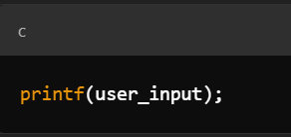

If user_input is %x %x %x, it will print random memory addresses, leaking sensitive data.

1. **Prevention Techniques:**

* Always **validate and sanitize user inputs**.
* Use format strings explicitly (e.g., printf("%s", user_input)).
* Avoid unsafe functions prone to such attacks.

# MAKE-UP JAN 2019

## What are block ciphers? Explain CBC and ECB with diagram

**What are Block Ciphers?**

1. **Definition**:  
   Block ciphers are cryptographic algorithms that encrypt plaintext data in fixed-size blocks (e.g., 64-bit or 128-bit) using a symmetric key. If the plaintext length is shorter than the block size, padding is added.
2. **Operation**:
   * Each block of plaintext is processed independently or in combination with other blocks, depending on the mode of operation.
   * A block cipher consists of two main processes: encryption and decryption.
3. **Characteristics**:
   * Requires a fixed-size key for encryption and decryption.
   * Provides confidentiality and data integrity.
   * Common examples include AES (Advanced Encryption Standard) and DES (Data Encryption Standard).
4. **Applications**:
   * Secure communication, file encryption, and digital signatures.

**Modes of Operation**

Block ciphers work in different modes to manage plaintext longer than the block size. Two important modes are **ECB (Electronic Codebook)** and **CBC (Cipher Block Chaining)**.

**1. ECB Mode (Electronic Codebook)**

**Description**:

* Each block of plaintext is encrypted independently using the same key.
* No relationship exists between blocks.

**Process**:

* Plaintext is divided into blocks.
* Each block is encrypted with the same key.

**Advantages**:

1. Simple implementation.
2. Allows parallel processing of blocks.

**Disadvantages**:

1. Does not provide data confidentiality for repeated plaintext patterns (e.g., identical plaintext blocks produce identical ciphertext blocks).
2. Susceptible to cryptographic attacks due to lack of randomness.

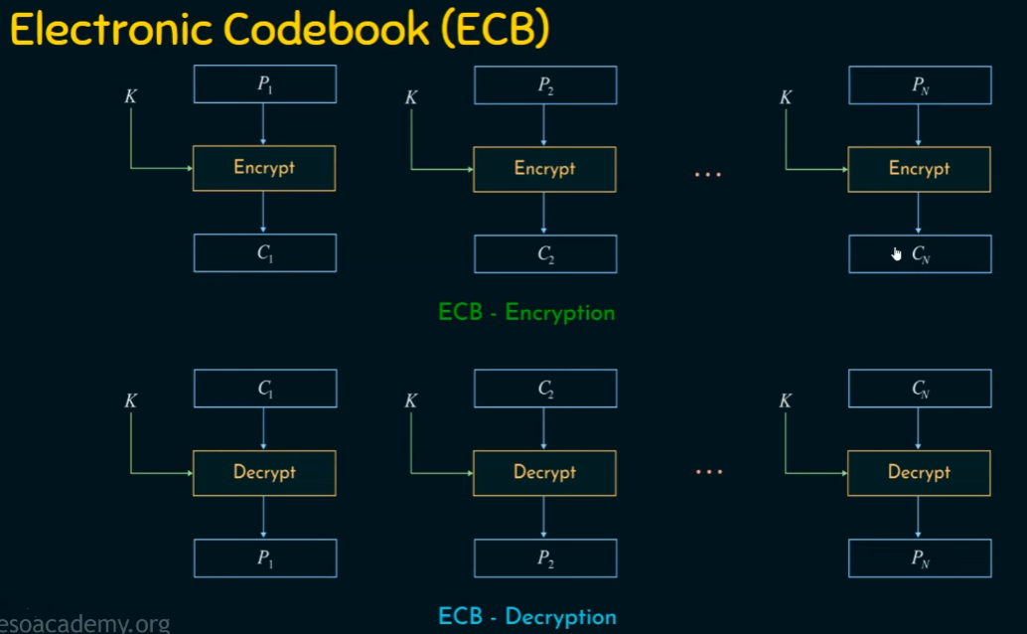

**2. CBC Mode (Cipher Block Chaining)**

**Description**:

* Each plaintext block is XORed with the previous ciphertext block before encryption.
* Requires an Initialization Vector (IV) for the first block to ensure randomness.

**Process**:

1. The first plaintext block is XORed with the IV and then encrypted.
2. Each subsequent plaintext block is XORed with the ciphertext of the previous block before encryption.

**Advantages**:

1. Provides confidentiality by ensuring identical plaintext blocks result in different ciphertext blocks.
2. Effective against pattern detection.

**Disadvantages**:

1. Slower than ECB due to dependency between blocks (sequential processing).
2. Requires IV to be shared securely.

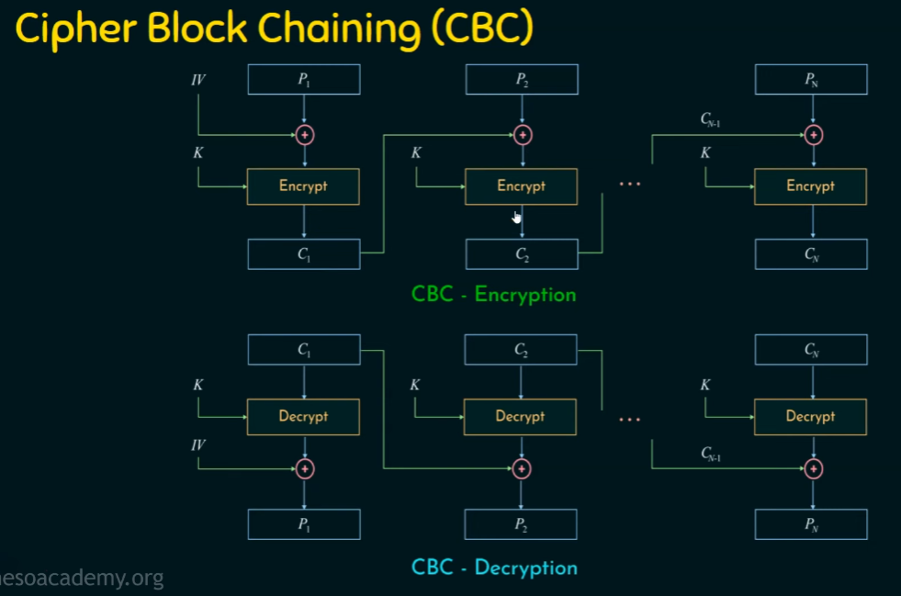

## What are security attacks explain them

Security attacks refer to any attempt to compromise the confidentiality, integrity, or availability of information or information systems. These attacks can target individuals, organizations, or governments, and they can take many forms. Below are some common types of security attacks, along with explanations of each.

**Types of Security Attacks**

1. **Malware Attacks:**
   * **Definition:** Malicious software designed to harm, exploit, or otherwise compromise a computer system or network.
   * **Types:**
     + **Viruses:** Self-replicating programs that attach themselves to legitimate files.
     + **Worms:** Standalone malware that replicates itself to spread to other computers.
     + **Trojan Horses:** Malware disguised as legitimate software that can create backdoors for attackers.
     + **Ransomware:** Malware that encrypts files and demands payment for decryption.
2. **Phishing:**
   * **Definition:** A social engineering attack where attackers impersonate a trustworthy entity to trick individuals into revealing sensitive information, such as passwords or credit card numbers.
   * **Method:** Often conducted through email or fake websites that mimic legitimate ones.
3. **Denial of Service (DoS) and Distributed Denial of Service (DDoS):**
   * **Definition:** Attacks aimed at making a service unavailable by overwhelming it with traffic.
   * **DoS:** A single source floods the target with requests.
   * **DDoS:** Multiple compromised systems (often part of a botnet) flood the target, making it difficult to mitigate.
4. **Man-in-the-Middle (MitM) Attacks:**
   * **Definition:** An attack where the attacker secretly intercepts and relays messages between two parties who believe they are communicating directly with each other.
   * **Method:** Can occur over unsecured networks or through compromised routers.
5. **SQL Injection:**
   * **Definition:** A code injection technique where an attacker inserts malicious SQL statements into a database query.
   * **Impact:** Can allow attackers to view, modify, or delete data in a database.
6. **Cross-Site Scripting (XSS):**
   * **Definition:** A vulnerability that allows attackers to inject malicious scripts into web pages viewed by other users.
   * **Impact:** Can be used to steal session cookies, redirect users, or perform actions on behalf of users.
7. **Credential Stuffing:**
   * **Definition:** An attack where attackers use stolen username and password pairs from one breach to gain unauthorized access to accounts on other services.
   * **Method:** Exploits the tendency of users to reuse passwords across multiple sites.
8. **Brute Force Attacks:**
   * **Definition:** An attack method that involves systematically trying all possible combinations of passwords until the correct one is found.
   * **Method:** Often automated using scripts or tools to speed up the process.
9. **Insider Threats:**
   * **Definition:** Security risks that originate from within the organization, often involving employees or contractors who misuse their access to systems and data.
   * **Impact:** Can lead to data breaches, fraud, or sabotage.
10. **Zero-Day Exploits:**
    * **Definition:** Attacks that occur on the same day a vulnerability is discovered and before a patch or fix is available.
    * **Impact:** Can be particularly dangerous because there is no defense against them until a patch is released.

## Illustrate blowfish algorithm with diagram.

**Blowfish Algorithm Overview**

Blowfish is a symmetric-key block cipher designed by Bruce Schneier in 1993. It is known for its speed and effectiveness in both software and hardware implementations. Blowfish operates on 64-bit blocks of data and supports key sizes ranging from 32 bits to 448 bits. It uses a Feistel network structure, which involves multiple rounds of processing to encrypt and decrypt data.

**Key Features of Blowfish**

* **Block Size**: 64 bits
* **Key Size**: Variable (32 to 448 bits)
* **Rounds**: 16 rounds of processing
* **Feistel Structure**: Uses a combination of substitution and permutation operations.

**Blowfish Algorithm Steps**

1. **Key Expansion**: The original key is expanded into several subkeys, which are used in the encryption and decryption processes.
2. **Data Encryption**: The plaintext data is divided into 64-bit blocks and processed through 16 rounds of the Feistel function.
3. **Data Decryption**: The ciphertext is decrypted using the same subkeys in reverse order.

**Blowfish Encryption Process**

1. **Key Expansion**:
   * The key is used to generate 18 subkeys (P-array) and four S-boxes (each containing 256 entries).
   * The key is XORed with the P-array to initialize it.
2. **Feistel Function**:
   * Each round consists of a Feistel function that takes half of the block and the subkey for that round.
   * The Feistel function involves:
     + **S-boxes**: Non-linear substitution operations.
     + **XOR**: Combining the output of the S-boxes with the other half of the data block.
     + **Permutation**: Rearranging bits in a specific order.
3. **Rounds**:
   * The data block is split into two halves (L and R).
   * For each of the 16 rounds, the following is performed:
     + ( L_i = R_{i-1} )
     + ( R_i = L_{i-1} XOR F(R_{i-1}, K_i) )
   * After 16 rounds, the two halves are swapped and combined to produce the final ciphertext.

**Blowfish Decryption Process**

The decryption process is similar to encryption but uses the subkeys in reverse order. The same Feistel structure is applied, ensuring that the original plaintext can be retrieved from the ciphertext.

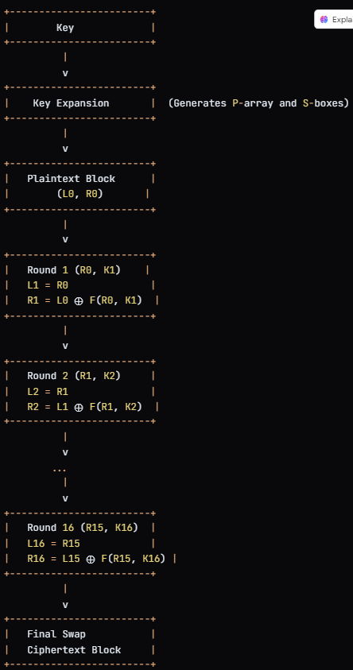

## Describe PKIX Architectural Model and Management Functions and Protocols

See notes

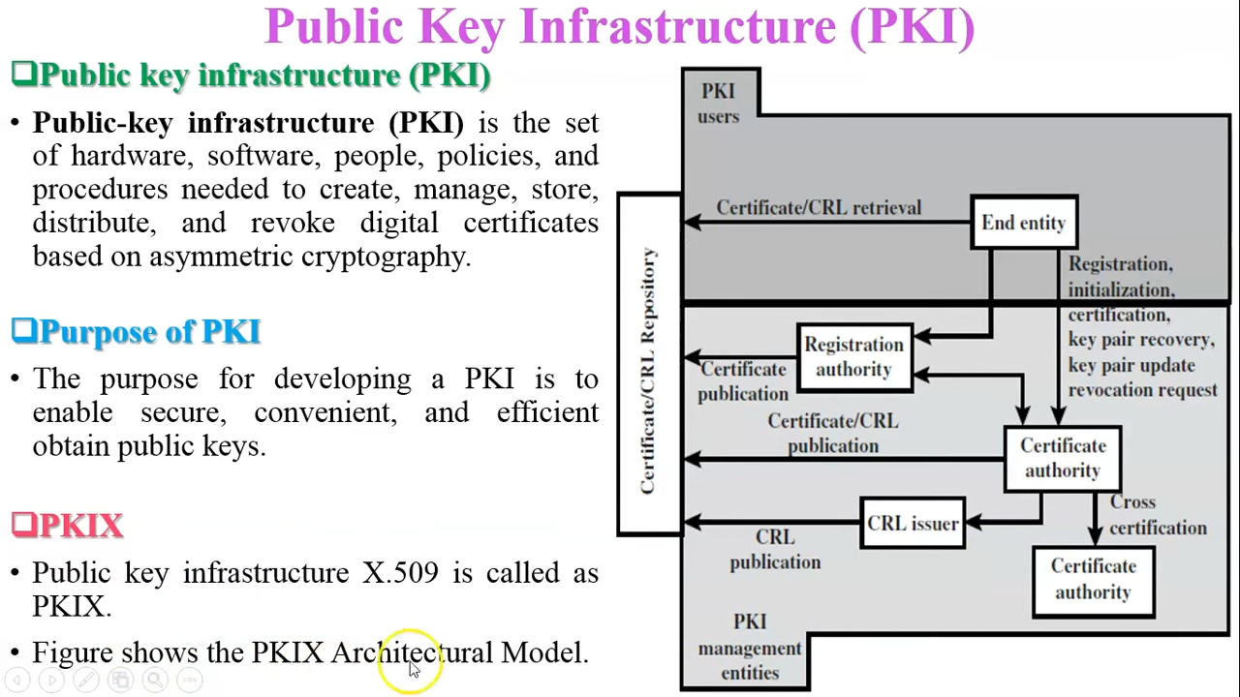

**PKIX Architectural Model**

PKIX (Public Key Infrastructure X.509) is a framework that defines the standards and protocols for managing digital certificates and public-key encryption. The PKIX architecture is designed to support the establishment and management of a public key infrastructure, providing a way to securely exchange information over insecure networks, such as the internet.

**Key Components of the PKIX Architectural Model**

1. **Entities**:
   * **End Entities**: These are the users or devices that utilize digital certificates for secure communication. They can be individuals, organizations, or machines that need to authenticate themselves or encrypt data.
   * **Certificate Authorities (CAs)**: Trusted entities that issue and manage digital certificates. They validate the identity of the entities requesting certificates and sign the certificates to ensure their authenticity.
   * **Registration Authorities (RAs)**: Entities that act as intermediaries between end entities and CAs. They are responsible for verifying the identity of entities requesting certificates and forwarding the requests to the CA.
2. **Certificates**:
   * Digital certificates are electronic documents that bind a public key to an entity's identity. They are signed by a CA to establish trust. The most common format for these certificates is X.509.
3. **Certificate Revocation**:
   * Mechanisms for revoking certificates that are no longer valid or should not be trusted. This includes:
     + **Certificate Revocation Lists (CRLs)**: Lists published by CAs that contain serial numbers of revoked certificates.
     + **Online Certificate Status Protocol (OCSP)**: A protocol for checking the revocation status of a certificate in real-time.
4. **Trust Model**:
   * The PKIX architecture relies on a hierarchical trust model where CAs are organized in a tree-like structure. Root CAs are at the top, and they can delegate authority to intermediate CAs, which in turn can issue certificates to end entities.

**PKIX Management Functions**

PKIX management functions encompass the processes and activities involved in the lifecycle of digital certificates. These functions include:

1. **Certificate Issuance**:
   * The process of generating and issuing digital certificates to end entities after validating their identities.
2. **Certificate Renewal**:
   * The process of renewing certificates before they expire to ensure continued trust and validity.
3. **Certificate Revocation**:
   * The process of invalidating certificates that are no longer trustworthy, either due to compromise, change in ownership, or other reasons.
4. **Certificate Distribution**:
   * The methods and protocols used to distribute certificates to end entities, ensuring they can access the public keys of other entities.
5. **Certificate Validation**:
   * The process of verifying the authenticity and validity of a certificate, including checking its signature, expiration date, and revocation status.
6. **Key Management**:
   * The processes involved in generating, storing, and protecting private keys associated with the public keys in the certificates.

**PKIX Protocols**

PKIX defines several protocols to facilitate the management of certificates and the establishment of secure communications. Some of the key protocols include:

1. **X.509 Certificate and CRL Protocol**:
   * Defines the format and structure of digital certificates and certificate revocation lists. X.509 is the standard that specifies the format of public key certificates.
2. **Certificate Management Protocol (CMP)**:
   * A protocol for managing certificates, including requests for issuance, renewal, and revocation. CMP is designed to work in various environments, including those requiring high security.
3. **Certificate Request Protocol (CRP)**:
   * A protocol for requesting certificates from a CA, allowing entities to submit their public keys and identification information.
4. **Online Certificate Status Protocol (OCSP)**:
   * A protocol used to obtain the revocation status of an individual certificate in real-time, providing a more timely alternative to CRLs.
5. **Simple Certificate Enrollment Protocol (SCEP)**:
   * A protocol designed for the automated enrollment of certificates, primarily in mobile and network devices.

## State and explain the principles differences between version-4 and version-5 of Kerberos with the Message Exchanges.

**Principle Differences Between Kerberos Version 4 (v4) and Version 5 (v5)**

Kerberos is a network authentication protocol that provides secure authentication for users and services in an insecure network. While both **v4** and **v5** are designed to achieve the same purpose, **Kerberos v5** introduces improvements to address limitations in **v4**. The main differences are outlined below:

**1. Protocol Design and Extensibility**

* **Kerberos v4**:
  + Designed with fixed data formats, which limits extensibility.
  + Difficult to adapt to new cryptographic algorithms or technologies.
* **Kerberos v5**:
  + Uses Abstract Syntax Notation One (ASN.1) for flexible data encoding (DER encoding).
  + Highly extensible to support new features, cryptographic algorithms, and future enhancements.

**2. Cryptographic Algorithms**

* **Kerberos v4**:
  + Limited to a single cryptographic algorithm, DES (Data Encryption Standard).
  + DES is now considered insecure due to its short key length.
* **Kerberos v5**:
  + Supports multiple encryption algorithms, including DES, 3DES, AES, and others.
  + Provides stronger security by allowing the use of modern cryptography.

**3. Addressing and Interoperability**

* **Kerberos v4**:
  + Only supports IPv4 addresses.
  + Limited interoperability due to specific constraints in the protocol.
* **Kerberos v5**:
  + Supports both IPv4 and IPv6 addresses, enhancing compatibility with modern networks.
  + Designed for better interoperability across different systems.

**4. Ticket Lifetime and Renewal**

* **Kerberos v4**:
  + Uses a fixed lifetime for tickets (e.g., 21 hours), which can be inflexible.
  + Tickets cannot be renewed or extended.
* **Kerberos v5**:
  + Allows configurable ticket lifetimes and supports renewable tickets.
  + Tickets can be extended if the user session requires it, improving usability.

**5. Cross-Realm Authentication**

* **Kerberos v4**:
  + Cross-realm authentication is complex and limited to a single hierarchical trust model.
* **Kerberos v5**:
  + Supports more flexible and scalable cross-realm authentication.
  + Can handle multiple trust relationships, including circular and non-hierarchical trust.

**6. Authentication Mechanism**

* **Kerberos v4**:
  + Vulnerable to password-guessing attacks due to weak protection mechanisms in the protocol.
* **Kerberos v5**:
  + Strengthened authentication mechanisms to resist offline password-guessing attacks.
  + Provides pre-authentication to mitigate replay attacks.

**7. Error Reporting**

* **Kerberos v4**:
  + Minimal and non-descriptive error messages, making debugging difficult.
* **Kerberos v5**:
  + Offers more detailed and specific error messages, improving troubleshooting and usability.

**Message Exchanges in Kerberos v4 and v5**

Below is a summary of the authentication exchanges in both versions:

**Kerberos v4 Message Exchanges**

1. **Authentication Service Exchange (AS)**:
   * The client requests an authentication ticket from the Authentication Server (AS).
   * AS sends back a Ticket-Granting Ticket (TGT) encrypted with the client’s password.
2. **Ticket Granting Exchange (TGS)**:
   * The client sends the TGT to the Ticket-Granting Server (TGS) to request access to a specific service.
   * TGS issues a service ticket.
3. **Client/Server Exchange**:
   * The client presents the service ticket to the target server for access.

**Kerberos v5 Message Exchanges**

Kerberos v5 follows the same structure but includes enhancements:

1. **Pre-Authentication**:
   * Adds an additional pre-authentication step to prevent replay attacks.
2. **Authentication Service Exchange (AS)**:
   * Similar to v4 but supports flexible ticket lifetimes, renewable tickets, and multiple cryptographic algorithms.
3. **Ticket Granting Exchange (TGS)**:
   * Same as v4 but enhanced for interoperability and extensibility.
4. **Client/Server Exchange**:
   * Similar to v4 but supports additional security features and better error handling.

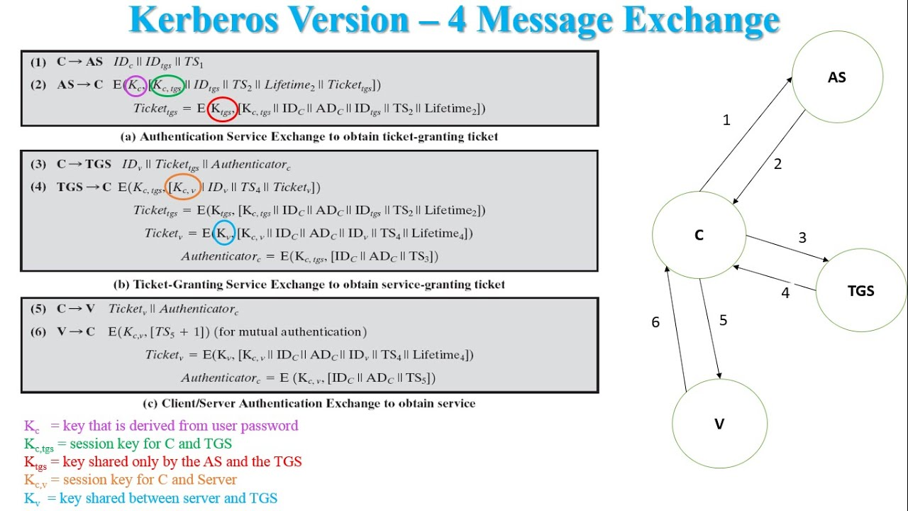

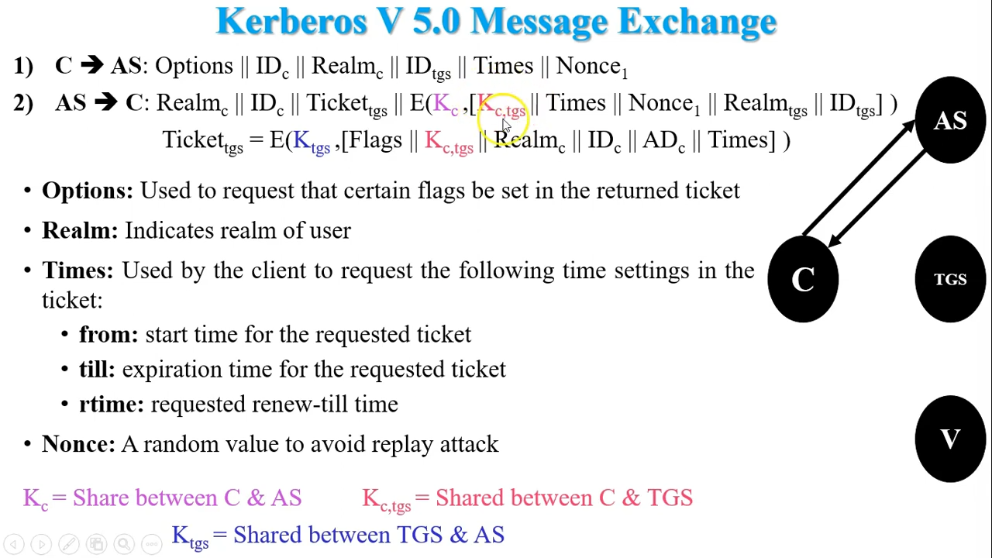

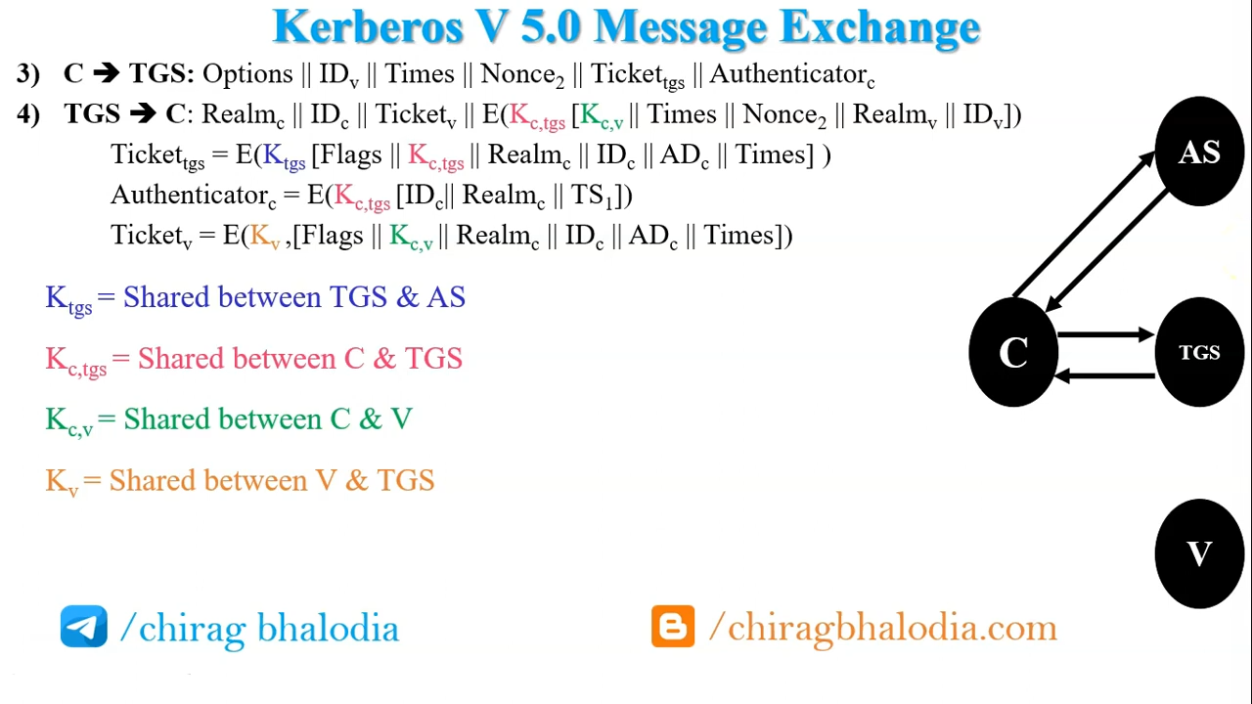

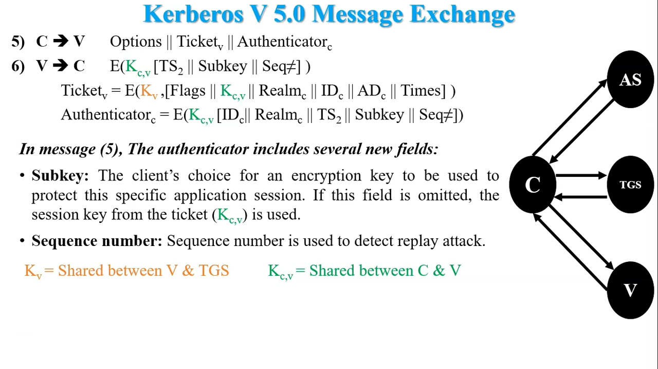

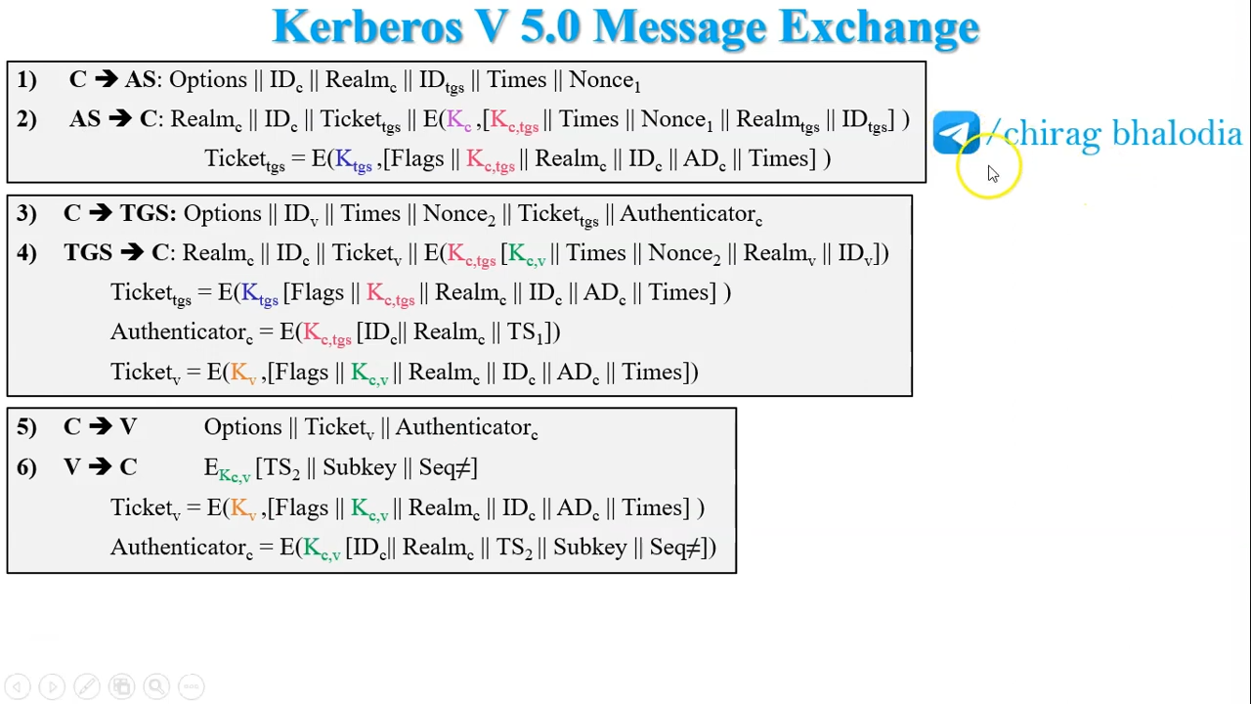

<https://www.youtube.com/watch?v=PE147fLSraU&ab_channel=ChiragBhalodia>

## RE-EXAM JAN 2019

## With the help of diagram explain the Cipher Feedback Mode block ciphers encryption and decryption.

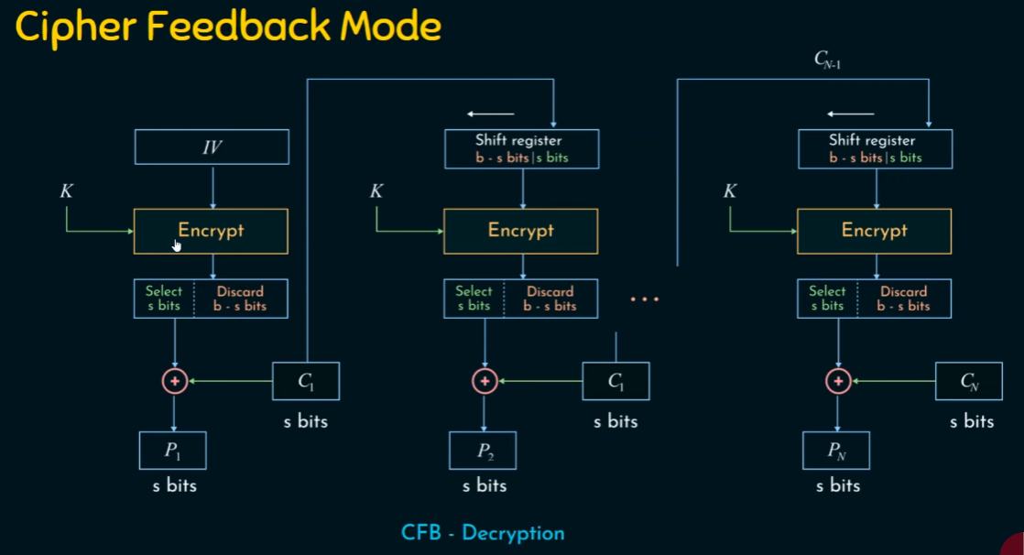

**Overview of Cipher Feedback Mode (CFB)**

CFB operates by using a block cipher to encrypt small segments of data (often one byte or one bit at a time) instead of the entire block at once. This mode transforms a block cipher into a self-synchronizing stream cipher, which is beneficial for applications where data comes in a continuous stream.

**Key Components**

1. **Block Cipher**: A symmetric key cipher that operates on fixed-size blocks of data (e.g., AES, DES).
2. **Initialization Vector (IV)**: A random or pseudo-random value that is used to ensure that the same plaintext will produce different ciphertexts when encrypted multiple times. The IV should be unique for each encryption session.
3. **Key**: A secret key shared between the sender and the receiver for encryption and decryption.

**Encryption Process in CFB Mode**

1. **Initialization**:
   * Choose a block cipher (e.g., AES) and set the key.
   * Generate an Initialization Vector (IV) of the same size as the block size (e.g., 128 bits for AES).
2. **Encryption Steps**:
   * Divide the plaintext into segments (often 8 bits or 1 byte) for processing.
   * Encrypt the IV using the block cipher to produce an initial output block.
   * XOR the output block with the first segment of plaintext to produce the first segment of ciphertext.
   * For subsequent segments:
     + Shift the previous ciphertext block into the input for the next encryption operation.
     + Encrypt the shifted value with the block cipher to produce a new output block.
     + XOR this output block with the next segment of plaintext to produce the next segment of ciphertext.
   * Repeat this process until all plaintext segments have been processed.

**Example of Encryption in CFB Mode**

1. **Input**:
   * Plaintext: **P1, P2, P3, ...**
   * Key: **K**
   * IV: **IV**
2. **Process**:
   * First output block: **O1 = E(K, IV)** (Encrypt the IV)
   * Ciphertext: **C1 = O1 ⊕ P1**
   * For the next segment:
     + Shift: **IV = C1**
     + Next output block: **O2 = E(K, IV)**
     + Ciphertext: **C2 = O2 ⊕ P2**
   * Continue this process for all segments.

**Decryption Process in CFB Mode**

The decryption process in CFB mode is similar to the encryption process, as it also requires the block cipher and the same key and IV.

1. **Initialization**:
   * Use the same block cipher (e.g., AES) and key.
   * Use the same IV that was used during encryption.
2. **Decryption Steps**:
   * The ciphertext is processed in segments, similar to encryption.
   * For the first segment:
     + Encrypt the IV: **O1 = E(K, IV)**
     + Plaintext: **P1 = O1 ⊕ C1**
   * For subsequent segments:
     + Shift the previous ciphertext block into the input for the next encryption operation.
     + Encrypt the shifted value: **O2 = E(K, IV)**
     + Plaintext: **P2 = O2 ⊕ C2**
   * Repeat this process until all ciphertext segments have been processed.

**Example of Decryption in CFB Mode**

1. **Input**:
   * Ciphertext: **C1, C2, C3, ...**
   * Key: **K**
   * IV: **IV**
2. **Process**:
   * First output block: **O1 = E(K, IV)** (Encrypt the IV)
   * Plaintext: **P1 = O1 ⊕ C1**
   * For the next segment:
     + Shift: **IV = C1**
     + Next output block: **O2 = E(K, IV)**
     + Plaintext: **P2 = O2 ⊕ C2**
   * Continue this process for all segments.

# Questions at the back of book

Ch 1

## What is the OSI security architecture?

**1. Introduction to OSI Security Architecture:**

* The **OSI Security Architecture** is part of the OSI Reference Model, which defines how communication should occur in a network.
* It focuses on providing security measures across all seven layers of the OSI model (Physical, Data Link, Network, Transport, Session, Presentation, and Application).
* The architecture addresses security mechanisms and services that protect data during transmission and ensure the integrity, confidentiality, and availability of information.

**2. Security Services:**

Security services in the OSI Security Architecture aim to provide protection for data transmission and include:

* **Confidentiality:** Ensures that information is accessible only to authorized entities.
* **Integrity:** Guarantees that data is accurate and unaltered during transmission.
* **Authentication:** Verifies the identity of users, devices, or entities involved in communication.
* **Non-repudiation:** Ensures that the sender cannot deny having sent the data.
* **Access Control:** Restricts unauthorized access to resources.
* **Availability:** Ensures that the system is available for authorized users when needed.
* **Accountability:** Tracks the activities of entities in the system to provide traceability.

**3. Security Mechanisms:**

Security mechanisms are techniques or protocols that implement the security services. Some key security mechanisms include:

* **Encryption:** Protects data confidentiality by converting plaintext into ciphertext.
* **Digital Signatures:** Provides data integrity and non-repudiation by using encryption to sign data.
* **Authentication Protocols:** Examples include Kerberos and Public Key Infrastructure (PKI) for authentication.
* **Firewalls:** Control access to network resources and protect against unauthorized access.
* **Access Control Lists (ACLs):** Define permissions for access to system resources.

**4. Security Requirements at Different Layers of the OSI Model:**

**1. Layer 7: Application Layer**

* **Function:**
  + **Provides network services directly to end-users and applications (e.g., web browsers, email clients).**
  + **Facilitates user interaction with the network and manages application-level protocols.**
* **Security Measures:**
  + **Authentication: Verifying user identities.**
  + **Encryption: Using SSL/TLS for secure data transmission.**
  + **Access Control: Restricting user permissions.**

**2. Layer 6: Presentation Layer**

* **Function:**
  + **Translates data between the application layer and the network; handles data formatting, encryption, and compression.**
  + **Ensures that data is in a usable format for the application layer.**
* **Security Measures:**
  + **Data Encryption: Encrypting data for confidentiality.**
  + **Data Compression: Reducing data size for efficient transmission.**

**3. Layer 5: Session Layer**

* **Function:**
  + **Manages sessions between applications; establishes, maintains, and terminates connections.**
  + **Controls the dialogues (connections) between computers.**
* **Security Measures:**
  + **Session Tokens: Authenticating sessions.**
  + **Session Encryption: Protecting session data from eavesdropping.**

**4. Layer 4: Transport Layer**

* **Function:**
  + **Provides reliable data transfer, error recovery, and flow control (e.g., TCP, UDP).**
  + **Ensures complete data transfer and integrity.**
* **Security Measures:**
  + **Transport Layer Security (TLS): Encrypting data during transmission.**
  + **Error Detection: Identifying and correcting transmission errors.**

**5. Layer 3: Network Layer**

* **Function:**
  + **Handles routing of data packets between devices across different networks (e.g., IP).**
  + **Determines the best path for data to travel from source to destination.**
* **Security Measures:**
  + **IPsec: Providing encryption and authentication at the IP layer.**
  + **Firewalls: Filtering traffic based on IP addresses.**

**6. Layer 2: Data Link Layer**

* **Function:**
  + **Provides node-to-node data transfer and error detection/correction (e.g., Ethernet, Wi-Fi).**
  + **Ensures reliable communication between directly connected nodes.**
* **Security Measures:**
  + **MAC Address Filtering: Controlling access based on device MAC addresses.**
  + **VLANs: Segmenting networks for enhanced security.**

**7. Layer 1: Physical Layer**

* **Function:**
  + **Transmits raw bitstreams over physical media (e.g., cables, radio waves).**
  + **Deals with the physical connection between devices.**
* **Security Measures:**
  + **Physical Security: Protecting hardware with locks and surveillance.**
  + **Secure Cabling: Using shielded cables to prevent eavesdropping.**

**5. Types of Security Threats Addressed:**

* **Passive Attacks:** Eavesdropping, traffic analysis, and unauthorized monitoring (e.g., packet sniffing).
* **Active Attacks:** Involves tampering with data, including data modification, insertion, deletion, or replay (e.g., man-in-the-middle attacks).
* **Denial of Service (DoS):** Preventing authorized access to a system by overwhelming it with traffic.
* **Spoofing:** Impersonating another user or device to gain unauthorized access.

**6. The Role of the Security Service Provider (SSP):**

* The **Security Service Provider (SSP)** is responsible for implementing security services and mechanisms within the OSI architecture.
* The SSP may be a hardware device, software application, or protocol that ensures data confidentiality, integrity, and availability.
* It can include technologies like encryption engines, firewalls, or intrusion detection systems (IDS).

**7. Key Components of OSI Security Architecture:**

* **Security Policy:** Defines the security objectives, rules, and guidelines to be followed.
* **Security Domain:** A logical grouping of resources, users, and systems sharing common security policies.
* **Security Protocols:** Define communication rules to ensure the security of transmitted data (e.g., SSL/TLS, IPsec).
* **Security Mechanisms:** Tools and techniques (like encryption) that ensure security services.

**8. Security Model in OSI Architecture:**

* The **OSI Security Model** emphasizes the relationship between security services and mechanisms across layers.
* It recognizes the dynamic nature of security, where measures evolve in response to emerging threats.
* The model aims to integrate security at each layer while ensuring inter-layer consistency and protection.

**9. Security Models and Frameworks:**

* **Bell-LaPadula Model:** Focuses on confidentiality by preventing unauthorized access.
* **Biba Model:** Emphasizes data integrity and prevents data modification by unauthorized users.
* **Clark-Wilson Model:** Ensures well-formed transaction rules and separation of duties to enforce integrity.

**10. Challenges in OSI Security:**

* **Complexity in Integration:** Coordinating security across all layers can be complex and resource-intensive.
* **Evolving Threats:** Security mechanisms need to be continuously updated to address new types of cyber threats.
* **Performance Impact:** Security measures like encryption and authentication can introduce overhead and impact system performance.
* **User Awareness:** Ensuring users understand security policies and mechanisms is critical to maintaining security.

## Provide an overview of the three types of cryptographic algorithms.

**1. Symmetric Key Cryptography (Secret Key Cryptography)**

**Key Features:**

* Uses a **single shared key** for both encryption and decryption.
* The sender and receiver must securely exchange the key before communication.
* Faster and more efficient than asymmetric cryptography, suitable for bulk data encryption.

**Applications:**

* Used in securing stored data (e.g., file encryption).
* Used in secure communications protocols like **SSL/TLS** for encrypting sessions.

**Strengths:**

* High speed and efficiency, especially for large amounts of data.
* Simplicity in implementation.

**Weaknesses:**

* Requires secure key distribution and management.
* If the key is compromised, the entire system is at risk.

**Examples of Algorithms:**

* **DES (Data Encryption Standard):** Outdated due to vulnerabilities but historically important.
* **AES (Advanced Encryption Standard):** Widely used and highly secure.
* **Blowfish and Twofish:** Efficient and flexible encryption algorithms.
* **RC4:** Previously used for stream encryption, now considered insecure.

**2. Asymmetric Key Cryptography (Public Key Cryptography)**

**Key Features:**

* Uses a **pair of keys**: a public key for encryption and a private key for decryption.
* Public keys are shared openly, while private keys are kept confidential.
* Operates on complex mathematical functions (e.g., factoring large numbers, elliptic curves).

**Applications:**

* **Digital signatures:** Ensures authenticity and non-repudiation.
* **Key exchange protocols:** Securely share symmetric keys (e.g., in HTTPS).
* **Email encryption:** Ensures confidentiality and integrity (e.g., PGP, S/MIME).

**Strengths:**

* Eliminates the need for secure key exchange.
* Enables non-repudiation through digital signatures.

**Weaknesses:**

* Slower than symmetric cryptography due to computational complexity.
* Relatively less efficient for encrypting large volumes of data.

**Examples of Algorithms:**

* **RSA:** Widely used for secure key exchange and digital signatures.
* **ECC (Elliptic Curve Cryptography):** Provides the same security as RSA with shorter key lengths, making it more efficient.
* **Diffie-Hellman:** Used for secure key exchange.

**3. Hash Functions**

**Key Features:**

* Converts data into a fixed-size hash value or digest.
* **One-way function:** Impossible (or computationally infeasible) to reverse or retrieve the original data.
* No keys are used in hash functions, as they do not involve encryption or decryption.

**Applications:**

* **Data integrity verification:** Ensures that data has not been altered during transmission.
* **Password storage:** Stores hashed passwords instead of plaintext.
* **Digital signatures:** Used to create the hash of a message.
* **Blockchain technology:** Forms the backbone of ledger security.

**Strengths:**

* High speed and simplicity.
* Provides strong integrity guarantees.

**Weaknesses:**

* Vulnerable to collisions if the algorithm is weak (two different inputs producing the same hash).
* No confidentiality as the hash does not encrypt data.

**Examples of Algorithms:**

* **MD5:** Fast but insecure due to vulnerability to collisions.
* **SHA-1:** More secure than MD5 but now deprecated.
* **SHA-2 (e.g., SHA-256, SHA-512):** Widely used and highly secure.
* **SHA-3:** The latest secure hashing standard.
* **HMAC (Hash-based Message Authentication Code):** Combines a hash function with a secret key for message authentication.

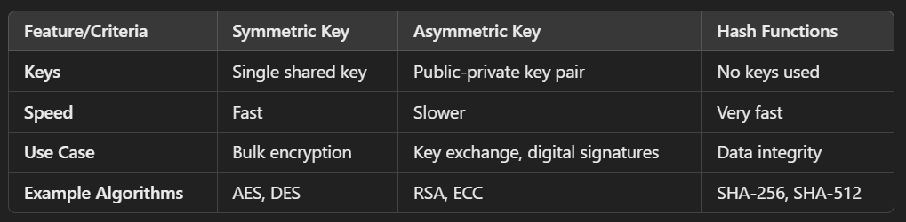

## List and briefly define categories of security services

**1. Confidentiality:**

* Ensures that sensitive information is accessible only to authorized entities.
* Protects against unauthorized disclosure of data during storage or transmission.
* Examples:
  + **Data Confidentiality:** Ensures content is not disclosed to unintended recipients.
  + **Traffic Confidentiality:** Protects metadata such as the identities of communicating parties or data flow patterns.

**2. Integrity:**

* Ensures that information is accurate and unaltered during transmission or storage.
* Protects against unauthorized modification, insertion, deletion, or replay of data.
* Types:
  + **Data Integrity:** Ensures the accuracy and consistency of data.
  + **System Integrity:** Ensures the proper functioning of hardware and software.

**3. Authentication:**

* Verifies the identity of users, devices, or systems involved in communication.
* Prevents impersonation or unauthorized access by confirming the legitimacy of entities.
* Types:
  + **Entity Authentication:** Ensures the identity of communicating parties.
  + **Message Authentication:** Verifies the origin and authenticity of a message.

**4. Non-Repudiation:**

* Ensures that neither the sender nor the receiver can deny their involvement in a communication or transaction.
* Provides proof of origin and delivery for accountability.
* Examples:
  + **Non-Repudiation of Origin:** The sender cannot deny sending the message.
  + **Non-Repudiation of Receipt:** The receiver cannot deny receiving the message.

**5. Access Control:**

* Restricts unauthorized access to systems, resources, or data.
* Enforces policies determining who can access what resources and under what conditions.
* Mechanisms include authentication, authorization, and permissions management.

**6. Availability:**

* Ensures that systems, applications, and data are accessible to authorized users when needed.
* Protects against disruptions caused by attacks like **Denial of Service (DoS)** or system failures.
* Aims to minimize downtime and maintain operational continuity.

**7. Accountability (Audit):**

* Tracks the actions and activities of users or systems within a network.
* Provides logs and evidence to detect and investigate security incidents.
* Facilitates forensic analysis and compliance with security policies.

## List and briefly define the fundamental security design principles

**Fundamental Security Design Principles**

1. **Least Privilege**
   * **Definition**: Users and systems should be granted the minimum level of access necessary to perform their functions.
   * **Purpose**: Reduces the risk of accidental or malicious misuse of privileges.
   * **Example**: A user in a finance department should only have access to financial data, not HR data.
2. **Defense in Depth**
   * **Definition**: Implementing multiple layers of security controls to protect information and resources.
   * **Purpose**: Provides redundancy; if one layer fails, others still provide protection.
   * **Example**: Using firewalls, intrusion detection systems, and antivirus software together.
3. **Fail-Safe Defaults**
   * **Definition**: Systems should default to a secure state, denying access unless explicitly granted.
   * **Purpose**: Minimizes the risk of unauthorized access due to misconfiguration.
   * **Example**: A new user account is created with no permissions until explicitly assigned.
4. **Separation of Duties**
   * **Definition**: Dividing responsibilities among different individuals to reduce the risk of fraud or error.
   * **Purpose**: Prevents any single individual from having control over all aspects of a critical process.
   * **Example**: In financial transactions, one person initiates a transaction while another approves it.
5. **Open Design**
   * **Definition**: Security mechanisms should not be secret; they should be open to scrutiny and review.
   * **Purpose**: Encourages transparency and allows for peer review, which can identify vulnerabilities.
   * **Example**: Using open-source software that can be audited by the community.
6. **Least Common Mechanism**
   * **Definition**: Minimizing the amount of shared resources among users to reduce the risk of information leakage.
   * **Purpose**: Limits the potential for unauthorized access to sensitive information.
   * **Example**: Separate databases for different departments instead of a single shared database.
7. **Psychological Acceptability**
   * **Definition**: Security measures should be easy to use and not overly burdensome for users.
   * **Purpose**: Ensures that users will comply with security policies and practices.
   * **Example**: Implementing single sign-on (SSO) to simplify user authentication.
8. **Auditability**
   * **Definition**: Systems should be designed to allow for monitoring and auditing of activities.
   * **Purpose**: Facilitates the detection of security breaches and compliance with regulations.
   * **Example**: Keeping logs of user access and changes to sensitive data.
9. **Compromise Detection**
   * **Definition**: Systems should have mechanisms to detect and respond to security breaches.
   * **Purpose**: Enables timely response to incidents to minimize damage.
   * **Example**: Intrusion detection systems (IDS) that alert administrators of suspicious activity.
10. **Simplicity**
    * **Definition**: Security designs should be as simple as possible to reduce complexity and potential vulnerabilities.
    * **Purpose**: Simplified systems are easier to understand, manage, and secure.
    * **Example**: Using straightforward access control lists instead of complex permission schemes.

## Provide an overview of the two major elements of network security.

**Major Elements of Network Security**

**1. Network Security Controls**

* **Definition**: These are the technical measures and tools implemented to protect the network and its resources from unauthorized access, misuse, or attacks.
* **Purpose**: To safeguard the integrity, confidentiality, and availability of data and network resources.

**Key Components**:

* **Firewalls**:
  + **Function**: Monitors and controls incoming and outgoing network traffic based on predetermined security rules.
  + **Purpose**: Acts as a barrier between trusted and untrusted networks, preventing unauthorized access.
* **Intrusion Detection and Prevention Systems (IDPS)**:
  + **Function**: Monitors network traffic for suspicious activity and can take action to block or alert on potential threats.
  + **Purpose**: Detects and responds to potential security breaches in real-time.
* **Virtual Private Networks (VPNs)**:
  + **Function**: Creates a secure, encrypted connection over a less secure network, such as the Internet.
  + **Purpose**: Protects data in transit and allows remote users to securely access the organization's network.
* **Access Control Mechanisms**:
  + **Function**: Regulates who can access specific resources and what actions they can perform.
  + **Purpose**: Ensures that only authorized users have access to sensitive information and systems.
* **Encryption**:
  + **Function**: Converts data into a coded format that can only be read by authorized parties.
  + **Purpose**: Protects data confidentiality during storage and transmission.
* **Antivirus and Anti-malware Software**:
  + **Function**: Detects, prevents, and removes malicious software from systems.
  + **Purpose**: Protects against malware infections that can compromise network security.

**2. Network Security Policies**

* **Definition**: These are formalized rules and guidelines that dictate how an organization manages and protects its network and data.
* **Purpose**: To establish a framework for maintaining security and ensuring compliance with legal and regulatory requirements.

**Key Components**:

* **Acceptable Use Policy (AUP)**:
  + **Function**: Outlines acceptable behaviors and practices for users accessing the network.
  + **Purpose**: Prevents misuse of network resources and sets expectations for user conduct.
* **Access Control Policy**:
  + **Function**: Defines who can access what resources and under what conditions.
  + **Purpose**: Ensures that access is granted based on the principle of least privilege.
* **Incident Response Policy**:
  + **Function**: Provides a structured approach for responding to security incidents.
  + **Purpose**: Ensures timely and effective responses to minimize damage and recover from incidents.
* **Data Protection Policy**:
  + **Function**: Establishes guidelines for handling, storing, and transmitting sensitive data.
  + **Purpose**: Ensures compliance with data protection regulations and protects user privacy.
* **Network Security Policy**:
  + **Function**: Outlines the overall security measures and protocols for protecting the network.
  + **Purpose**: Provides a comprehensive framework for maintaining network security.
* **Training and Awareness Programs**:
  + **Function**: Educates employees about security risks and best practices.
  + **Purpose**: Promotes a security-conscious culture within the organization.

## Briefly explain the concepts of trust and trustworthiness in cryptography

**1. Trust in Cryptography:**

* **Definition:** Trust refers to the reliance on a system, entity, or process to behave as expected without malicious intent.
* **Basis of Trust:** Trust is established based on evidence, reputation, certifications, or previous interactions.
* **Role in Cryptographic Systems:**
  + Trust is placed in cryptographic protocols to secure communication.
  + Entities like users, devices, and systems trust certificates issued by **Certificate Authorities (CAs)**.
  + Trust underpins the use of encryption keys and algorithms to maintain confidentiality and integrity.
* **Examples:**
  + Trusting a website’s **SSL/TLS certificate** for secure communication.
  + Trusting a public key in **asymmetric cryptography** for authentication.

**2. Trustworthiness in Cryptography:**

* **Definition:** Trustworthiness is the measure of an entity's reliability, integrity, and ability to perform securely as expected.
* **Key Attributes of Trustworthiness:**
  + **Integrity:** The entity does not compromise data.
  + **Competence:** The system or entity operates correctly without vulnerabilities.
  + **Transparency:** The entity's operations are clear and verifiable.
  + **Resilience:** The entity withstands attacks or failures and continues to operate securely.
* **Role in Cryptographic Systems:**
  + Trustworthiness ensures that cryptographic components (e.g., algorithms, protocols, keys) function securely.
  + It reduces risks of unauthorized access, tampering, or breaches.
* **Examples:**
  + A **cryptographic algorithm** (e.g., AES) is trustworthy when it is widely analyzed and proven secure.
  + Trustworthy entities like **Trusted Third Parties (TTPs)** ensure secure key management and data handling.

**3. Relationship Between Trust and Trustworthiness:**

* **Trust Depends on Trustworthiness:** An entity is trusted if it is deemed trustworthy based on evidence, experience, or assurance.
* **Dynamic Nature of Trust:** Trust can be established, maintained, or lost based on the entity's demonstrated trustworthiness over time.

**4. Applications in Cryptography:**

* **Public Key Infrastructure (PKI):** Trust is established through trusted certificate authorities that validate the trustworthiness of public keys.
* **Blockchain:** Relies on trustless mechanisms (e.g., consensus algorithms) to establish trust in a decentralized environment.
* **Secure Communication Protocols:** Trust is crucial in establishing secure sessions, e.g., using **TLS/SSL** or **IPsec**.

**5. Challenges in Trust and Trustworthiness:**

* **Trust Misplacement:** Blind trust in an unverified entity can lead to vulnerabilities (e.g., phishing attacks).
* **Erosion of Trustworthiness:** A previously trustworthy entity may lose its reliability due to compromise or obsolescence (e.g., weak cryptographic algorithms).
* **Establishing Trust in Dynamic Environments:** Ensuring trust in rapidly changing networks (e.g., IoT or mobile networks) is challenging.

## Consider a Feistel cipher composed of sixteen rounds with a block length of 128 bits and a key length of 128 bits. Suppose that, for a given k, the key scheduling algorithm determines values for the first eight round keys, k1, k2, c k8, and then sets k9 = k8, k10 = k7, k11 = k6, c, k16 = k1 Suppose you have a ciphertext c. Explain how, with access to an encryption oracle, you can decrypt c and determine m using just a single oracle query. This shows that such a cipher is vulnerable to a chosen plaintext attack. (An encryption oracle can be thought of as a device that, when given a plaintext, returns the corresponding cipher text. The internal details of the device are not known to you and you cannot break open the device. You can only gain information from the oracle by making queries to it and observing its responses.)

**Vulnerability Analysis of the Feistel Cipher**

**Key Observation**

* The key scheduling algorithm creates a symmetry in round keys
* k9 = k8, k10 = k7, k11 = k6, ..., k16 = k1
* This symmetry introduces a critical weakness in the cipher's design

**Attack Strategy**

1. **Oracle Query Approach**
   * Choose a specific plaintext P that, when encrypted, will reveal the decryption mechanism
   * Select P such that its encryption can help recover the original message
2. **Specific Plaintext Selection**
   * Choose P = c ⊕ (some known value)
   * Encrypt P using the encryption oracle
   * Let the resulting ciphertext be C'
3. **Decryption Process**

Steps:

a) Encrypt P = c ⊕ X

b) Observe the resulting ciphertext C'

c) Analyze the relationship between C' and the original ciphertext

**Mathematical Proof of Vulnerability**

1. **Encryption Process**
   * Due to the symmetric key scheduling
   * The encryption and decryption processes become essentially identical
   * Reversing the rounds becomes trivial
2. **Key Symmetry Effect**
   * The round keys used in encryption and decryption become mirror images
   * This allows direct reconstruction of the original message

- c = Original Ciphertext

- P = c ⊕ X (Chosen Plaintext)

- C' = Encryption(P)

Attack Steps:

1. Select a known value X

2. Compute P = c ⊕ X

3. Query oracle with P

4. Receive C'

5. Analyze relationship between C' and c

**Proof Outline**

1. The symmetrical key scheduling means encryption and decryption processes are nearly identical
2. By carefully choosing P, you can force the cipher to essentially "decrypt" the original ciphertext
3. A single oracle query reveals the original message m

**Cryptographic Significance**

* This demonstrates a critical weakness in Feistel network design
* Symmetric key scheduling can introduce predictable vulnerabilities
* Highlights the importance of robust key expansion algorithms

**Practical Implications**

* Such a cipher would be considered cryptographically weak
* The attack requires only a single oracle query
* Reveals fundamental flaws in the cipher's structural design

## Let p be a permutation of the integers 0, 1, 2, c , (2n- 1), such that p(m) gives the permuted value of m, 0 … m 6 2n. Put another way, p maps the set of n-bit integers onto itself, and no two integers map into the same integer. DES is such a permutation for 64-bit integers. We say that p has a fixed point at m if p(m) = m. That is, if p is an encryption mapping, then a fixed point corresponds to a message that encrypts to itself. We are interested in the number of fixed points in a randomly chosen permuta tion p. Show the somewhat unexpected result that the number of fixed points for p is 1 on an average, and this number is independent of the size of the permutation.

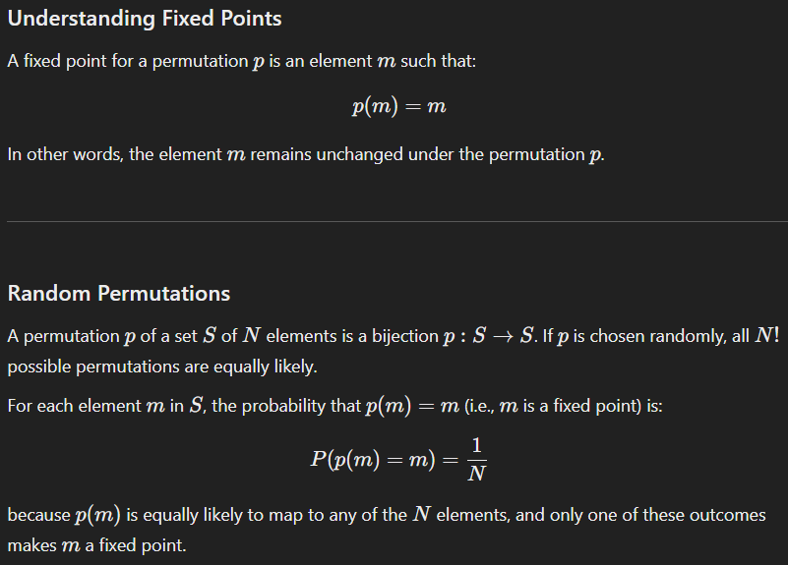

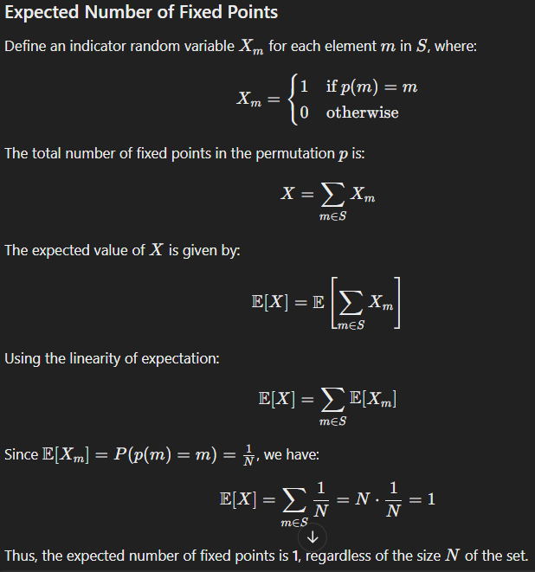

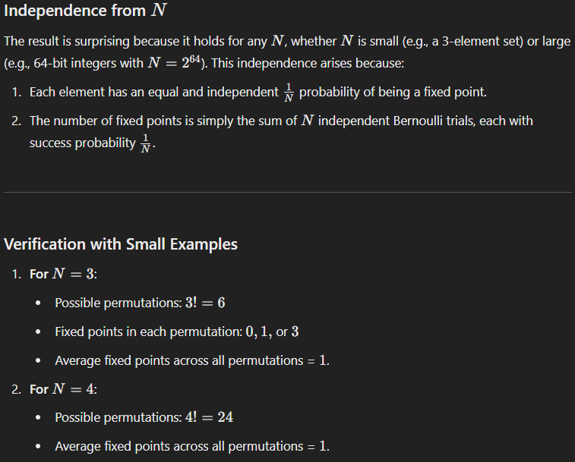

Transport Vs Tunnel Mode:

<https://www.ques10.com/p/13442/differentiate-between-the-transport-mode-and-tunne/>

| **Transport mode** | **Tunnel mode** |
| --- | --- |
| Here end hosts do IPsec encapsulation of their own data; hence IPsec needs to implemented on each end-hosts | IPsec gateways provide service to other hosts in peer-to-peer tunnels; hence the end-hosts don’t need IPsec. |
| Lower overhead than tunnel mode | More overhead required |
| No edits on IP header | The entire packet is hashed or encrypted; IP header is applied to the packet during transit. |
| Used in securing communication from one device to another. | Used to tunnel traffic from one site to another |
| It is good for ESP host-to-host traffic | It is good for VPNs, gateway-to-gateway security. |
| Provides protection primarily to upper layer protocols | Provides protection to entire IP packet |
| AH in transport mode authenticates the IP payload and selected portions of IP header. | AH in tunnel mode authenticates the entire inner IP packet and selected portions of the outer IP header. |
| ESP in transport mode encrypts and optionally authenticates the IP payload but not the IP header. | ESP in tunnel mode encrypts and optionally authenticates the entire inner IP packet, including the inner IP header. |

## What are the basic approaches to bundling SAs?

**1. Transport Adjacency**

* **Definition**:
  + Transport adjacency refers to the application of more than one security protocol (such as Authentication Header (AH) and Encapsulating Security Payload (ESP)) to the same IP packet without invoking tunneling.
* **Mechanism**:
  + In this approach, both AH and ESP can be applied to the same packet. For example, AH can provide integrity and authentication, while ESP can provide confidentiality through encryption.
* **Processing**:
  + The processing of these protocols occurs at a single IPsec instance, specifically at the ultimate destination. This means that the packet is processed once, and both security features are applied simultaneously.
* **Nesting**:
  + Further nesting of protocols (i.e., applying additional layers of AH or ESP) does not yield additional benefits because the processing is done at one point. The ultimate destination handles the security processing, making additional layers redundant.
* **Example**:
  + Consider a scenario where a company wants to secure communication between two offices. They can use transport adjacency to apply both AH and ESP to the same IP packet. This way, the packet is authenticated and encrypted in a single processing step, ensuring both integrity and confidentiality without the overhead of multiple processing layers.
* **Use Case**:
  + Transport adjacency is suitable for environments where performance is critical, and a single layer of security suffices, such as internal communications within a trusted network.

**2. Iterated Tunneling**

* **Definition**:
  + Iterated tunneling refers to the application of multiple layers of security protocols through IP tunneling. This allows for encapsulating packets multiple times, each time potentially using different security protocols.
* **Mechanism**:
  + Each layer of tunneling can use different security protocols and can originate or terminate at different IPsec sites along the path. This means that each tunnel can have its own security associations and policies.
* **Nesting**:
  + This approach allows for multiple levels of nesting, providing flexibility in security configurations. Each tunnel can encapsulate packets independently, adding layers of security.
* **Example**:
  + Imagine a scenario where a user is connecting to a corporate network from a public Wi-Fi hotspot. The user first establishes a VPN connection (first tunnel) to a remote access server using ESP for encryption. Then, the remote access server establishes another VPN connection (second tunnel) to the corporate network, possibly using a different security protocol or configuration. Each tunnel can have its own security policies, and the data is encrypted at both levels.
* **Use Case**:
  + Iterated tunneling is ideal for complex network architectures, such as when data needs to traverse multiple security domains (e.g., connecting through different ISPs or networks) or when different security policies are required at various points in the network.

Scope of AH for transport and tunnel mode

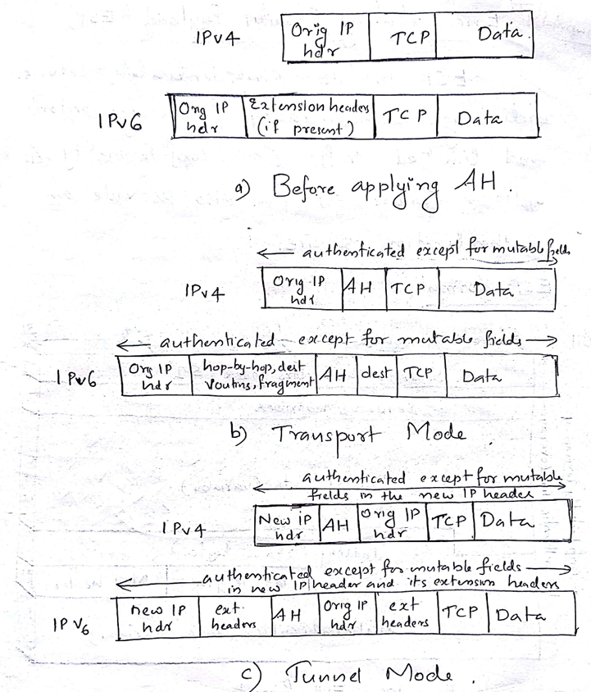

Birthday Paradox:

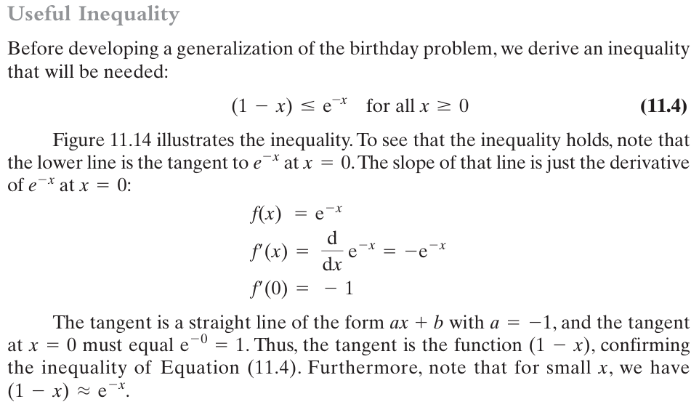

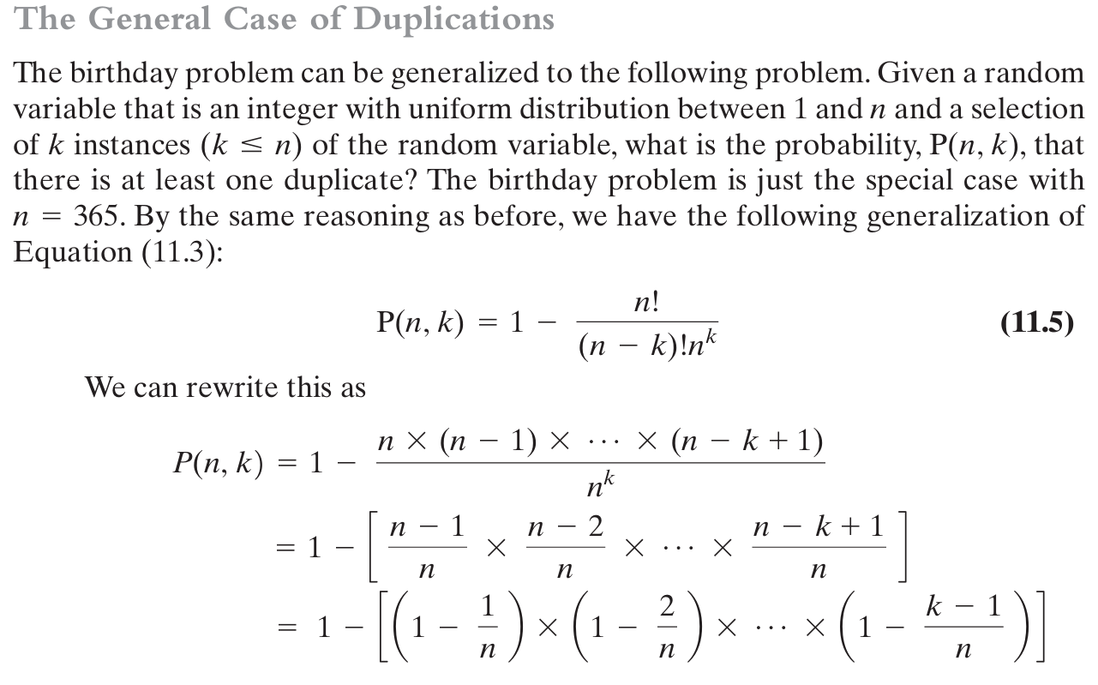

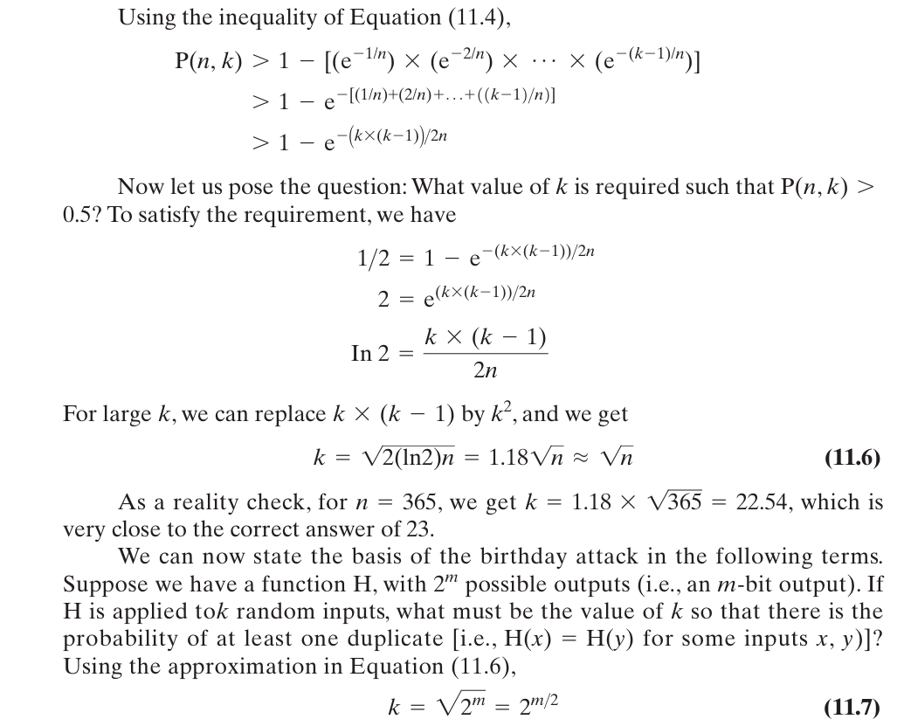

## The first 16 bits of the message digest in a PGP signature are translated in the clear. a. To what extent does this compromise the security of the hash algorithm? b. To what extent does it in fact perform its intended function, namely, to help deter mine if the correct RSA key was used to decrypt the digest?

**a. Not at all.**  
The disclosure of the first 16 bits of the message digest in the clear does not compromise the security of the hash algorithm. This is because the message digest is already encrypted with the sender's private key, and anyone in possession of the public key can decrypt it and recover the entire digest. The disclosed 16 bits do not reveal any new or sensitive information about the hash function or the original message.

**b. The probability that a message digest decrypted with the wrong key would have an exact match in the first 16 bits with the original message digest is 2−162^{-16}2−16 (1 in 65,536).**  
This low probability makes it highly unlikely that a random or incorrect RSA key would produce a digest whose first 16 bits match the disclosed bits in the signature. Therefore, the disclosed 16 bits serve as an effective mechanism to verify that the correct RSA key was used to decrypt the digest, without compromising security.

Elaborate ans

**a. To what extent does this compromise the security of the hash algorithm?**

The security of the hash algorithm is generally not compromised by revealing the first 16 bits of the message digest in the clear. Here’s why:

1. **Hash Collision Resistance:** Hash functions like SHA-256 or SHA-1 are designed to be collision-resistant. Even if 16 bits of the hash are known, finding another input that produces the same hash would still require a significant amount of computational effort. For a 16-bit segment, there are 216=65,5362^{16} = 65,536216=65,536 possible values, which is trivial to brute-force. However, this does not weaken the hash's security for the remaining bits or compromise its overall strength.
2. **Preimage Resistance:** The known 16 bits do not significantly help an attacker find the original input (preimage resistance). The attacker would still need to brute-force the remaining bits of the hash or the input itself, which remains computationally infeasible for strong hash functions.
3. **Selective Disclosure:** Only a small, predictable portion of the hash (16 bits) is disclosed. This is unlikely to provide significant leverage to an attacker because the disclosed bits are insufficient to meaningfully reverse-engineer the original message or the rest of the hash.

**b. To what extent does it perform its intended function, namely, to help determine if the correct RSA key was used to decrypt the digest?**

The inclusion of the first 16 bits of the hash in the clear serves its intended function effectively:

1. **Integrity Check for Decryption:** After decrypting the signature using the sender's public RSA key, the receiver obtains the hash of the message. The receiver can compare the first 16 bits of the computed hash (based on the message) with the 16 bits revealed in the signature. If they match, it strongly indicates that:
   * The RSA key used for decryption is correct.
   * The message has not been tampered with after signing.
2. **Efficient Error Detection:** If the 16 bits do not match, the receiver can immediately reject the signature without needing to compute the full hash or perform more intensive verification. This saves computational resources and provides a quick way to detect incorrect key usage or message corruption.
3. **Limited Security Risk:** The disclosed 16 bits are insufficient for an attacker to forge a signature or deduce the private key. They act as a lightweight verification mechanism without undermining the cryptographic strength of the RSA key or the hash function.

## Section 10.2 describes a man-in-the-middle attack on the Diffie-Hellman key exchange protocol in which the adversary generates two public-private key pairs for the attack. Could the same attack be accomplished with one pair? Explain.

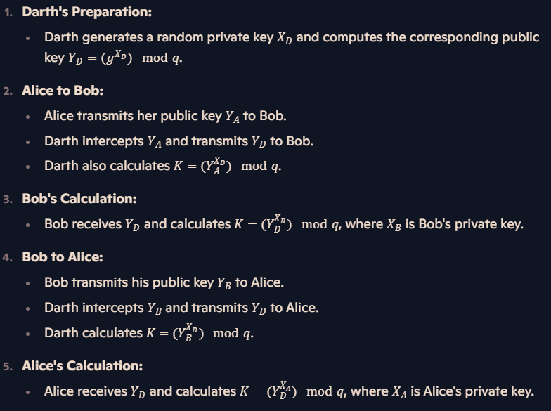

With 2 keys:

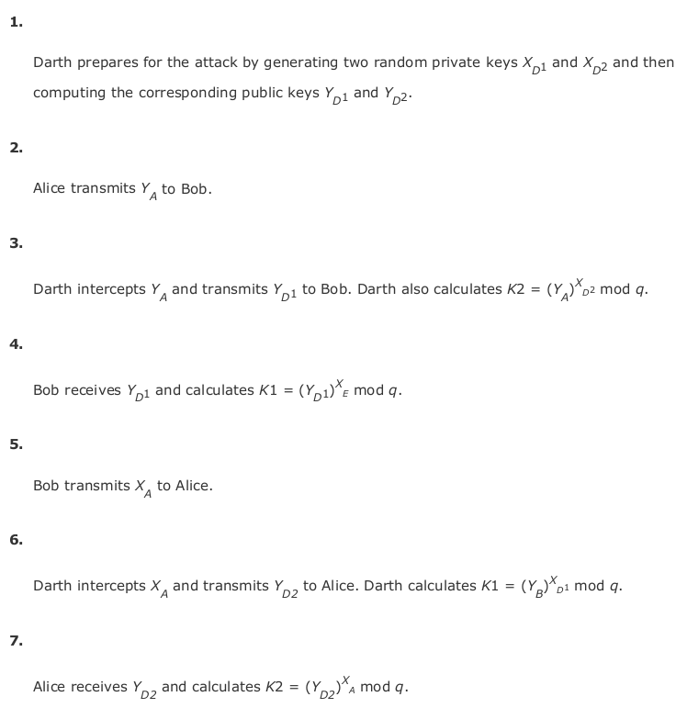

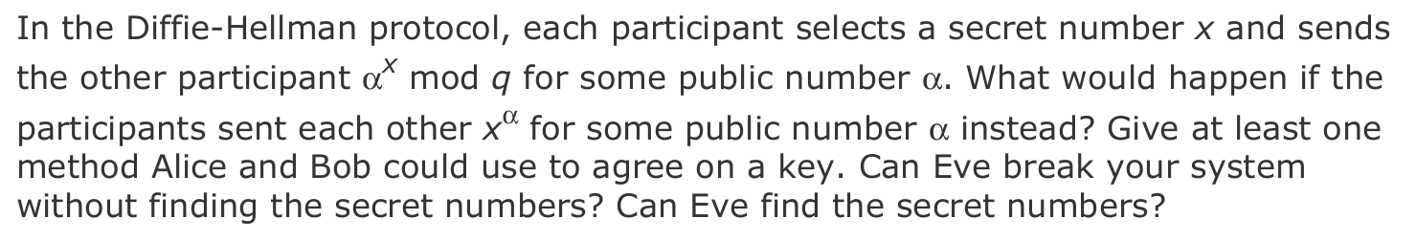

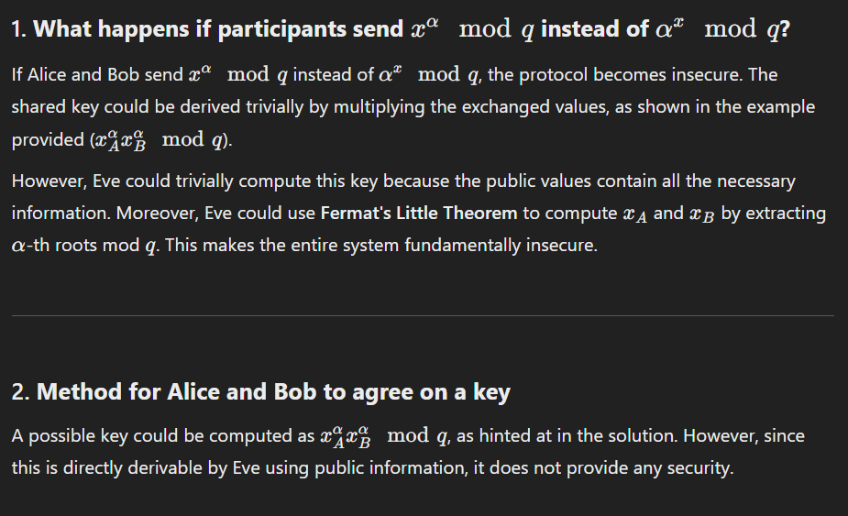

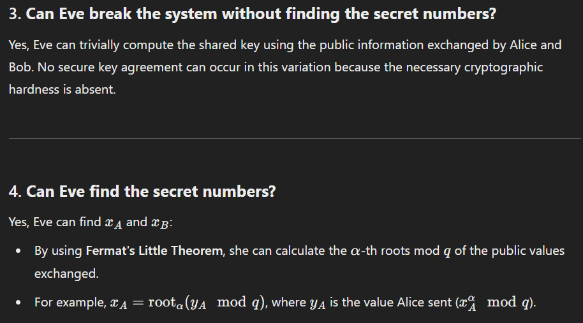

Elliptic Curve Cryptography

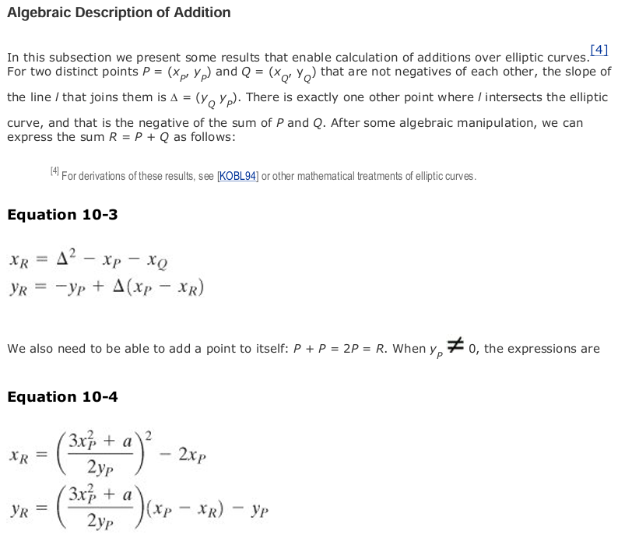

For sha 512

